Updated Mitigation assessment report for NDC 3.0
Preliminary Analysis for Uganda’s Nationally Determined Contribution (NDC 3.0)

Prepared for
Climate Change Department (CCD),
Ministry of Water and Environment,
Government of Uganda

Executive Summary

Uganda’s development over the coming decades will be shaped by rapid population growth, urbanization, and rising demand for energy, transport, housing, food, and sanitation services. This analysis demonstrates that many of the investments required to meet these development needs also deliver substantial benefits to human health and wellbeing, economic productivity and the environment. Across the scenarios assessed, the most significant gains arise from improvements in household energy access, urban transport systems, sanitation and waste management.
Under Reference scenario assumptions, national greenhouse gas emissions are projected to increase substantially as population, economic activity, and energy demand expand. In the absence of additional mitigation measures, emissions are expected to reach approximately 150–170 MtCO₂eq by 2035 and around 200 MtCO₂eq by mid-century. Implementation of the measures already included in NDC 2.0 could reduce emissions by an estimated 40–45 MtCO₂eq by 2035, with additional candidate measures providing the potential to deliver a further 10–25 MtCO₂eq reduction over the same period. Looking toward 2050, the scope for transformational change becomes more pronounced as the long-term effects of early investments accumulate. Actions included in NDC 2.0 are projected to deliver reductions of approximately 70–80 MtCO₂eq by mid-century, while the further candidate measures assessed in this analysis could reduce emissions by an additional 20–70 MtCO₂eq.
The transition to clean cooking emerges as the single largest source of immediate development benefits. Expanding access to modern cooking technologies sharply reduces indoor air pollution (drastically improving health outcomes) and releases time for education and income-generating activities. These benefits are estimated to reach approximately USD 2-4% of GDP depending on the pathway, while also reducing pressure on forests and supporting the transition of the land sector toward a net carbon sink. However, the analysis shows that clean cooking alone does not fully stabilize emissions from the building sector. Most GHG emissions reductions related to building energy transitions occur in the land use sector as unsustainable biomass extraction is reduced or eliminated. As urban energy demand continues to grow with rising population and incomes, additional measures to support electrification, energy efficiency and managing electricity demand in buildings will therefore be required to also stabilize or lower direct emissions.
Investments in transport systems deliver some of the most cost-effective development gains. Expanding public transport, improving vehicle efficiency, and supporting non-motorized mobility reduce congestion, improve air quality, and lower road fatalities while enhancing access to jobs and services. These measures generate strong economic and social returns across all scenarios. However, the analysis also shows that without sustained progress in vehicle electrification, transport emissions will continue to grow alongside rising mobility demand. Electrification of the vehicle fleet offers substantial mitigation potential but requires significant upfront investment in vehicles and charging infrastructure.
Improvements in sanitation and waste management represent another high-value investment area. Expanding wastewater treatment coverage and modernizing solid waste systems produce major public health and environmental benefits, particularly in rapidly urbanizing areas. These interventions are prioritized because of their health and environmental benefits rather than their mitigation potential. Nevertheless, continued population growth and urbanization will increase waste volumes over time, underscoring the need for sustained investment in waste infrastructure and service delivery capacity.
The agriculture, forestry, and land-use sector remain the dominant source of long-term emissions, driven primarily by livestock production. Livestock emissions increase steadily across all scenarios and remain the largest single contributor to national emissions by mid-century. The analysis shows that improvements in other sectors alone cannot offset this growth. Targeted livestock mitigation measures, such as productivity improvements, feed management, and manure management, would therefore be needed to stabilize emissions from the land sector and achieve long-term climate goals.
The energy sector plays a central enabling role in Uganda’s development and decarbonization pathway. Under current policy trajectories, rapid electrification of households, transport, and industry is expected to drive strong growth in electricity demand. Without sufficient expansion of low-carbon generation capacity, this demand growth can lead to rising emissions from the power sector. In contrast, scenarios aligned with the current Energy Policy demonstrate that maintaining a largely decarbonized electricity sector is achievable. Strengthening investment in renewable energy and grid infrastructure is therefore critical to ensure that electrification delivers its full development and climate benefits.
The NDC 3.0 candidate scenario illustrates that a pathway consistent with net-zero emissions by around 2070 is technically feasible for Uganda. Achieving this trajectory would require deep decarbonization of the energy supply sector, accelerated transformation of land systems, and sustained investment in transport, buildings, and waste infrastructure. However, the analysis indicates that the scale of investment required is substantially higher than under current policy pathways, with investment requirements rising 15-20% higher than in the Reference scenario with gross capital fixed formation peaking at around 30% of GDP. Mobilizing this level of investment will depend on strengthened institutional capacity, enhanced policy coordination, and expanded access to domestic and international climate finance.
Overall, the findings underscore a central message: Uganda’s development and climate objectives are closely aligned. Investments that improve health, productivity, and economic opportunity, particularly in clean cooking, transport, sanitation, and energy systems, also deliver significant emissions reductions. Realizing these benefits will require sustained investment, targeted sectoral policies, and coordinated planning across government institutions and development partners.

Table of Content
1. Introduction 10
1.1 Background and Objectives 10
1.2 Uganda’s Socioeconomic Context 11
1.3 National Planning and Policy Framework 11
2. Analytical Approach and Methodology 12
2.1 Modelling Frameworks (CLEWs and SISEPUEDE) 12
2.2 Scenario Framework 13
2.3 Data Harmonisation and Stakeholder Engagement 13
3. National Results 15
3.1 Historical Emissions (2015–2019) 15
3.2 Overall emission pathways 15
3.3 Development Co-Benefits 20
3.3.1 Assumptions 20
3.5.2 Results 20
4. Sectoral Results 23
4.1 Energy Sector 23
4.1.1 Sector Background 23
4.1.2 Key Drivers and Assumptions 23
4.1.3 Mitigating Actions 25
4.1.4 CLEWs Results 26
4.1.5 SISEPUEDE Results 37
4.2 Industry Sector 44
4.2.1 Sector Background 44
4.2.2 Key Drivers and Assumptions 45
4.2.3 Mitigating Actions 45
4.2.4 CLEWs Results 46
4.2.5 SISEPUEDE Results 48
4.3 Agriculture Sector 51
4.3.1 Sector Background 51
4.3.2 Key Drivers and Assumptions 52
4.3.3 Mitigating Actions 52
4.3.4 CLEWs Results 53
4.3.5 SISEPUEDE Results 58
4.4 Land 63
4.4.1 Sector Background 63
4.4.2 Key Drivers and Assumptions 63
4.4.3 Mitigating Actions 64
4.4.4 CLEWs Results 65
4.4.5 SISEPUEDE Results 67
4.5 Waste Sector 72
4.5.1 Sector Background 72
4.5.2 Key Drivers and Assumptions 72
4.5.3 Mitigating Actions 74
4.5.4 CLEWs Results 74
4.5.5 SISEPUEDE Results 80
5. Conclusions 85
Appendices 89
Appendix 1. Development co-benefits assumptions and parameters 89
Appendix 2. Implementation of Mitigation Measures in the CLEWs Model 91
Appendix 3: SISEPUEDE Mitigation Measures and Implementation Levels, NDC2 and HBLE 96

List of Figures
Figure 1. Projected total GHG emissions under the Reference, NDC 2.0 and NDC 3.0 pathways, including land-use emissions, CLEWs and SISEPUEDE, 2020–2050 (MtCO₂eq) 18
Figure 2. Projected total GHG emissions under the Reference, NDC 2.0 and NDC 3.0 pathways, excluding land-use emissions, CLEWs and SISEPUEDE, 2020–2050 (MtCO₂eq) 19
Figure 3. Projected total GHG emissions under the under the Reference, NDC 2.0 and NDC 3.0 pathways by IPCC category, including land use change, CLEWs and SISEPUEDE, 2020–2050 (MtCO₂eq) 20
Figure 4. Projected total GHG emissions under the under the Reference, NDC 2.0 and NDC 3.0 pathways by IPCC category, excluding land use change, CLEWs and SISEPUEDE, 2020–2050 (MtCO₂eq) 21
Figure 5. Projected total development benefits under the Reference, NDC 2.0 and NDC 3.0, CLEWs and SISEPUEDE, 2020–2050 ($ Billion) 23
Figure 6. Projected total development benefits under the Reference, NDC 2.0 and NDC 3.0, CLEWs and SISEPUEDE, 2020–2050 (percentage share of GDP) 23
Figure 7. Energy Industries Sector Emissions by Scenario, 2021–2050 (MtCO₂eq) 29
Figure 8. Electricity Generation Mix under Reference. NDC 2.0 and NDC 3.0 scenarios, 2021–2050 (TWh) 30
Figure 9. Total annualized power sector investment ($ million, left) and average per unit cost of electricity (cents/kWh, right), by scenario, 2021–2050 31
Figure 10. Oil export revenue under Reference. NDC 2.0 and NDC 3.0 scenarios, 2021–2050 ($ million) 32
Figure 11. Buildings Sector Emissions by Scenario, 2021-2050 (MtCO₂eq) 33
Figure 12. Buildings energy use under Reference. NDC 2.0 and NDC 3.0 Scenarios, 2021–2050 (PJ) 34
Figure 13. Direct, indirect, and total costs of energy use in the buildings sector by scenario, 2021–2050 ($ million) 35
Figure 14: Transport Sector Emissions by Scenario, 2021-2050 (MtCO₂eq) 36
Figure 15. Transport Energy Demand by Mode and Scenario, 2021–2050 (PJ) 37
Figure 16. Transport Fuel Use by Energy Carrier and Scenario, 2021–2050 (PJ) 37
Figure 17. Direct costs ($ million, left) and external costs ($ million, right) of the transport sector by scenario, 2021–2050 38
Figure 18. Total energy use (PJ, left), average electric vehicle share of fleet (%, centre), and average on-road fuel economy (MJ/km, right) by scenario, 2021–2050 38
Figure 19. Electricity production under BAU (left), NDC 2.0 (center), and NDC 3.0 (right) in electricity and heat generation (PJ). 40
Figure 20. Emissions for BAU (gray), NDC 2.0 (yellow), and NDC 3.0 (green) in electricity and heat generation. 41
Figure 21. Total energy demands in commercial and residential subsectors in the Reference (left), NDC 2.0 (center), and NDC 3.0 (right) pathways (PJ) 42
Figure 22. Total fuel consumption in demands in commercial and residential subsectors in in the Reference (left), NDC 2.0 (center), and NDC 3.0 (right) pathways (PJ) 43
Figure 23. Emissions for Reference (gray), NDC 2.0 (yellow), and NDC 3.0 (green) in commercial and residential buildings (MtCO2e). 44
Figure 24. Passenger-kilometer demand (pkm) by transportation type for Reference (left), NDC 2.0 (center), and NDC 3.0 (right) 45
Figure 25. Freight megatonne-kilometer (mt-km) demand by transportation type for Reference (left), NDC 2.0 (center), and NDC 3.0 (right). 45
Figure 26. Emissions for Reference (gray), NDC 2.0 (yellow), and NDC 3.0 (green) in electricity and heat generation (MtCO2e). 46
Figure 27. IPPU Sector Emissions by Scenario, 2021–2050 (MtCO₂eq) 49
Figure 28. IPPU Sector Fuel Use for the NDC2.0 and NDC3.0 Scenario, 2021–2050 (PJ) 49
Figure 29. IPPU Sector Total Cost by Scenario ($m), 2021–2050 50
Figure 30. Total fuel consumption in demands in non-energy industries in in the Reference (left), NDC 2.0 (center), and NDC 3.0 (right) pathways (PJ). 51
Figure 31. Emissions for Reference (gray), NDC 2.0 (yellow), and NDC 3.0 (green) in industrial (excluding energy industries) combustion (MtCO2e). 51
Figure 32. Total industrial production by year and tonnage for key drivers of IPPU. 52
Figure 33. Emissions for Reference (gray), NDC 2.0 (yellow), and NDC 3.0 (green) in industrial procceses and product use (IPPU, MtCO2e). 53
Figure 34. Livestock Sector Emissions by Scenario, 2021–2050 (MtCO₂eq) 56
Figure 35. Livestock population by breed under the Reference, NDC2.0 and NDC3.0 scenarios (2021–2050). 56
Figure 36. Livestock Sector Total Cost (left), Total Investment (centre) and average costs (right) by Scenario ($m), 2021–2050 57
Figure 37. Crops Sector Emissions by Scenario, 2021–2050 (MtCO₂eq) 58
Figure 38. Average crop production cost ($ per tonne, left), average crop yield (centre) and total cropland area by scenario, 2021–2050 59
Figure 39. Total population of cattle in Reference (left), NDC 2.0 (center), and NDC 3.0 (right) pathways. 60
Figure 40. Total population of all livestock in Reference (left), NDC 2.0 (center), and NDC 3.0 (right) pathways. 61
Figure 41. Manure management pathways 61
Figure 42. Emissions for Reference (gray), NDC 2.0 (yellow), and NDC 3.0 (green) in industrial the Livestock subsector (MtCO2e). 62
Figure 43. Crop production for Reference (left), NDC 2.0 (center), and NDC 3.0 (right) in total tonnage. 63
Figure 44. Emissions for Reference (gray), NDC 2.0 (yellow), and NDC 3.0 (green) in industrial the Crops subsector (MtCO2e). 64
Figure 45. Benefits associated with increases in crop production when compared to Reference pathway for NDC 2.0 (left), and NDC 3.0 (right) in billion USD. 65
Figure 46. LULUCF Emissions by Scenario, 2021–2050 (MtCO₂eq) 67
Figure 47. Land use allocation by category under the Reference, NDC 2.0, and NDC 3.0 scenarios (2021–2050) (million hectares) 68
Figure 48. Total ecosystem services under the Reference, NDC2.0, and NDC3.0 scenarios (2021–2050) 69
Figure 49. Land use areas by class in Reference (left), NDC 2.0 (center), and NDC 3.0 (right) in million ha. 70
Figure 50. Net emissions for Reference (gray), NDC 2.0 (yellow), and NDC 3.0 (green) due to annual sequestration capacity in forests (MtCO2e). 71
Figure 51. Total above-ground biomass C stock loss estimated for Reference (grey), NDC 2.0 (yellow), and NDC 3.0 (green) in Mt. 71
Figure 52. Emissions for Reference (gray), NDC 2.0 (yellow), and NDC 3.0 (green) due to removals for fuelwood and harvested wood products (MtCO2e). 72
Figure 53. Emissions for Reference (gray), NDC 2.0 (yellow), and NDC 3.0 (green) due to deforestation for land use conversion (MtCO2e). 72
Figure 54. Total permanent and seasonal wetlands area for Reference (left), NDC 2.0 (center), and NDC 3.0 (right) in million ha. 73
Figure 55. Costs and benefits associated with land use and land change in NDC 2.0 (left), and NDC 3.0 (right) in billion USD. 74
Figure 56. Solid Waste Sector Emissions by Scenario, 2021–2050 (MtCO₂eq) 77
Figure 57. Solid Waste Emissions by Treatment Pathway by Scenario, 2021–2050 (MtCO₂eq) 78
Figure 58. Solid waste sector costs by scenario, 2021–2050, total direct cost ($ million, top left), total external cost ($ million, top right), average disposal cost ($ per tonne waste, bottom left), and average societal cost ($ per tonne waste, bottom right) 78
Figure 59. Liquid waste sector emissions by scenario, 2021–2050 (million tonnes CO₂eq) 79
Figure 60. Liquid Waste Emissions by Treatment Pathway by Scenario, 2021–2050 (MtCO₂eq) 80
Figure 61. Liquid waste sector costs by scenario, 2021–2050, total direct cost ($ million, top left), total external cost ($ million, top right), average disposal cost ($ per tonne waste, bottom left), and average societal cost ($ per tonne waste, bottom right) 81
Figure 62. Solid waste generation by Reference (left), NDC 2.0 (center), and NDC 3.0 (right) pathways. 82
Figure 63. Solid waste treatment pathway shared for Reference (left), NDC 2.0 (center), and NDC 3.0 (right) pathways. 83
Figure 64. Solid waste treatment emissions for Reference (gray), NDC 2.0 (yellow), and NDC 3.0 (green) pathways, MtCO2e. 83
Figure 65. Costs and benefits associated with solid waste collection in NDC 2.0 (left) and NDC 3.0 (right) in billion USD. 84
Figure 66. Wastewater treatment shares in Reference (left), NDC 2.0 (center), and NDC 3.0 (right) pathways. 85
Figure 67. Wastewater treatment emissions for Reference (gray), NDC 2.0 (yellow), and NDC 3.0 (green) pathways, MtCO2e. 85
Figure 68. Costs and benefits associated with wastewater treatment in NDC 2.0 (left) and NDC 3.0 (right) in billion USD. 86

1. Introduction

1.1 Background and Objectives
Climate ambition in developing countries often presents a development dilemma: efforts to adopt more ambitious climate targets can appear conflict with immediate national priorities such as expanding domestic energy supply, increasing consumption, and developing fossil resources for both domestic use and export. Uganda is advancing an ambitious agenda under the Fourth National Development Plan (NDP IV, 2025–2030), which aims to accelerate inclusive growth, industrialization, and job creation to address persistent gaps in income generation, infrastructure, and service delivery. These priorities are anchored in Vision 2040, which outlines Uganda’s long-term aspiration to transition into a modern and prosperous society.
While promoting economic development, Uganda remains committed to environmental sustainability and climate resilience. Although current greenhouse gas (GHG) emissions are relatively low, around 110 MtCO₂eq in 2021, representing just 0.2% of global emissions, they are expected to rise with continued population growth, urbanization, and economic expansion. Understanding how different development and mitigation scenarios influence future emissions is therefore essential for informing Uganda’s next Nationally Determined Contribution (NDC 3).
Uganda’s Updated NDC (2022) provides a key reference point for this analysis, outlining mitigation and adaptation measures aligned with national development priorities. To support the preparation of NDC 3, the Government of Uganda is working with partners including the World Bank and Agence Française de Développement (AFD). Two whole economy modelling frameworks are being used to assess the Updated NDC and explore alternative development scenarios: the Climate, Land, Energy and Water Systems (CLEWs) model, implemented by AFD, and the Simulation of Sectoral Pathways and Uncertainty Exploration for Decarbonization (SISEPUEDE), led by the World Bank.
The analytical process applies the Robust Decision Making (RDM) methodology to examine how uncertainty in socioeconomic trends, technology costs, and climate conditions may affect Uganda’s development and emissions outcomes. RDM enables the exploration of a wide range of plausible futures, helping identify strategies that consistently deliver high net benefits and remain effective even under adverse or unexpected conditions. This evidence supports the development of a resilient, uncertainty-tolerant approach to NDC 3.
This interim report is part of an initiative designed to provide evidence and analysis in support of the development of Uganda’s NDC 3.0 by:
- Developing modeling frameworks to quantify the emission, costs and development benefits of different development strategies across key sectors following IPCC categories.
- Assessing how mitigation measures from the Updated NDC (2022) would contribute to the priorities of NDP IV (2025–2030).
- Developing alternative scenarios, with stakeholder input, that lead to higher net benefits and can serve as the basis for NDC 3.0 targets.
- Defining NDC 3.0 targets under both conditional and unconditional financing scenarios and a range of other uncertainties.
- Strengthening national technical capacity through open-source modelling, transparent data, and shared analytical tools.

This report presents preliminary results for objective 1-3 from the CLEWS and SISEPUEDE frameworks.

1.2 Uganda’s Socioeconomic Context

Uganda’s economy has shown steady growth. After declining to 3% during the covid-pandemic, GDP growth rates have rebounded consistently every year, rising to 6.1% in 2024, nearly reaching the pre-covid growth rate of 6.4% achieved in 2019. GDP per capita was around USD 1,080 (2024) and total GDP is projected to increase from USD 40.8 billion (2020) to USD 440 billion (2050). Despite this progress, productivity remains low, with approximately 72% of the workforce engaged in subsistence agriculture, and the Human Development Index (0.52) highlights ongoing challenges in health, education, and income generation.
Rapid population growth, from 46 million (2024) to a projected 86 million by 2050, will intensify pressure on land, water, infrastructure, and energy systems. Without additional mitigation efforts, GHG emissions could nearly double by 2050, rising to 190-220 MtCO₂eq, driven mainly by land-use change, agriculture, and increasing energy demand. These trends underscore the importance of assessing the extent to which current NDC measures align with national mitigation targets and support development priorities. Rising emission trends also highlight the need to assess and propose alternative mitigation scenarios, to inform the development of the third updated Nationally Determined Contributions (NDC 3.0).

1.3 National Planning and Policy Framework

Uganda’s development and climate ambitions are anchored in a set of national policies and strategies that shape the assessment of mitigation scenarios:

- Vision 2040 outlines the country’s long-term aspiration to become a modern and prosperous society.

- The Fourth National Development Plan (NDP IV, 2025/2026–2030) translates Vision 2040 into action through five strategic priorities:
  - Production and value addition
  - Human capital development
  - Private-sector competitiveness
  - Sustainable infrastructure
  - Governance and security

- The National Climate Change Policy (NCCP, 2015) provides overarching guidance for all climate change interventions.

- The Green Growth Development Strategy (2017–2030) offers a framework for inclusive and environmentally sustainable economic development.

- The National Climate Change Act (2021) establishes the legal and policy foundation for coordinated and integrated climate action.

Aligned with these priorities, Uganda’s Updated Nationally Determined Contribution, NDC 2.0 (2022), identifies mitigation and adaptation actions aimed at supporting low-carbon economic growth and climate resilience. Key interventions include climate-smart agriculture, forest and wetland restoration, renewable energy expansion, and improved waste management, contributing to Uganda’s broader aspiration for ten-fold economic growth by 2040.

The Updated NDC is reinforced by complementary sectoral plans and strategies, including:

- The NDC 2.0 Stocktake Report (2025) provides a structured midpoint review of Uganda's progress in implementing its Updated NDC for the period 2020/21–2030/31. Conducted under the Africa NDC Hub supported by the African Development Bank, it evaluates sectoral achievements to date across mitigation, adaptation, and means of implementation, identifies key gaps and barriers, including data limitations, weak MRV systems, and financing shortfalls, and generates evidence-based recommendations to inform Uganda's forthcoming NDC 3.0.

- The Long-Term Climate Strategy (LTS, 2025) sets out Uganda's overarching vision of becoming "a Uganda that prospers throughout its transformation into a climate resilient and low-carbon society by 2050." Developed by the Ministry of Water and Environment, the LTS provides the long-range strategic compass aligning Uganda's socioeconomic transformation with the objectives of the Paris Agreement and includes a low-emission scenario modelling a pathway toward net zero emissions by 2065 across all key sectors.

- The Energy Transition Plan (ETP) outlines a scenario to net-zero emissions in the power sector by 2050.

- The National E-Mobility Strategy promotes clean and efficient transport systems.

- The Agro-Industrialization Program Implementation Action Plan (2020-2025) addresses key challenges in agricultural production, agro-processing, and value addition (including climate change).

- The Integrated Transport Infrastructure Services Program Implementation Plan (2020-2025) aims to create a safe, inclusive, and sustainable multi-modal transport system.

2. Analytical Approach and Methodology

2.1 Modelling Frameworks (CLEWs and SISEPUEDE)

This analysis draws on two distinct modelling systems, CLEWs and SISEPUEDE, to assess development and mitigation pathways in support of Uganda’s third Nationally Determined Contribution (NDC3). While both frameworks examine the linkages between economic activity, energy systems, and greenhouse gas emissions, they differ in structure and methodological design. Results from both models are presented together to provide a comprehensive assessment of Uganda’s potential development and decarbonisation pathways.
- CLEWS (Climate, Land, Energy and Water Systems)
CLEWS is a bottom-up, technology-rich optimisation model that represents the interactions among Uganda’s energy, land, water, and agricultural systems. It identifies least-cost combinations of technologies and resource scenarios to meet projected national demands, while simulating the impacts of policy interventions. The model results are reported at pl across the following sectors: Energy, Industrial Processes and Product Use (IPPU), Agriculture, Forestry and Other Land Use (AFOLU), and Waste.
- SISEPUEDE (Simulation of Sectoral Pathways and Uncertainty Exploration for Decarbonization)
SISEPUEDE is a bottom-up emissions inventory modelling framework, based primarily on the IPCC guidelines for national greenhouse gas inventories, that is designed to assess the technical costs and co-benefits of mitigation actions. SISEPUEDE includes over 70 policy transformations across 5 sectors and 21 subsectors. It represents numerous cross- and intra-sectoral interactions to give a comprehensive picture of drivers, emissions, energy demand, and costs and benefits of emissions reducing policy transformations.

2.2 Scenario Framework
This analysis constructs and evaluates a set of development and mitigation scenarios to assess their implications for Uganda's greenhouse gas (GHG) emissions, resource systems, and socioeconomic outcomes through 2050. Four core scenarios form the basis of the assessment:
- The Reference scenario is aligned with the Tenfold Growth Strategy from the Ministry of Energy and Mineral Development's Least-Cost Electricity Generation and Transmission Plan (LCGTP, FY2025/26–FY2039/40), with no mitigating actions applied, providing the baseline against which mitigation outcomes are measured.
- The NDC2.0 Scenario incorporates the full suite of mitigation measures outlined in Uganda's Updated Nationally Determined Contribution (2022), implemented from 2025 onwards. The scenario quantifies the resulting emission reductions, resource implications, and development co-benefits relative to the Reference scenario.
- The NDC 3.0 Candidate scenario is aligned with the Policy Targets Scenario from the Ministry of Energy and Mineral Development's Least-Cost Electricity Generation and Transmission Plan (LCGTP, FY2025/26–FY2039/40) and builds upon the NDC 2.0 scenario by introducing additional mitigation measures from 2025 onwards, achieving deeper emissions reductions across sectors through a faster transition away from carbon-intensive technologies and fuels, alongside more ambitious structural changes in energy systems, transport, industry, and land management practices.

2.3 Data Harmonisation and Stakeholder Engagement
To ensure comparability between the two independently developed modelling frameworks, a harmonised evidence base was established as the foundation for all analyses. Core datasets were drawn from Uganda's national policy and statistical documents, including Vision 2040, NDP IV (2025–2030), the Updated Nationally Determined Contribution (2022), Uganda's national GHG inventory, the UBOS Statistical Abstract, and sectoral data compiled from relevant Ministries, Departments and Agencies.
Data collection and stakeholder engagement were undertaken in parallel, with each process helping to strengthen the completeness of inputs, resolve inconsistencies, and improve the quality of scenario assumptions. Running these activities side by side ensured that data refinements and clarification of sectoral practices informed modelling choices in real time. Additionally, this concurrent approach reduced biases typical of sequential methods while enabling instantaneous co-creation of assumptions with stakeholders.
The first technical workshop, held in June 2025, brought together representatives from key ministries and agencies to review preliminary datasets and provide input on scenario design. The discussions focused on assessing the initial data, identifying missing information, clarifying mitigation actions included in the Updated NDC (2022), and refining choices related to scenario structure. The workshop also introduced the XLRM framework, linking national development priorities with the modelling levers and performance metrics required for quantitative assessment. Following the first workshop, a series of bilateral and virtual consultations with sector institutions were used to obtain missing or updated data and to validate or adjust the assumptions underlying the scenarios. These engagements were critical in resolving discrepancies across datasets, clarifying policy measures and sectoral trends, and ensuring that the underlying data reflected current national plans and sector realities. The insights gathered were incorporated into the harmonised dataset and informed subsequent revisions to scenario definitions.
A second validation workshop, held in April 2026, provided an opportunity to present model results to government stakeholders and subject them to technical scrutiny. The discussions served to verify the plausibility of outputs across sectors, surface any remaining data inconsistencies, and confirm the interpretation of scenario outcomes prior to finalisation of the report.
The final modelling dataset combined information from national planning documents such as NDP IV, Vision 2040, and the Updated NDC (2022), along with sectoral statistics from UBOS and line ministries and historical emissions from CCD. International sources, FAO, IEA, IPCC, and the World Bank, were incorporated only where national data were unavailable. Remaining gaps were addressed through proxy estimates, stakeholder validation, or structured assumptions designed to maintain consistency across sectors.
Harmonisation across the CLEWs and SISEPUEDE models included alignment of socioeconomic assumptions (population and GDP trajectories sourced from UBOS and NDP IV), historical emissions (calibrated to Uganda's official GHG inventory), mitigation measures (based on a common interpretation of the Updated NDC (2022)), and technology and cost parameters (using national data where available, supplemented by international sources). Where national data were unavailable, proxy or regional values were applied and documented transparently. This technical harmonisation ensured that, despite their methodological differences, both models operated from a consistent and nationally aligned basis. Detailed assumptions specific to each subsector are highlighted within the corresponding sectoral results sections of this report.

3. National Results

3.1 Historical Emissions (2015–2019)

Uganda’s national GHG inventory reports total emissions increasing from 105.46 MtCO₂eq in 2015 to 111.27 MtCO₂eq in 2019. Land Use, Land-Use Change and Forestry (LULUCF) remains the largest contributor to national emissions, followed by livestock, waste, and energy-related sources.

Key trends from the 2015–2019 national GHG inventory include:

- LULUCF emissions remained dominant, increasing from 52.9 MtCO₂eq in 2015 to 55.7 MtCO₂eq in 2019, accounting for approximately 50% of total national emissions.
- Livestock emissions rose steadily from 25.3 MtCO₂eq to 27.3 MtCO₂eq over the same period.
- Energy sector emissions increased from 8.5 MtCO₂eq to 12 MtCO₂eq, with growth observed across Energy Industries (1.A.1), Manufacturing Industries and Construction (1.A.2), Transport (1.A.3), and Other Sectors (1.A.4), driven by expanding fossil fuel consumption and charcoal production.
- Industrial Processes and Product Use (IPPU) emissions increased marginally from 0.36 MtCO₂eq in 2015 to 0.37 MtCO₂eq in 2019.
- Waste sector emissions (solid and wastewater) changed from 14.6 MtCO₂eq in 2015 to 13.5 MtCO₂eq in 2019, reflecting evolving waste management and population dynamics.

These values form the calibration basis for the Reference scenarios in both the CLEWs and SISEPUEDE models. The total GHG emissions trajectories from both models are presented in separate appendices to this report

3.2 Overall emission pathways

Uganda’s long-term emissions trajectory is shaped by the interactions between rapid economic growth, structural transformation, land-use dynamics, and the pace of mitigation actions. Across all scenarios, population growth, urbanization, industrialization, and rising incomes drive strong increases in demand for energy, transport, housing, food production, waste treatment and infrastructure buildout. The principal difference between pathways is therefore not whether emissions initially rise, but rather how quickly structural transitions emerge across the economy and whether long-term growth remains coupled to emissions-intensive resource use.

Under the Reference pathway, total national greenhouse gas emissions increase steadily from approximately 105 MtCO₂eq in 2015 to around 157–171 MtCO₂eq by 2035 and approximately 198–204 MtCO₂eq by 2050 across the CLEWs and SISEPUEDE trajectories. While the two models produce similar long-term pathways, CLEWs projects somewhat higher emissions in the earlier decades, primarily due to a slower transition away from traditional biomass and greater pressure on forest resources. This divergence highlights the importance of assumptions regarding biomass sustainability, household fuel switching, and land-energy interactions in determining near-term emissions outcomes.

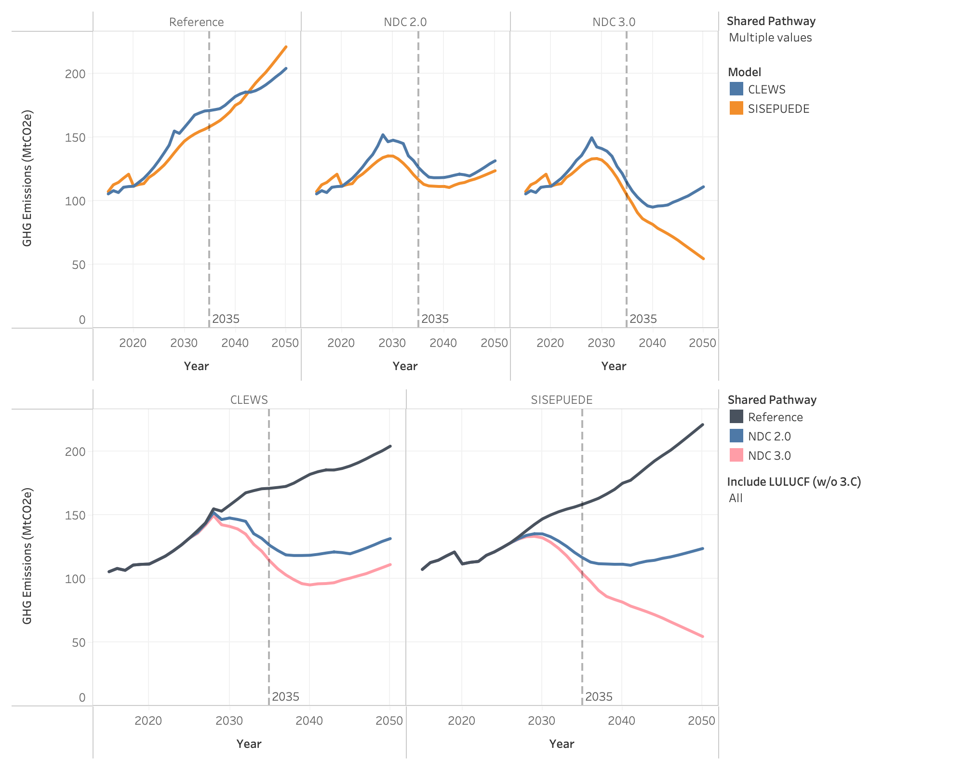
Figure 1. Projected total GHG emissions under the Reference, NDC 2.0 and NDC 3.0 pathways, including land-use emissions, CLEWs and SISEPUEDE, 2020–2050 (MtCO₂eq)
The NDC 2.0 pathway moderates this growth substantially, reducing emissions to approximately 126 MtCO₂eq by 2035 and 131MtCO₂eq by 2050 for CLEWs and 113 MtCO₂eq and 115 MtCO₂eq for SISEPUEDE in the same years. Under the more ambitious NDC 3.0 Candidate pathway, emissions peak during the late 2020s before declining through much of the 2030s, reaching approximately 114 MtCO₂eq by 2035 and 111 MtCO₂eq by 2050. The divergence between scenarios becomes increasingly pronounced after 2030 as land restoration, electrification, clean cooking transitions, and low-carbon infrastructure investments begin reshaping the economy.

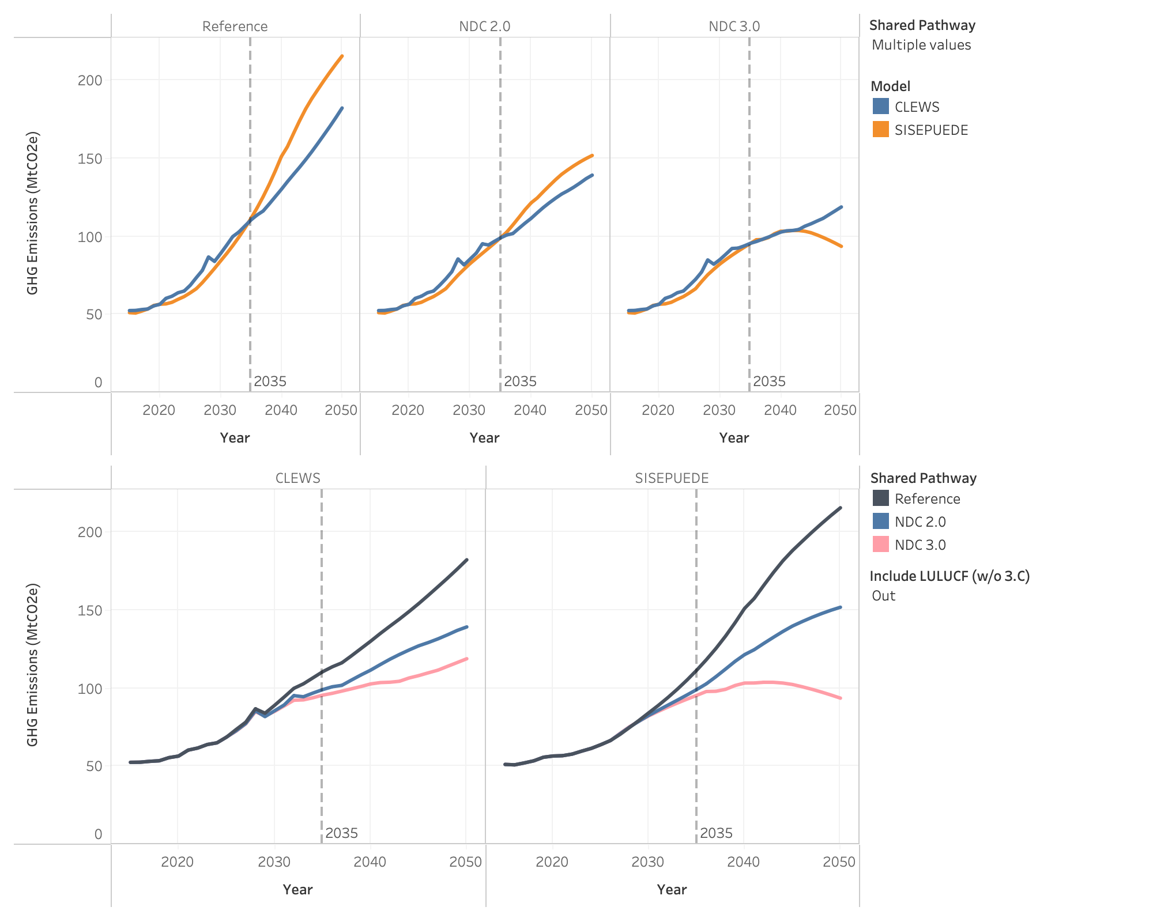
Figure 2. Projected total GHG emissions under the Reference, NDC 2.0 and NDC 3.0 pathways, excluding land-use emissions, CLEWs and SISEPUEDE, 2020–2050 (MtCO₂eq)
While the two modelling frameworks produce somewhat different absolute emissions levels, particularly in the near term, they show strong agreement regarding the overall direction of structural change. CLEWs generally projects somewhat higher emissions during the 2020s due to continued growth in traditional biomass use in the earlier and stronger land-energy interactions, highlighting the importance of assumptions regarding biomass sustainability, household fuel switching, and forest resource depletion. However, both models indicate that Uganda’s long-term emissions trajectory is ultimately determined by the pace of transition away from unsustainable biomass dependence and the extent to which rapid economic growth is accompanied by structural decarbonisation across energy, transport, industry, and land systems. As shown in Figure 2, the differences in overall emission pathways between the two modelling frameworks largely disappear when the land use sector is excluded.

Land-use change remains the dominant source of national emissions in the near term across all scenarios. Under the Reference pathway, continued agricultural expansion, forest degradation, and growing demand for charcoal and fuelwood drive land-use emissions upward through the late 2020s, peaking at nearly 69 MtCO₂eq under the CLEWs trajectory. Thereafter, emissions begin declining gradually as accessible forest resources become increasingly depleted and natural regeneration progressively constrains further land conversion.

The mitigation pathways fundamentally alter this trajectory. Under both NDC 2.0 and NDC 3.0, accelerated clean cooking adoption, improved charcoal production efficiency, plantation forestry, forest restoration, and wetland rehabilitation substantially reduce pressure on natural forests while increasing long-term carbon sequestration. By 2035, land-use emissions decline to approximately 27 MtCO₂eq under NDC 2.0 and approximately 18 MtCO₂eq under NDC 3.0, compared to roughly 60 MtCO₂eq under the Reference scenario. Under both mitigation pathways, the land sector eventually transitions from a net emissions source to a net carbon sink, although this occurs significantly earlier under NDC 3.0.

This distinction is important because the decline in land-use emissions under the Reference scenario reflects resource depletion and biomass scarcity, whereas the mitigation pathways achieve a structural transformation of the land sector through deliberate policy intervention and technological transition. The results therefore highlight the central role of clean cooking, sustainable biomass management, and ecosystem restoration within Uganda’s long-term decarbonization strategy.

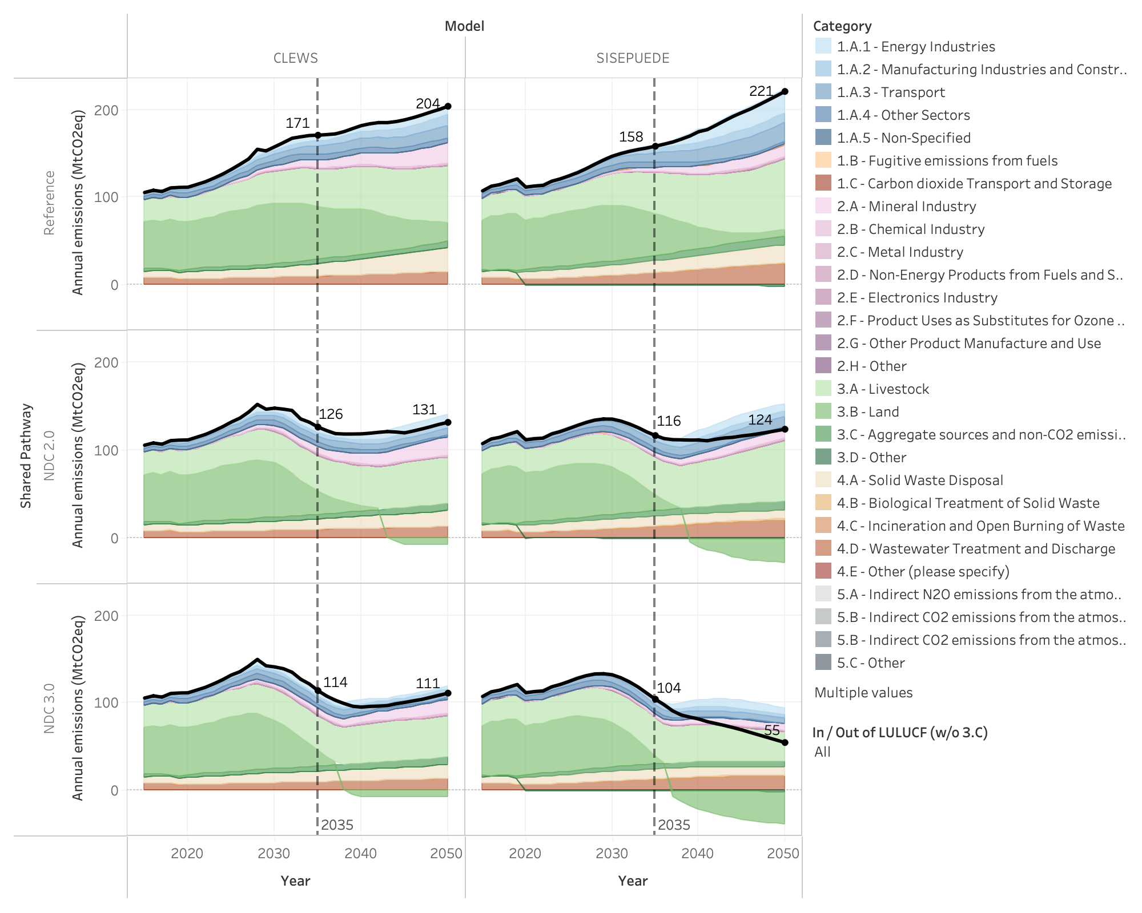
Figure 3. Projected total GHG emissions under the under the Reference, NDC 2.0 and NDC 3.0 pathways by IPCC category, including land use change, CLEWs and SISEPUEDE, 2020–2050 (MtCO₂eq)

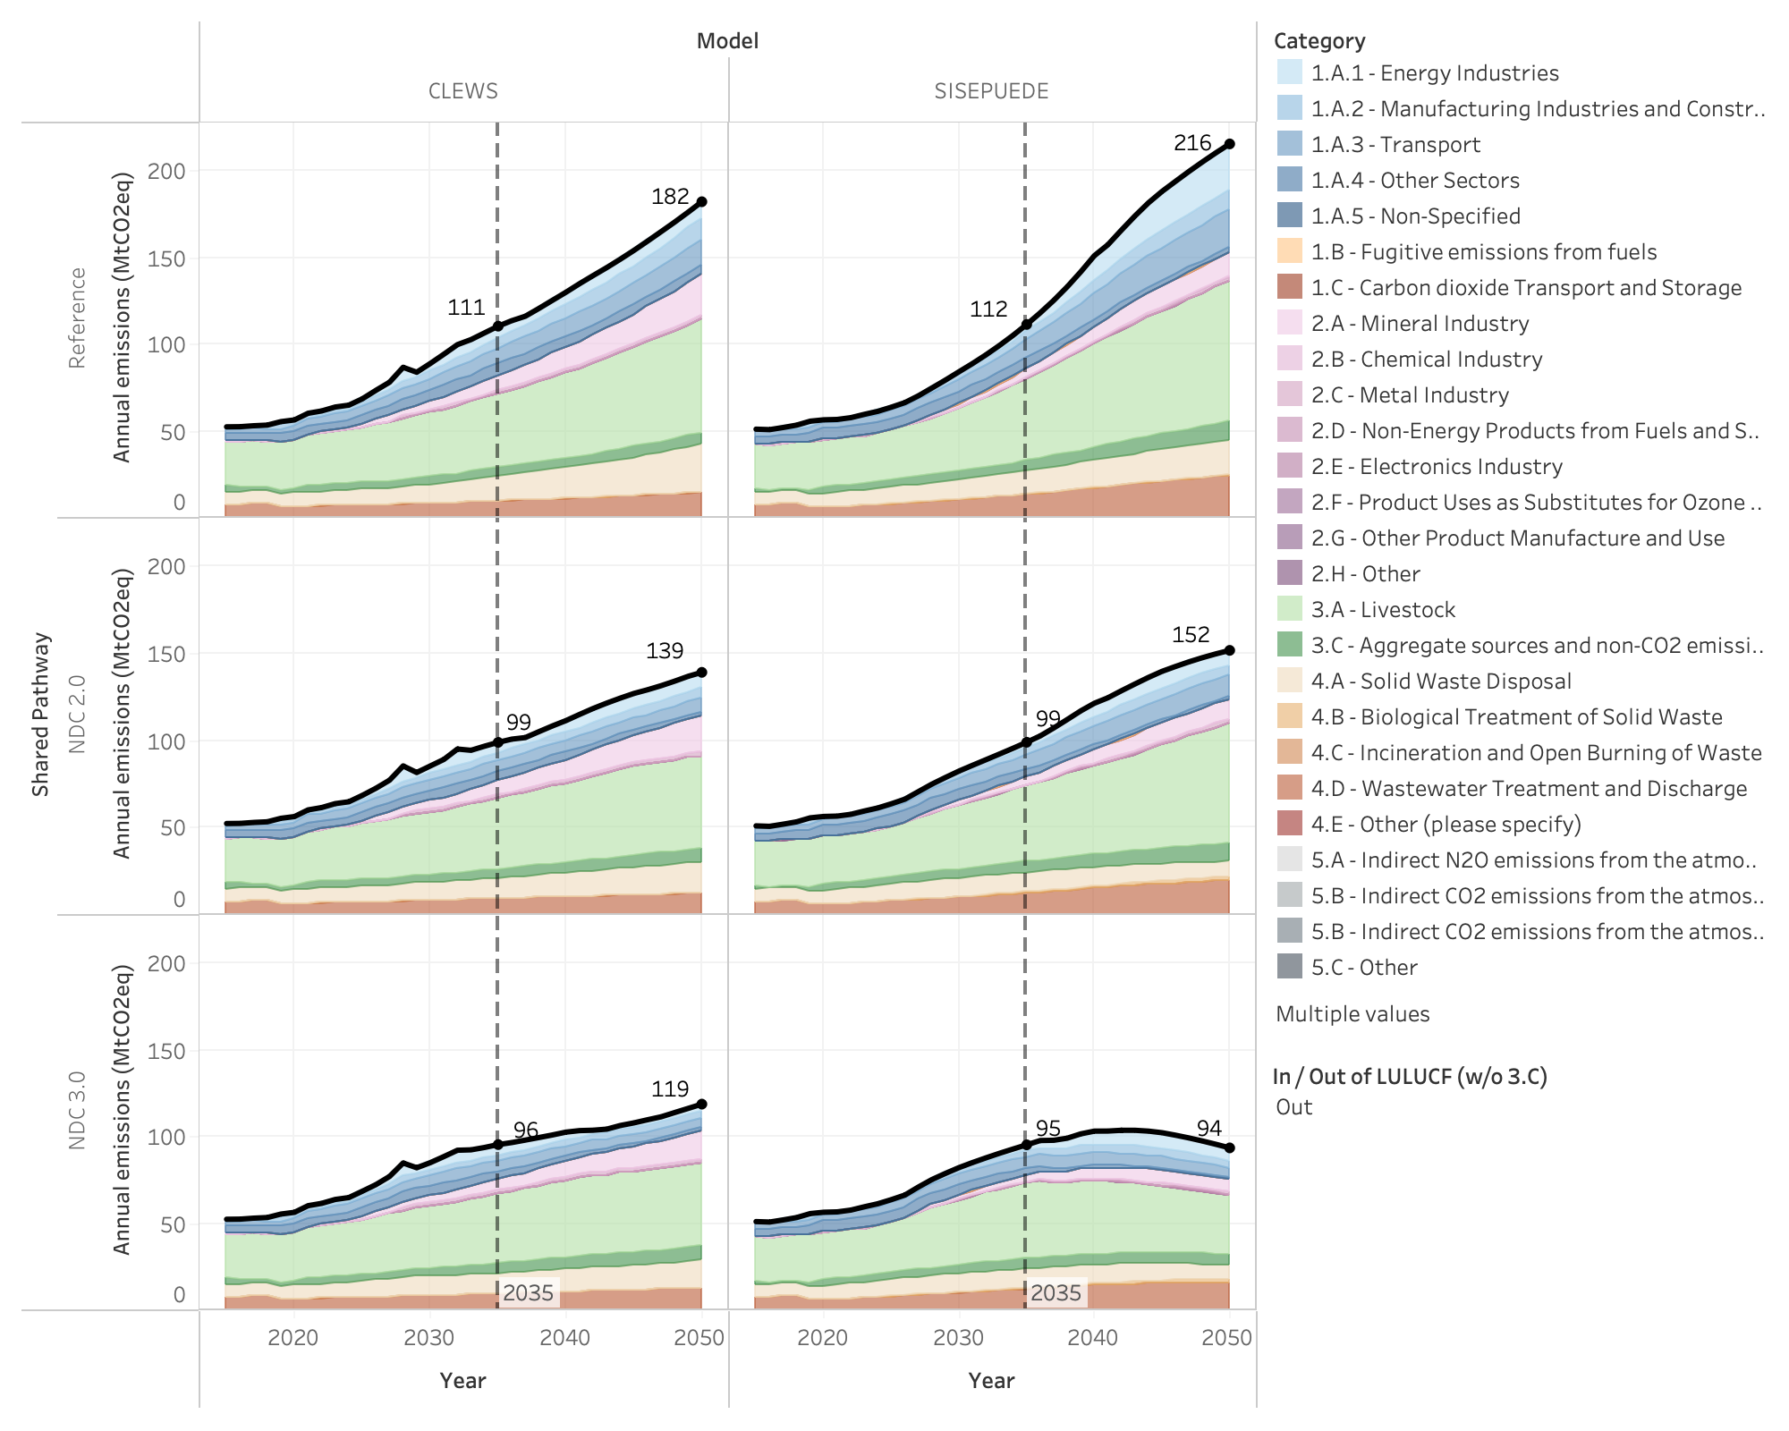
Figure 4. Projected total GHG emissions under the under the Reference, NDC 2.0 and NDC 3.0 pathways by IPCC category, excluding land use change, CLEWs and SISEPUEDE, 2020–2050 (MtCO₂eq)
As land-use emissions decline over time, the composition of Uganda’s emissions profile shifts progressively toward energy-, industry-, transport-, and consumption-driven sources. Across all scenarios, livestock remains one of the largest and most persistent sources of emissions due to continued herd expansion and the prevalence of relatively low-productivity cattle systems. Industrial emissions also grow rapidly as cement, steel, mining, and other energy-intensive industries expand to support infrastructure development and economic transformation under Vision 2040 and NDP IV.

The Reference pathway produces particularly rapid growth in industrial and transport emissions. Expanding vehicle ownership, freight demand, and urban mobility drive continuous increases in petroleum consumption, while large-scale industrialization significantly increases demand for coal, natural gas, and electricity. The commissioning of major steel and cement plants during the late 2020s contributes to a visible acceleration in emissions growth across both modelling frameworks.

Under the NDC pathways, these trends are moderated through a combination of energy efficiency improvements, electrification, modal shift, industrial fuel switching, expanded public transport systems and electric vehicle deployment. By 2050, transport emissions under NDC 3.0 fall to approximately one quarter of Reference levels despite continued growth in mobility demand, while industrial emissions are significantly reduced through accelerated fuel substitution and cleaner energy supply. Nevertheless, non-land emissions continue growing across all pathways as economic activity expands, illustrating the scale of the long-term decarbonization challenge associated with industrialization and rising material consumption.

3.3 Development Co-Benefits

3.3.1 Assumptions

Development co-benefits are quantified by applying sector-specific valuation parameters to changes in energy use, transport activity, waste treatment, sanitation access, and ecosystem services under each scenario relative to the Reference scenario. The same valuation framework is applied consistently across both the NDC2.0 and candidate NDC 3.0 scenarios, capturing improvements in health, productivity, environmental quality, and overall welfare on a comparable basis.

All co-benefit values are calibrated to 2021 monetary terms and escalated over time using GDP per capita growth, reflecting the increasing economic valuation of health, productivity, and environmental outcomes as incomes rise. The framework explicitly tracks eight categories of externality: indoor air pollution; road accident costs; traffic congestion; local air pollution; solid waste environmental damage; health and sanitation impacts from liquid waste disposal; environmental costs from liquid waste disposal; and ecosystem services. Full details of the parameters and assumptions are provided in Appendix 1.

The valuation framework is identical across both scenarios. However, in the CLEWs analysis a fundamental distinction lies in the role these benefits play within the modelling structure. In the NDC 2.0 scenario, co-benefits are calculated as an output of the model. They are quantified after the fact but do not influence the investment and technology choices driving the optimisation. In the NDC 3.0 scenario, the eight externality categories are incorporated directly into the model's cost structure, allowing them to actively shape system decisions alongside capital and operating costs. The NDC 3.0 is thus designed to specifically identify mitigating actions that have high synergy with development objectives.

3.5.2 Results

Both NDC scenarios generate substantial development benefits relative to the Reference scenario, and both produce positive net benefits when monetised co-benefits are assessed alongside direct system costs. As shown in Figure 5 and Figure 6, annual net benefits increase progressively over the modelling period as clean cooking, transport, sanitation, waste, ecosystem restoration, and clean energy measures scale up.

Under CLEWs, annual net benefits reach approximately USD 22.2 billion per year by 2050 under NDC 2.0, equivalent to around 4.8% of GDP, and approximately USD 27.2 billion per year under NDC 3.0, equivalent to around 5.8% of GDP. SISEPUEDE produces broadly comparable results for the more ambitious pathway, with annual net benefits reaching approximately USD 12.4 billion under NDC 2.0 and USD 29.8 billion under NDC 3.0 by 2050. Differences between the two models reflect methodological differences and accounting conventions. In particular, food and agriculture co-benefits are reported as a separate category in SISEPUEDE, while comparable effects are included within broader cost-saving categories in CLEWs.

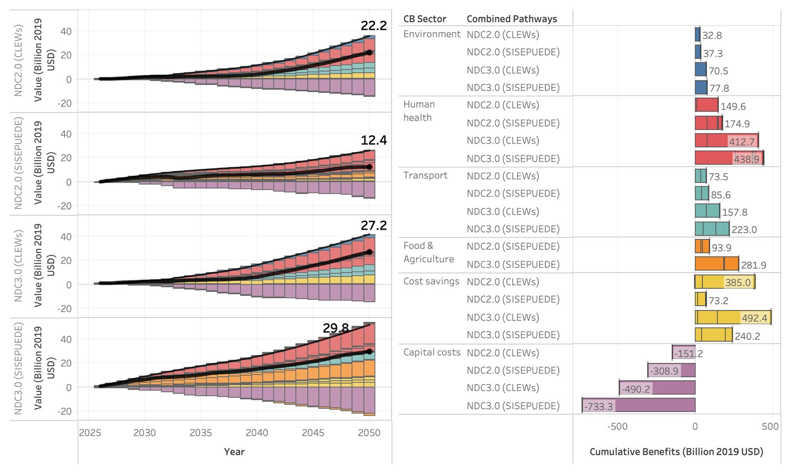
Figure 5. Projected total development benefits under the Reference, NDC 2.0 and NDC 3.0, CLEWs and SISEPUEDE, 2020–2050 ($ Billion)

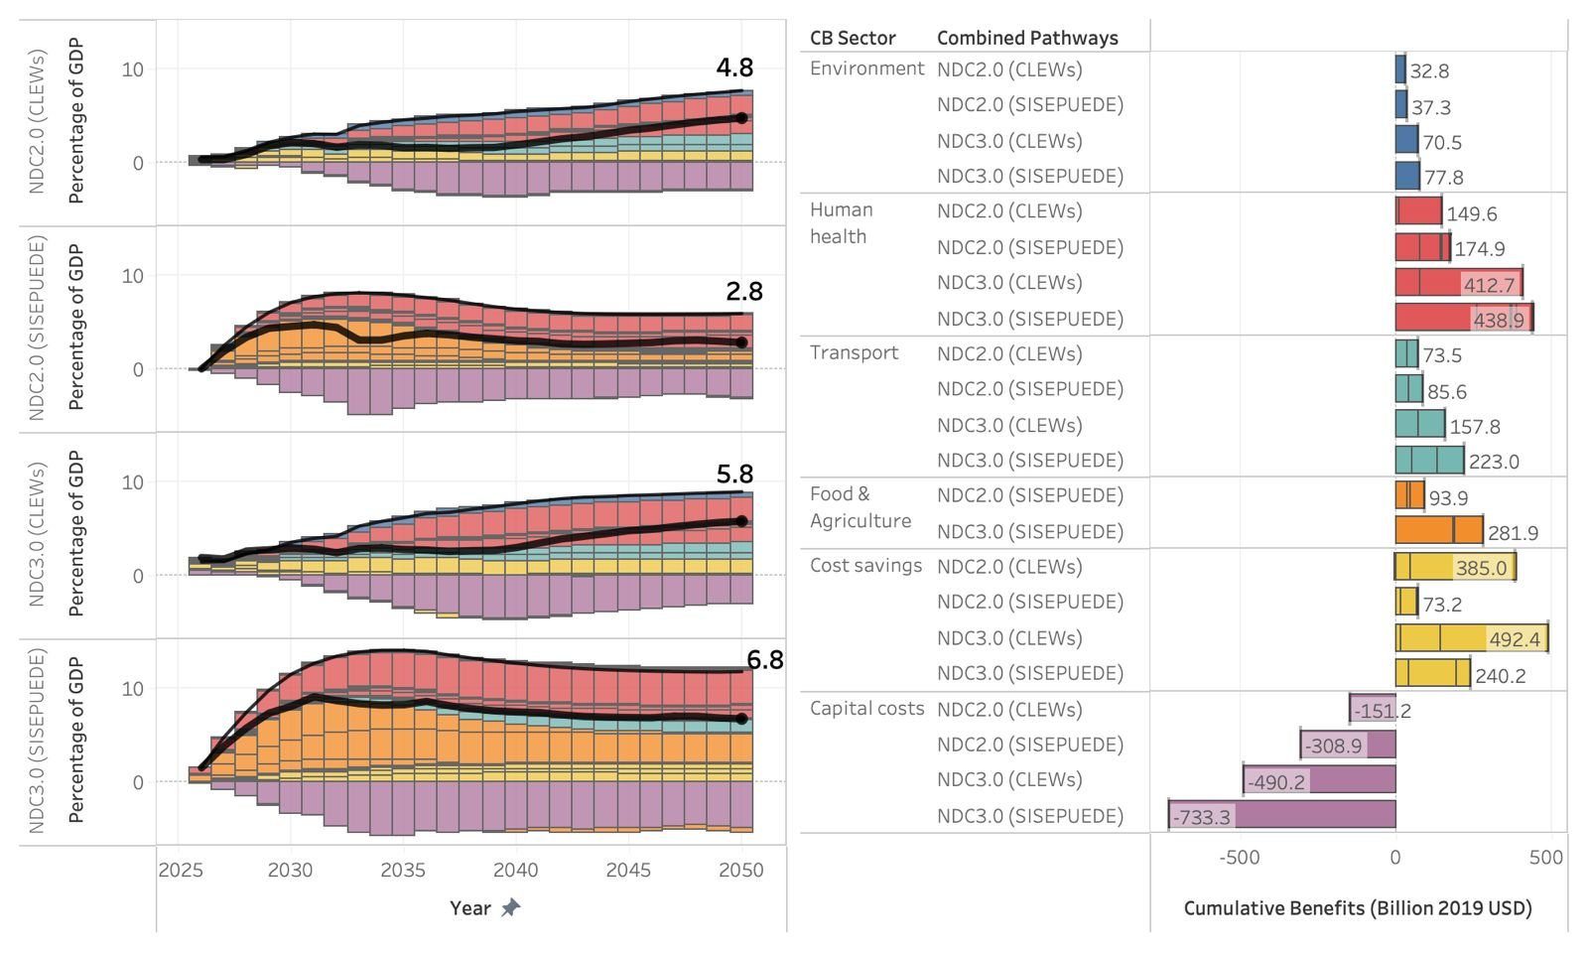
Figure 6. Projected total development benefits under the Reference, NDC 2.0 and NDC 3.0, CLEWs and SISEPUEDE, 2020–2050 (percentage share of GDP)

The results also show that these benefits are associated with substantial investment requirements. Additional cumulative capital costs are estimated at approximately USD 151 billion under NDC 2.0 and USD 490 billion under NDC 3.0 in CLEWs. In SISEPUEDE, cumulative capital costs are higher, reaching approximately USD 309 billion under NDC 2.0 and USD 733 billion under NDC 3.0. The incremental capital requirement of moving from NDC 2.0 to NDC 3.0 is therefore substantial, amounting to approximately USD 339 billion in CLEWs and USD 424 billion in SISEPUEDE over the modelling period. This highlights that the more ambitious pathway is not only a higher-benefit pathway, but also a significantly higher-investment pathway.

Despite these higher capital requirements, the cumulative benefits generated under NDC 3.0 are also substantially larger. In CLEWs, the largest increases relative to NDC 2.0 come from human health benefits, transport co-benefits, environmental benefits, and system cost savings. Human health benefits rise from approximately USD 150 billion under NDC 2.0 to more than USD 410 billion under NDC 3.0, driven primarily by accelerated reductions in indoor air pollution from clean cooking transitions. Transport co-benefits increase from approximately USD 74 billion to USD 158 billion, reflecting reduced congestion, fewer accidents, lower local air pollution, and improved transport system efficiency. SISEPUEDE shows a similar pattern, with particularly large gains in human health, transport, food and agriculture, and cost savings under NDC 3.0.

The timing of these benefits is also important. The capital costs required to deliver the transition must be mobilised early and sustained throughout the modelling period, while many of the largest benefits accumulate progressively as systems transform and avoided damages increase. This creates a financing and implementation challenge: although the long-term net benefits are strongly positive, realising them depends on the ability to mobilise upfront investment, coordinate delivery across sectors, and maintain policy continuity over time.

Overall, the co-benefit results reinforce the central finding that Uganda’s climate and development objectives are strongly synergistic. Investments in clean cooking, transport system modernisation, sanitation and waste infrastructure, ecosystem restoration, and clean energy expansion deliver large gains in health, productivity, environmental quality, and economic wellbeing while also reducing emissions. At the same time, the scale of capital investment required, especially under NDC 3.0, should not be understated. Achieving the higher-ambition pathway will require expanded access to domestic and international climate finance, stronger implementation capacity, and coordinated planning across sectors to convert high long-term net benefits into deliverable investment programs.

4. Sectoral Results

4.1 Energy Sector

4.1.1 Sector Background
Uganda's energy sector is characterised by a heavy reliance on biomass, which accounts for approximately 87% of total final energy consumption, predominantly in the form of firewood and charcoal used for cooking and heating across rural and urban households. Modern energy remains a small share of the overall mix, with electricity accounting for only around 2% of final energy consumption. National grid electricity access stands at approximately 25% of the population, with rural access considerably lower at around 9%2.
On the generation side, Uganda's electricity supply is dominated by hydropower, with installed capacity reaching 2,048 MW as of end-2024, anchored by the Nalubaale, Kiira, Bujagali, Karuma, and Isimba facilities. The government has identified further large hydropower projects, including the 840 MW Ayago, 400 MW Kiba, and 392 MW Oriang dams, to meet projected long-term demand growth. Despite the generation surplus, transmission and distribution constraints continue to limit access, particularly in rural areas.
In terms of emissions, the energy sector contributes approximately 10.7% of Uganda's total national GHG emissions, with transport as the dominant subsector driver due to near-total dependence on imported petroleum fuel. Electricity generation contributes negligibly to sectoral emissions, reflecting the low-carbon hydropower-dominated grid. As Uganda pursues industrialisation and urbanisation under NDP IV and Vision 2040, energy demand is projected to rise substantially. The Ministry of Energy and Mineral Development's Least-Cost Electricity Generation and Transmission Plan projects electricity demand growth of 15.3% per year, making the sector central to both development and NDC ambitions.

4.1.2 Key Drivers and Assumptions

Energy demand across all subsectors is projected to grow substantially over the modelling period, driven primarily by population growth, rising GDP, and expanding electricity access in line with NDP IV targets. In the buildings’ subsector, demand growth reflects a gradual transition away from biomass toward modern fuels as incomes rise. Transport demand is driven by vehicle stock growth and freight activity, both closely tied to economic expansion, while the timing and scale of electrification across vehicle segments is a critical scenario differentiator. On the supply side, new generation capacity is selected through least-cost optimisation, with hydropower remaining dominant in the near term and the role of solar and other renewables increasing across scenarios.

The following tables summarise the base year assumptions used in the CLEWs and SISEPUEDE model.

- Energy Industries

Parameter | 2021 Value
Total electricity demand2 | 17.24 PJ
Power generation mix | Hydro ~98% dominant
Transmission losses7 | 4.8% (CLEWs)
Distribution losses7 | 17.0% (CLEWs)
Total installed capacity7 | 1.4 GW

Transmission and distribution losses are assumed to decline linearly to 3.0% and 9.0% respectively by 2040, in line with the Least Cost Generation and Transmission Plan and held constant thereafter.

- Transport

Parameter | 2021 Value
Total passenger vehicle stock | Vehicle stock 2025  - Cars 0.513  - Buses 0.321  - Commercial Veh 0.192  - Motorcycles 1.570
Fuel use by energy carrier (PJ)2 | Total fuel use by energy carrier is 54.6 PJ:  - Gasoline: 30.3  - Diesel: 24.0  - Jet fuel: 0.4  - Electricity: 0.0  - LPG: 0.0  - Natural Gas: 0.0
Fuel use by mode (PJ)2 | Total fuel use by mode 54.6 PJ:  - Road: 50.9  - Rail: 1.7  - Aviation: 0.4  - Navigation: 1.8

- Buildings

Parameter | 2021 Value
Commercial fuel use (PJ)2 | Biomass: 207.9  Charcoal: 13.4  LPG: 0.5  Electricity: 2.8  Biogas: 1.1
Residential fuel use (PJ)2 | Biomass: 318.0  Charcoal: 63.8  Kerosene: 0.4  LPG: 0.7  Electricity: 3.2  Biogas: 0.2

4.1.3 Mitigating Actions
All NDC 2.0 measures are carried forward into the NDC 3.0 scenario, with one additional measure applied on top.
- Electricity Generation
Mitigation Measure | Scenario | Description
Reduction in T&D Losses | NDC 2.0 & NDC 3.0 | Reduces transmission and distribution losses in line with the Ministry of Energy and Mineral Development's Least-Cost Electricity Generation and Transmission Plan (LCGTP, FY2025/26). Under NDC 2.0, transmission efficiency improves to 97% by 2040; under NDC 3.0, more ambitious targets raise transmission efficiency to 99% by 2050.
Renewable Energy Generation | NDC 2.0 & NDC 3.0 | Enables investment in landfill gas generation and geothermal capacity under the NDC 2.0 scenario, introducing additional low-carbon generation sources beyond the Reference trajectory.
Power Sector Technology Targets | NDC 3.0 only | Applies binding capacity targets for solar, wind, geothermal, and hydro, accelerating low-carbon generation deployment.
- Industrial Energy Use
Mitigation Measure | Scenario | Description
Industrial Energy Efficiency | NDC 2.0 & NDC 3.0 | 10% reduction in industrial energy use from reference by 2025
Industrial Fuel Switching | NDC 2.0 & NDC 3.0 | 25% of industrial energy met by sustainable biomass by 2030, rising to 40% by 2040
- Residential and Commercial Energy Use
Mitigation Measure | Scenario | Description
Lighting Energy Efficiency | NDC 2.0 & NDC 3.0 | Introduction of energy-efficient lighting (CFLs, LEDs) targeting 75% reduction from reference by 2030
Residential Cooling Efficiency | NDC 2.0 & NDC 3.0 | Efficiency improvements for residential cooling appliances
Residential Clean Cooking (Efficiency and Fuel Switch) | NDC 2.0 & NDC 3.0 | Achieves 50% electric cooking penetration by 2025.
Improved Biomass Cookstoves | NDC 2.0 & NDC 3.0 | Improves efficiency of traditional cooking technologies, reducing biomass demand.
Commercial Cooking Transition | NDC 2.0 & NDC 3.0 | Adoption of improved stoves (50%), LPG (15%), and electric cooking (35%) in institutions.
- Transport Energy Use
Mitigation Measure | Scenario | Description
Vehicle Fuel Efficiency Improvements (GFEI 50×50) | NDC 2.0 & NDC 3.0 | Improves fuel economy by ~20% by 2030, ~35% by 2040, and ~50% by 2060.
Alternative Fuels Deployment | NDC 2.0 & NDC 3.0 | Introduces LNG, ethanol, and biodiesel at ~1% annual growth.
Electric Bus Deployment | NDC 2.0 & NDC 3.0 | Includes at least 200 electric buses in GKMA by 2030.
Non-Motorised Transport (NMT) Infrastructure | NDC 2.0 & NDC 3.0 | Develops 100 km of NMT corridors by 2030.
Transit-Oriented Development (TOD) | NDC 2.0 & NDC 3.0 | Urban planning measures reduce motorised travel demand by ~5% by 2050.
Public Transport System Improvements | NDC 2.0 & NDC 3.0 | Deployment of ~1,000 high-capacity buses and intelligent transport systems (ITS), reducing vehicle-km and increasing load factors.
Freight Efficiency Improvements | NDC 2.0 & NDC 3.0 | Improves load factors in road freight transport.
Rail Rehabilitation (Freight – MGR) | NDC 2.0 & NDC 3.0 | Rehabilitation of 634 km of railway by 2026, improving freight efficiency (~22%).
Passenger Rail Expansion (GKMA) | NDC 2.0 & NDC 3.0 | Development of 61 km of passenger rail services, improving transport efficiency.
Unconstrained Electric Vehicle (EV) Adoption | NDC 3.0 | Removes upper-bound constraints on EV penetration, enabling accelerated electrification.
- Charcoal Production
Mitigation Measure | Scenario | Description
Improved Charcoal Kilns | NDC 2.0 & NDC 3.0 | Increases charcoal conversion efficiency to ~100% improved kiln usage by 2030.

A detailed description of how each mitigation measure is implemented within the models, including parameter specifications and modelling constraints, is provided in the Appendix 2.

4.1.4 CLEWs Results

4.1.4.1 Energy Industries

The development of Uganda’s energy sector and associated emissions is shaped by three primary interacting structural dynamics. First, Uganda faces an unprecedented expansion challenge in the electricity sector. As industrialisation accelerates, urbanisation continues, and access to electricity broadens across households and productive sectors, electricity demand is projected to grow at roughly 15% annually over much of the modelling horizon. Sustaining this pace of growth requires a near-continuous expansion of generation, transmission, and distribution infrastructure throughout the period to 2050 resulting in huge investment needs.

Second, the development of Uganda’s upstream oil industry and associated refinery and downstream industries introduce new sources of emissions not currently present in the country. Third, emissions from charcoal production, which is presently the single largest contributor to energy sector emissions decline progressively over time as the adoption of modern cooking fuels reduce dependence on solid biomass. Together, these dynamics produce an emissions trajectory that rises significantly in the near and medium term before moderating later in the modelling horizon, with the pace and ultimate scale of emissions growth determined primarily by technology choice in the power sector.

In aggregate terms, emissions from energy industries rise from 1.8 MtCO₂eq in 2021 to 7.2 MtCO₂eq by 2035 and 9.6 MtCO₂eq by 2050 under the Reference scenario (Figure 7). The NDC 2.0 scenario produces a broadly similar outcome, reaching 6.5 MtCO₂eq in 2035 and 9.2 MtCO₂eq by 2050, reflecting the fact that the additional mitigation measures introduced in this pathway do not fundamentally alter the underlying structure of electricity generation, because the targets are for low quantities of power generation capacity relative to the capacity needs. By contrast, the NDC 3.0 scenario diverges substantially from the Reference trajectory, with emissions reaching 6.4 MtCO₂eq by 2035 before declining to 3.9 MtCO₂eq by 2050 as the specific technology targets leave less need for natural gas generation and emissions are consequently lowered.

Figure 7. Energy Industries Sector Emissions by Scenario, 2021–2050 (MtCO₂eq)
Uganda’s electricity system is currently hydropower-based, providing the country with a low-carbon generation foundation that constitutes a major asset. However, the remaining technically and economically viable hydropower potential is limited relative to the scale of future electricity demand growth. Hydropower generation stabilises at approximately 25 TWh from the mid-2030s onwards as the major remaining sites are developed, after which hydro declines steadily as a share of total generation within a rapidly expanding electricity system. Additional resources are therefore required to meet growing demand, and the expansion reflects a cost-effective pathway considering both Uganda’s underlying resource endowment and the relative economics of available technologies. A near term spike in emissions can be observed around 2027-2028, when current installed capacity is insufficient to meet the rapidly growing demand and diesel-based generation that can be deployed quickly is required, before the Oriang, Kiba and Muzizi hydro power plants come online in 2029.

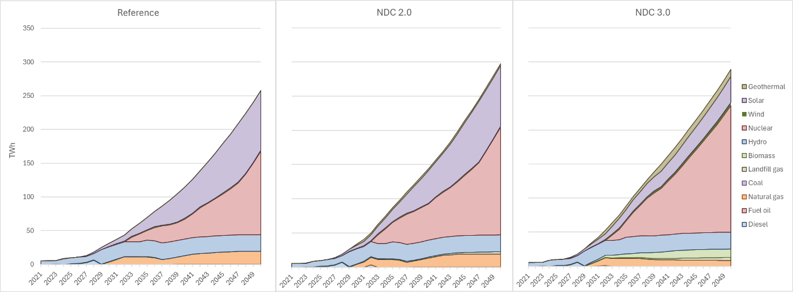
Figure 8. Electricity Generation Mix under Reference. NDC 2.0 and NDC 3.0 scenarios, 2021–2050 (TWh)
Solar Photovoltaics, paired with natural gas and battery storage, emerge as one of the most cost-effective generation options and expand rapidly across all scenarios. In the Reference and NDC 2.0 where generation is determined by least cost investment and solar reaches around 25% market share by 2035 and over 30% by 2050. However, because solar output is variable, it cannot fully meet Uganda’s growing demand for reliable round-the-clock electricity from industry, commerce, and urban households. The system therefore requires additional firm baseload capacity.

Natural gas provides part of this role, with imported pipeline gas assumed to become available from around 2030. However, supply constraints limit gas generation to roughly 4000 MW of capacity (including 1000 MW cogeneration), restricting its long-term contribution. Under these conditions, nuclear power emerges from the least-cost optimization as the principal long-term baseload solution, expanding to approximately 20% of generation by 2035 and becoming the dominant generation source from the late 2030s onwards. This is not imposed as a policy assumption but results directly from the model’s optimization under projected demand growth, hydropower constraints, limited gas availability, and assumed technology costs.

The NDC 2.0 scenario does not fundamentally alter this trajectory. Faster electrification increases overall electricity demand, requiring additional generation capacity, but the system continues to evolve along a similar pathway of expanding nuclear and solar generation alongside constrained gas supply. Additional technologies such as geothermal and landfill gas provide incremental emissions reductions without substantially changing the overall structure of the generation mix.

The binding generation capacity targets introduced under NDC 3.0 represent the primary driver of power sector emission reductions. By mandating accelerated deployment of geothermal, hydro, and nuclear capacity, the measure structurally displaces natural gas from the generation mix. Geothermal generation reaches approximately 4.9 TWh by 2035 and 10.4 TWh by 2050 under NDC 3.0, compared to zero under the Reference and 2.8 TWh under NDC 2.0. Nuclear expands significantly to approximately 30 TWh by 2035 and 186 TWh by 2050, compared to 14 TWh and 134 TWh under the Reference and 28 TWh PJ and 157 TWh under NDC 2.0 by 2035 and 2050 respectively, becoming the dominant generation source from the mid-2030s in all scenarios. Natural gas generation remains at approximately 24 TWh across all scenarios by 2035, before transiting into a more mid-merit role by 2050 under NDC 3.0, in contrast to the Reference and NDC 2.0 scenarios where natural gas continues to serve as baseload capacity. Solar generation under NDC 3.0 is substantially lower than under other scenarios due to the 10 GW capacity target applied in 2040.

Investment requirements for power generation, transmission, and distribution to meet these targets are unprecedented in scale for Uganda (Figure 9). Annualized investment in power infrastructure reaches approximately $7–8 billion in the NDC 2.0 and NDC 3.0 scenarios, while the Reference scenario remains substantially lower at around $5.7 billion annually, though this still represents a dramatic increase relative to current investment levels. As electrification of demand, particularly in the buildings sector, accelerates in the Reference scenario during the second half of the modelling period, the investment gap between the Reference and NDC scenarios narrows to around $2 billion by 2050, when annual investment requirements exceed $25 billion across all scenarios.

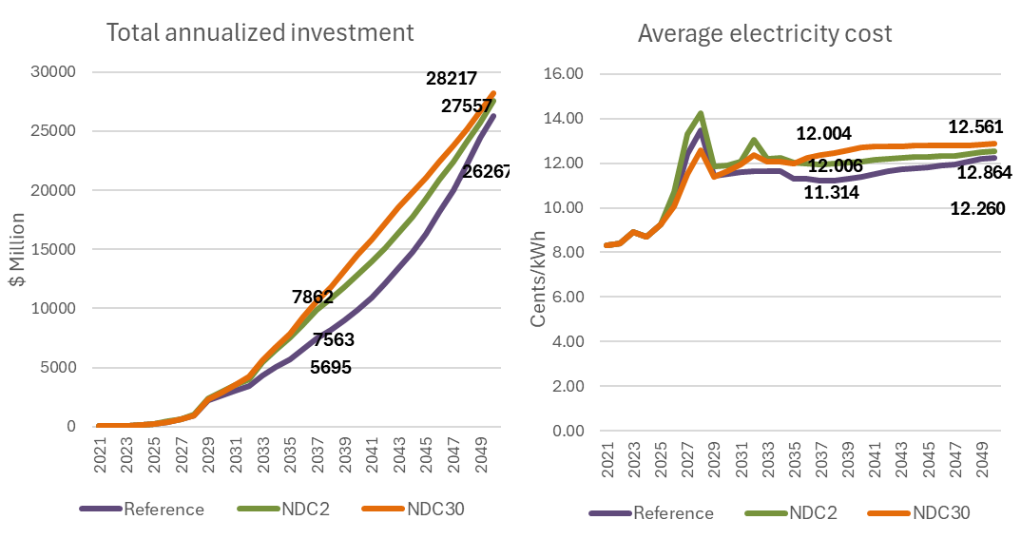
Figure 9. Total annualized power sector investment ($ million, left) and average per unit cost of electricity (cents/kWh, right), by scenario, 2021–2050
Average electricity costs also rise from current levels (Figure 9). Higher demand growth and additional infrastructure investment in the NDC scenarios push costs above those in the Reference scenario but increases remain within 10% of the Reference scenario costs for the entire model horizon. The gap also narrows towards the end of the horizon, with average electricity costs stabilizing in the range of 12–13 cents/kWh across all three scenarios by 2050. The previously discussed capacity shortfall in 2027–2028 results in a temporary price spike during those years, which subsides after new hydropower capacity comes online in 2029.

Domestic oil production and refining are assumed to come online in 2027, marking a major structural shift in Uganda’s energy system and external trade balance. The development of the upstream oil sector, associated export infrastructure, and domestic refinery generates substantial new export revenues, estimated at approximately $2–3 billion annually during the early years of production, although actual revenues remain highly sensitive to international oil price volatility and future global oil demand trends. At the same time, domestic refining significantly reduces the need for imported petroleum products, improving energy security and lowering import expenditures.

Over time, however, net oil exports decline in relative and eventually absolute terms as a growing share of domestic crude production is directed towards meeting rising national demand for transport fuels and industrial energy use. In the NDC scenarios, export revenues remain higher over the long term because improvements in vehicle efficiency, electrification of transport, and modal shifts towards public and non-motorized transport reduce domestic petroleum demand relative to the Reference scenario. This allows a larger share of production to remain available for export.

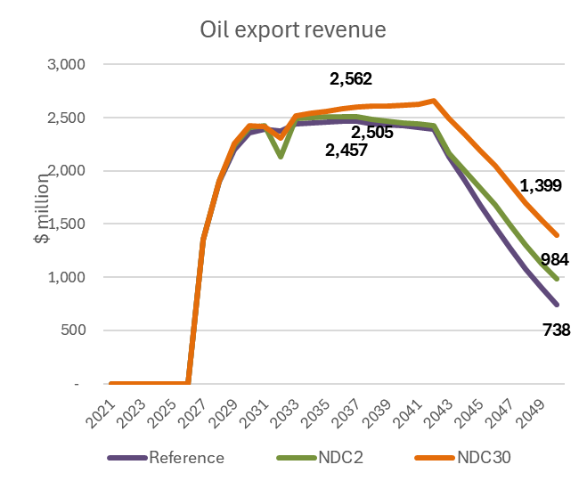
Figure 10. Oil export revenue under Reference. NDC 2.0 and NDC 3.0 scenarios, 2021–2050 ($ million)
While the oil sector provides important economic and fiscal benefits, it also introduces a significant new source of greenhouse gas emissions into Uganda’s energy system. Emissions from upstream oil production, transport, and refining are estimated at approximately 1 MtCO₂eq annually once the sector is fully operational. These emissions arise primarily from energy use in extraction and processing operations, refinery fuel combustion, and associated fugitive and process emissions. As a result, the oil sector becomes one of the principal drivers of the increase in energy industry emissions during the late 2020s and 2030s across all scenarios.

Charcoal demand drops across all three scenarios as building energy use switches to cleaner fuels like electricity and LPG. As a result, emissions from charcoal production (mainly methane) peaks at around 2 MtCO₂eq in the late 2020s, before dropping to 0.2-0.4 MtCO₂eq by the end of the period. The drop happens earlier in the NDC scenarios, where the 2035 50% clean cooking targets drive rapid change. In the reference case the clean cooking transition lags the NDC cases by about 5 years. The NDC scenarios also see a transition towards more efficient charcoal production from improved earthen mounds, thereby reducing the upstream needs for biomass and resulting in land use change emissions.

4.1.4.2 Buildings (Residential and Commercial)

The transition of the building sector is driven overwhelmingly by a significant shift away from traditional biomass and charcoal towards cleaner cooking fuels, particularly electricity and LPG. This transition occurs in all scenarios, including the reference scenario, but is accelerated in the NDC scenarios by the 2035 targets of 50% share of clean cooking. Under the Reference scenario, buildings sector emissions rise from 4.9 MtCO₂eq in 2021 to 6.4 MtCO₂eq by 2035 before declining to 3.0 MtCO₂eq by 2050 as cleaner fuels gradually penetrate the market over time.

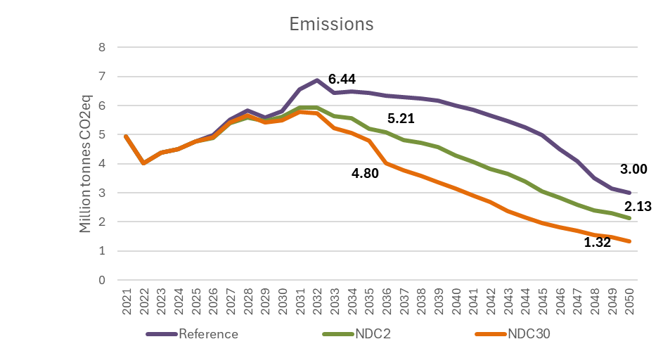
Figure 11. Buildings Sector Emissions by Scenario, 2021-2050 (MtCO₂eq)
Under the NDC pathways this transition is accelerated (Figure 12). Electric cooking, improved cookstoves, LPG adoption, and expanded electricity access progressively displace wood and charcoal use in both residential and commercial cooking. This substantially increases electricity demand in the buildings sector and contributes directly to the rapid growth in power sector investment and generation discussed in Section 4.1.4.1. Under NDC 2.0 and especially NDC 3.0, the transition occurs earlier and at much larger scale, with electricity and LPG progressively replacing traditional solid fuels across households, schools, institutions, and commercial cooking applications.

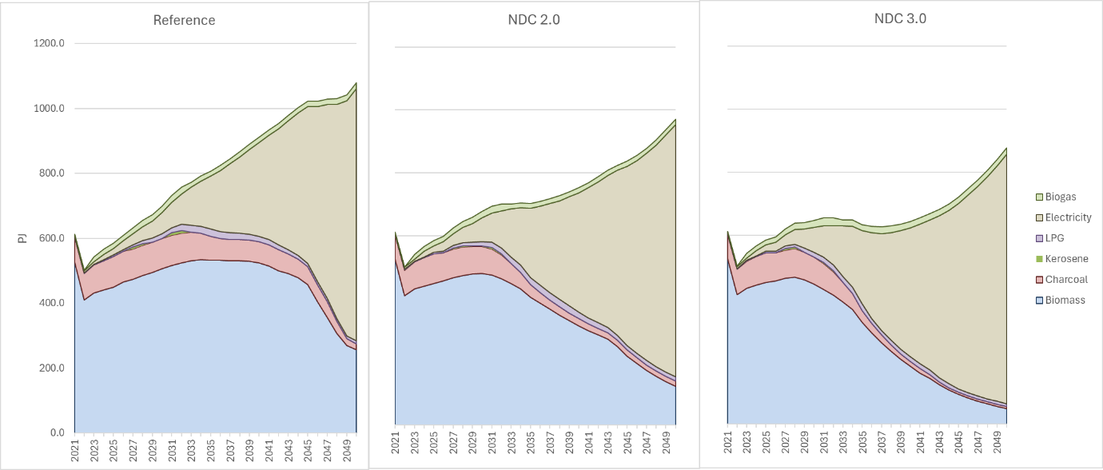
Figure 12. Buildings energy use under Reference. NDC 2.0 and NDC 3.0 Scenarios, 2021–2050 (PJ)
The transition produces a shift in the composition of direct emissions rather than a simple elimination of combustion-related emissions. Traditional biomass and charcoal combustion are major sources of methane and nitrous oxide, particularly under inefficient combustion conditions common in household and institutional cooking. As these fuels are displaced, direct non-CO₂ emissions decline substantially. At the same time, increased LPG consumption introduces additional CO₂ emissions from fossil fuel combustion, partially offsetting these gains. As a result, the reduction in direct buildings-sector emissions, while significant, is more moderate than might initially be expected from the scale of the fuel transition alone.

The largest climate benefit of the clean cooking transition therefore lies outside the buildings sector’s direct energy emissions. Reduced demand for fuelwood and charcoal lowers pressure on forests and woodlands, reducing unsustainable biomass harvesting and the associated land-use change emissions. In practice, the transition away from traditional biomass acts as an indirect mitigation measure in the AFOLU sector by slowing deforestation and forest degradation linked to charcoal production and fuelwood collection. These avoided land-use emissions are substantially larger than the direct reductions in methane and nitrous oxide emissions within the buildings sector itself and represent the principal long-term climate benefit of the transition (refer to section 4.4).

The transition also has important economic and social implications (Figure 13). Cleaner cooking fuels and expanded electrification increase direct household and commercial energy expenditures relative to continued reliance on traditional biomass, particularly because biomass is often collected informally or purchased at prices that do not reflect its full environmental and health costs. As a result, direct system costs rise under the NDC scenarios due to higher fuel costs and investment in electric cooking technologies, appliances, electricity access infrastructure, LPG distribution systems, and cleaner institutional cooking equipment.

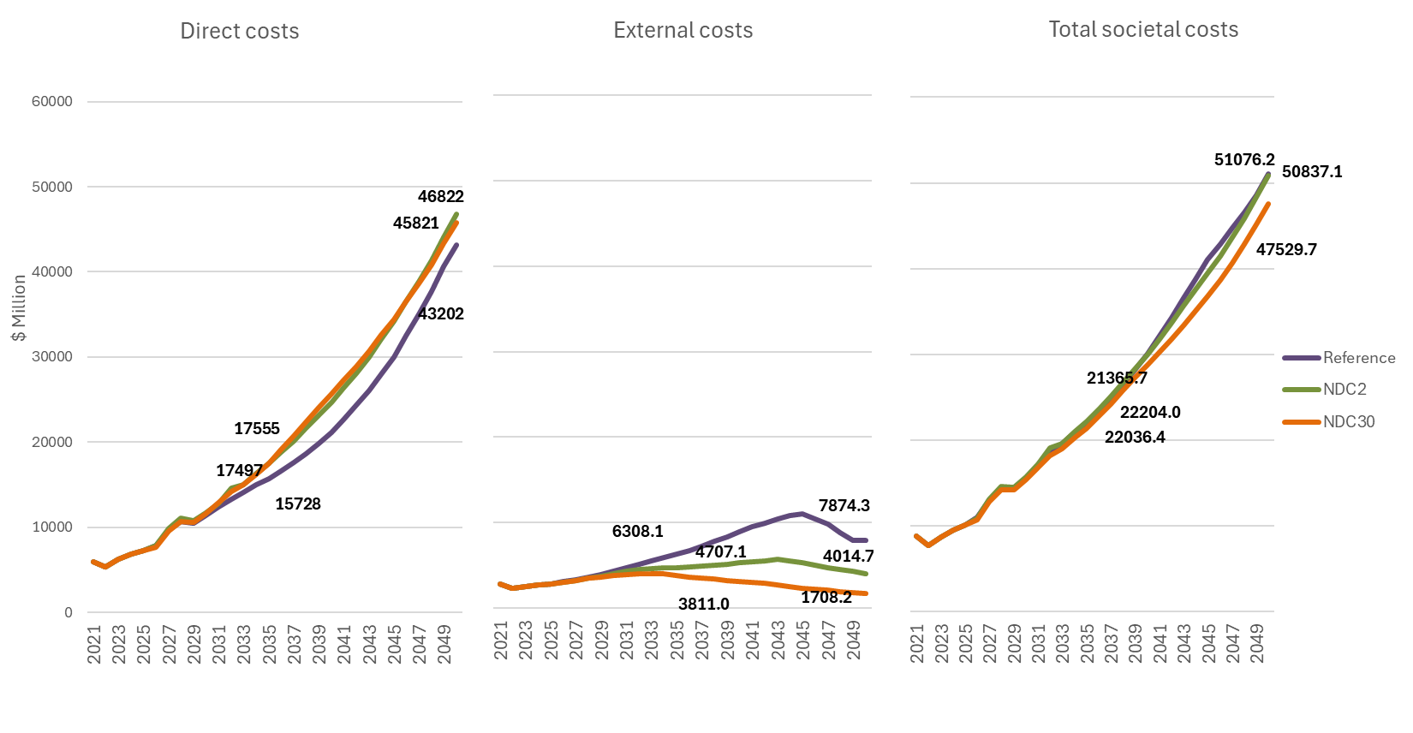
Figure 13. Direct, indirect, and total costs of energy use in the buildings sector by scenario, 2021–2050 ($ million)
However, these higher direct expenditures are more than offset by reductions in external costs, particularly the health burden associated with indoor air pollution. Continued biomass use in the Reference scenario over a longer time period results in persistently high exposure to particulate matter and other harmful pollutants from household and institutional cooking, driving large health-related societal costs throughout the modelling period. Under the NDC pathways, reductions in biomass combustion substantially lower exposure to indoor air pollution, producing major public health benefits and large reductions in associated external costs. By 2050, these avoided damages become large enough under the more ambitious NDC 3.0 pathway where these external costs are monetized to outweigh the additional direct system costs of the transition, reducing total societal costs below the Reference scenario.

The buildings sector transition can therefore be understood primarily as a public health and development strategy with significant climate co-benefits. While the transition contributes to direct emissions reductions within the energy system, its largest benefits arise from avoided deforestation, improved household air quality, reduced health burden, and broader improvements in energy access and quality of life.

4.1.4.3 Transport

The transport sector outlook is dominated by very rapid growth in underlying mobility demand driven by economic development, urbanization, population growth, and structural transformation of the economy. Rising household incomes substantially increase demand for personal mobility and private vehicle ownership, while industrialization, agricultural expansion, construction activity, and fixed capital formation drive rapid growth in freight transport demand.

Despite this rapid growth in mobility demand, energy demand and emissions do not increase proportionally. Even under the Reference scenario, improvements in vehicle efficiency, gradual fleet turnover, and fuel switching moderate the growth in fuel consumption relative to transport activity. Under the Reference scenario, transport sector emissions rise from 3.9 MtCO₂eq in 2021 to 7.7 MtCO₂eq by 2035 and 11.94 MtCO₂eq by 2050, while total transport energy demand increases from approximately 55 PJ in 2021 to 114 PJ by 2035 and 195 PJ by 2050 (Figure 14 and Figure 15).

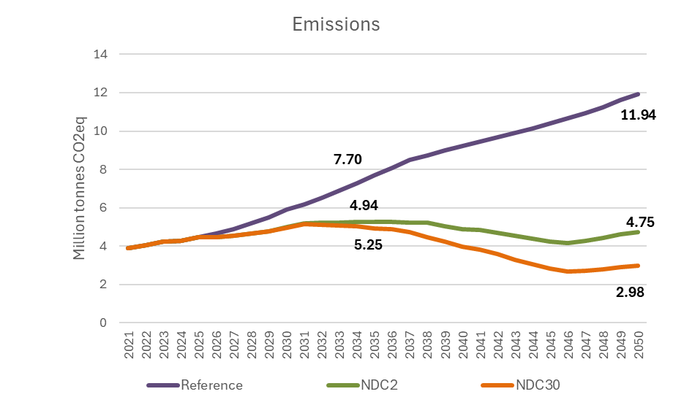
Figure 14: Transport Sector Emissions by Scenario, 2021-2050 (MtCO₂eq)
The Reference pathway remains heavily reliant on petroleum fuels throughout the modelling horizon (Figure 16), with rising private vehicle use emerging as the principal driver of both energy demand and emissions growth. Private car energy demand alone increases from approximately 18 PJ in 2021 to 64 PJ by 2035 and 115 PJ by 2050, reflecting the increasing dominance of road-based passenger transport as incomes rise faster than the expansion of alternative transport systems.

However, the largest societal impacts of the transport sector arise not from greenhouse gas emissions, but from congestion, accidents, and associated public health and economic damages. As vehicle ownership expands rapidly, external costs rise sharply across all scenarios. Motorcycle transport in particular plays a central role in Uganda’s urban transport system but also contributes disproportionately to accident-related injuries and fatalities, especially collisions involving motorcycles and pedestrians. Increasing congestion further reduces economic productivity, increases travel times, and worsens local environmental conditions in urban areas. Under the Reference scenario, these combined external costs rise from approximately 7% of GDP in 2021 to over 10% by 2050 substantially exceeding the scale of direct climate damages from the sector itself.

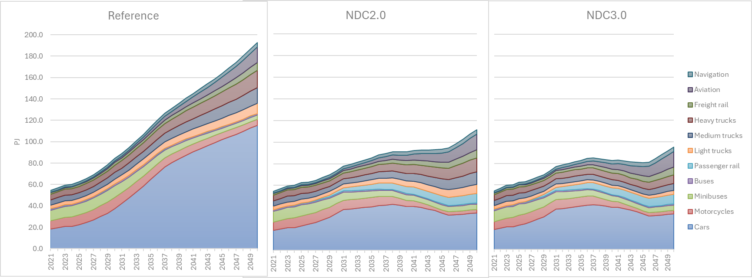Figure 15. Transport Energy Demand by Mode and Scenario, 2021–2050 (PJ)

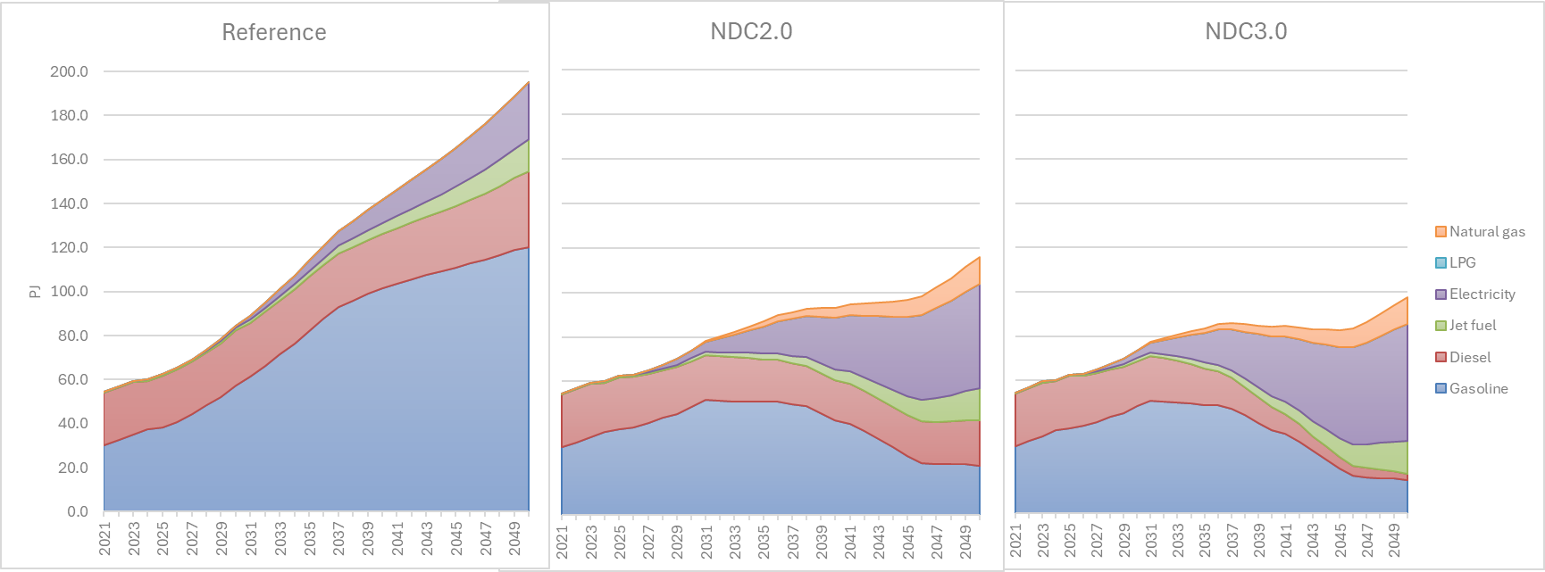Figure 16. Transport Fuel Use by Energy Carrier and Scenario, 2021–2050 (PJ)
While the estimated external costs become very large by mid-century (Figure 17), this reflects the combination of rapid motorisation, increasing urban congestion, rising values of time in a growing economy, and persistently high accident exposure under a road-dominated transport system. The estimates should therefore be interpreted as indicative of the scale of economic and societal risks associated with unmanaged transport growth rather than as precise point estimates. Other measures beyond those assessed here could be pursued to reduce traffic accidents and congestion.

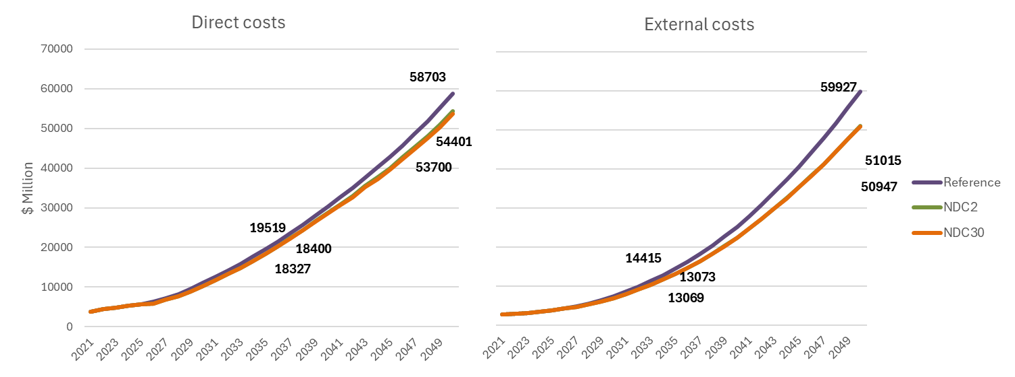
Figure 17. Direct costs ($ million, left) and external costs ($ million, right) of the transport sector by scenario, 2021–2050
As a result, interventions that reduce total vehicle kilometers travelled on roads generate substantial development benefits regardless of their direct climate impacts. Investments in public transport systems, freight rail, transit-oriented development, and non-motorized transport infrastructure all moderate the growth in road traffic while improving overall transport system efficiency. Rail transport is particularly important for freight movement, where shifting bulk cargo away from heavy-duty trucking reduces fuel consumption, congestion, road degradation, and accident risk simultaneously. Non-motorized transport measures including improved pedestrian infrastructure, cycling networks, and safer urban design exhibit especially strong benefit-to-cost ratios because relatively modest infrastructure investments can generate large reductions in congestion, accident exposure, fuel use, and local air pollution while improving urban accessibility.

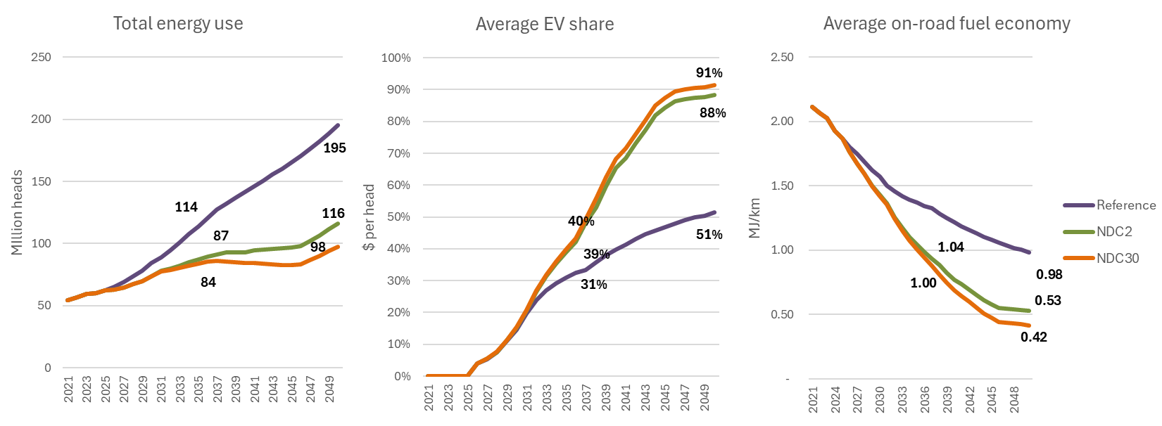Figure 18. Total energy use (PJ, left), average electric vehicle share of fleet (%, centre), and average on-road fuel economy (MJ/km, right) by scenario, 2021–2050
Under the NDC scenarios, these structural interventions are combined with vehicle efficiency improvements and rapid electrification of the transport sector. Total transport energy demand declines substantially relative to the Reference despite continued growth in mobility and economic activity, reaching 116 PJ by 2050 under NDC 2.0 and 98 PJ under NDC 3.0. At the same time, the composition of energy demand shifts away from petroleum products towards electricity as electric vehicle penetration accelerates during the second half of the modelling period. Under NDC 2.0, electric vehicles account for approximately 88% of the fleet by 2050, rising to approximately 91% under NDC 3.0. The main difference between the NDC 3.0 and 2.0 scenarios is the electrification of the heavier vehicle segments (larger trucks and buses). These vehicles make up a small share of total vehicle stock, but have much higher fuel use per vehicle kilometer and also significantly higher annual mileage per vehicle, so the impact on total fuel use and emissions is significantly greater than the relatively small difference in total EV market share (around 3%)

These combined measures produce substantial emissions reductions while simultaneously delivering broader development benefits. Under NDC 2.0, transport sector emissions fall to 4.75 MtCO₂eq by 2050, while the more ambitious NDC 3.0 pathway reduces emissions further to approximately 2.98 MtCO₂eq, around 75% below the Reference scenario. Importantly, these reductions are achieved without constraining mobility demand or economic growth. Instead, they result from a combination of more efficient vehicles, lower-carbon energy sources, and transport system designs that reduce dependence on inefficient and congested road transport. In fact, total mobility increases slightly in the NDC scenarios as a result of improved transportation opportunities such as metro systems and non-motorized transport infrastructure.

The economic implications of the transition are also favorable. Although the mitigation pathways require substantial upfront investment in rail infrastructure, public transport systems, electric vehicles, charging infrastructure, and urban transport improvements, these investments are increasingly offset over time by lower fuel expenditures, improved transport efficiency, and reduced external damages. Total transport system costs fall below the Reference trajectory by 2035 under both NDC pathways and remain lower throughout the remainder of the modelling period. At the same time, avoided external costs associated with congestion, accidents, and local pollution generate additional societal benefits estimated at roughly $9 billion annually by 2050 compared to the Reference scenario.

The transport transition should therefore be understood not primarily as a climate mitigation strategy, but as a broader economic development and urban efficiency strategy with major climate co-benefits. Measures that reduce inefficient road transport dependence particularly investments in public transport, rail systems, and non-motorized mobility simultaneously improve economic productivity, public health, urban livability, energy security, and emissions outcomes.

4.1.5 SISEPUEDE Results

4.1.5.1 Energy Industries

Electricity production in Uganda has historically been provided through renewables, primarily driven by hydropower, which has comprised over 95% of production in recent years. However, the rapid expansion in grid-based electricity access and economic and population growth expected in Vision 2040 will necessitate significant transformation of Uganda’s power generation systems.
The drivers of electricity sector outcomes under SISEPUEDE (Figure 19) reflect the combined effect of demand-side assumptions and the mitigating actions applied to each pathway. Under the Reference pathway, the rapid expansion of total generation is driven by the underlying socioeconomic trajectory aligned with Vision 2040, including a baseline transition from traditional biomass toward modern fuels in buildings, growth in vehicle stock and freight activity in transport, and expanded industrial output. Without additional efficiency or electrification measures beyond those already implicit in the baseline, total generation rises to approximately 865 PJ by 2050. The NDC 2.0 measures applied to end-use sectors, including the 75% improvement in lighting efficiency, residential cooling efficiency improvements, accelerated clean cooking transitions, and the 10% reduction in industrial energy use by 2025, moderate this demand expansion. The cumulative effect of these measures reduces total generation requirements to approximately 740 PJ by 2050, even as electrification displaces a larger share of biomass and petroleum use in end-use sectors. Under NDC 3.0, the further tightening of efficiency targets, including the long-term 60% improvement in electricity end-use efficiency by 2070 and the deeper electrification of cooking and transport, reduces total generation requirements further to approximately 578 PJ by 2050.
On the supply side, the composition of generation is shaped by the mitigating actions specified in Section 4.1.3. Under the Reference pathway, the generation mix evolves in line with the 2040 capacity shares specified in the LCGTP, with gas progressively integrated into the system to complement hydropower, nuclear, and solar. The NDC 2.0 measures introduce additional low-carbon generation sources through investment in landfill gas and geothermal capacity, modestly altering the composition of the mix without fundamentally displacing gas. Under NDC 3.0, the binding capacity targets for solar, wind, geothermal, and hydropower progressively reshape the supply mix, with the share of gas declining as the cumulative effect of the targets materializes after 2040. The generation mix and production targets in SISEPUEDE have been aligned with 2040 generation targets produced in the 2023 Least Cost Generation Transmission Plan (LCGTP), with hydropower (25.9%), nuclear (41.0%), solar (10.9%), geothermal (9%), and gas (9%) making up the primary sources of generation by 2040.
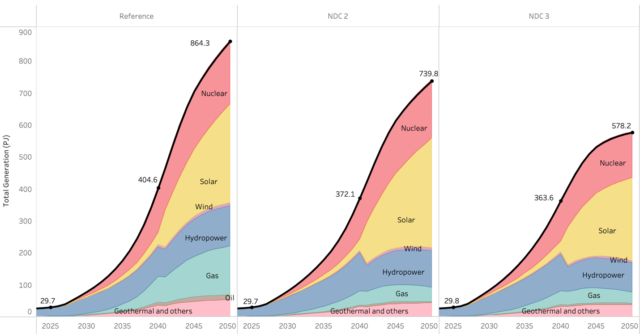Figure 19. Electricity production under BAU (left), NDC 2.0 (center), and NDC 3.0 (right) in electricity and heat generation (PJ).
The emissions trajectories (Figure 20) reflect the interaction of these demand- and supply-side dynamics. Under the Reference pathway, emissions remain negligible through the late 2020s, when the generation mix is still dominated by hydropower, and rise progressively from the early 2030s onward as gas capacity expands to meet growing demand. The acceleration around 2040 coincides with the full integration of gas into the system. Under NDC 2.0, lower aggregate demand combined with the introduction of geothermal and landfill gas substantially reduces emissions relative to the Reference, although the underlying role of gas in the supply mix limits the depth of these reductions. Under NDC 3.0, emissions follow a trajectory broadly similar to NDC 2.0 through the early 2040s, when both pathways are shaped primarily by the same baseline expansion of low-carbon capacity and the moderating effect of end-use efficiency on demand. The divergence emerges in the second half of the 2040s, when the binding renewable and low-carbon capacity targets progressively displace gas from the supply mix. Emissions peak in the mid-2040s before declining through the end of the modeling horizon.

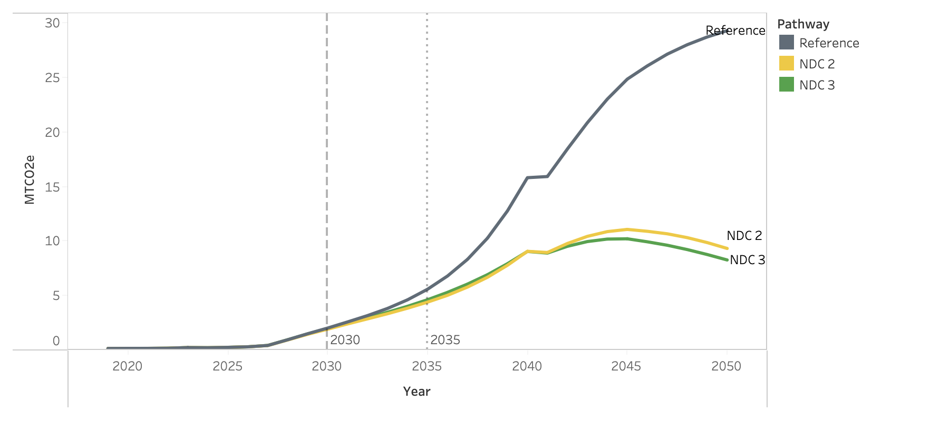Figure 20. Emissions for BAU (gray), NDC 2.0 (yellow), and NDC 3.0 (green) in electricity and heat generation.

4.1.5.2 Commercial and Residential

The drivers of energy demand in the commercial and residential subsectors reflect the combined effect of underlying socioeconomic growth and the mitigating actions applied to each pathway. Under the Reference pathway, the baseline transition from traditional biomass and charcoal toward modern fuels, aligned with Vision 2040 and the LCGTP, is already incorporated through gradual fuel switching and expanded electricity access in households and businesses. Even without additional mitigation measures, biomass and charcoal consumption declines progressively, with electricity surpassing biomass as the largest single source of final energy in 2040, when total electricity consumption reaches 285.4 PJ and biomass consumption falls to 283.0 PJ. Total energy demand continues to grow, however, reaching approximately 820 PJ by 2050 as population growth, rising incomes, and expanded commercial activity drive aggregate demand higher despite the underlying fuel transition (Figure 21) .
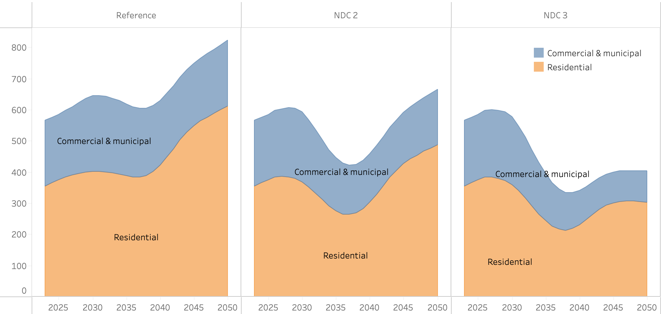Figure 21. Total energy demands in commercial and residential subsectors in the Reference (left), NDC 2.0 (center), and NDC 3.0 (right) pathways (PJ)
The NDC 2.0 measures accelerate this transition and reduce overall demand through a combination of end-use efficiency improvements and faster fuel switching. The 75% improvement in lighting efficiency, enhanced residential cooling efficiency, the residential clean cooking target of 50% electric cooking penetration by 2025, the commercial cooking transition toward improved stoves, LPG, and electric cooking, the improved biomass cookstoves measure, and the deployment of advanced charcoal production kilns reduce per-unit energy demand indicators, measured on a household basis in the residential sector and relative to GDP in the commercial and municipal sectors, more rapidly than the underlying socioeconomic drivers expand them. The result is the characteristic saddle-shaped trajectory visible in the demand profile between 2030 and 2045, with total demand declining through the late 2030s before resuming a more moderate upward trend as electrification of cooking displaces the remaining biomass and LPG use. Under this pathway, electricity becomes the dominant final energy source by 2039, one year earlier than in the Reference. The NDC 3.0 measures extend these effects through sustained long-term investments and policy measures focused on electrification, alongside improvements in appliance, lighting, and broader electrical system efficiencies through 2050 and 2070, including the 60% improvement in overall electricity end-use efficiency by 2070. These measures further suppress aggregate demand and accelerate the displacement of biomass and LPG-based cooking technologies with electric cooking systems, with electricity becoming dominant by 2038 and total demand stabilizing at approximately 405 PJ by 2050. In the Reference pathway, biomass remains the largest single source of energy until 2040, when total electricity consumption reaches 285.4 PJ, surpassing biomass consumption at 283.0 PJ (Figure 22).

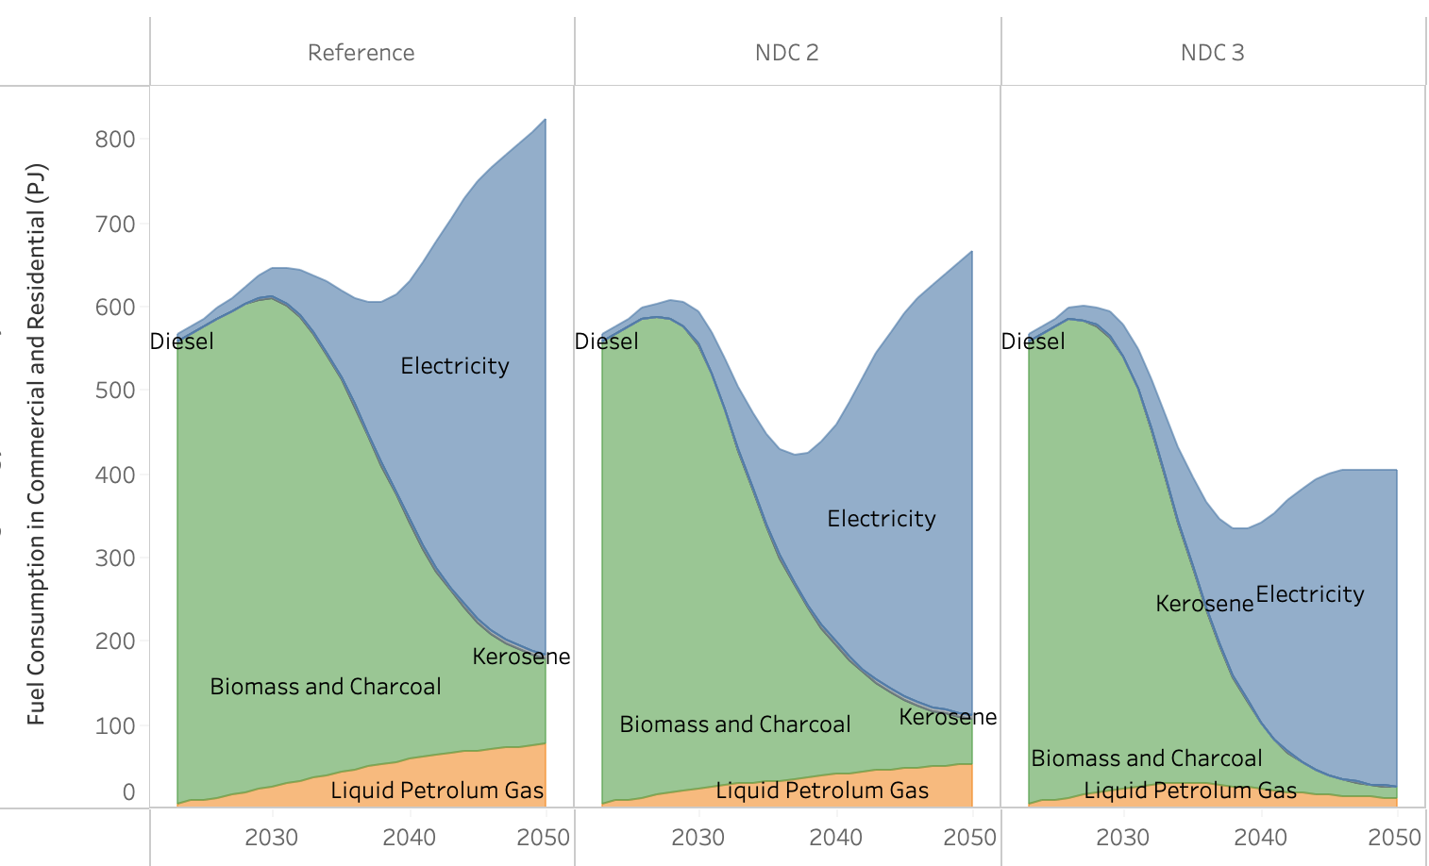
Figure 22. Total fuel consumption in demands in commercial and residential subsectors in in the Reference (left), NDC 2.0 (center), and NDC 3.0 (right) pathways (PJ)

The emissions trajectories reflect the interaction between these demand- and fuel-mix dynamics, with one important accounting distinction (Figure 23). Direct emissions from the commercial and residential subsectors in SISEPUEDE are driven primarily by kerosene and LPG combustion, while emissions associated with biomass fuelwood consumption are accounted for under the AFOLU sector through the Forest Land (i.e. Removals category). Although biomass continues to be used in the Reference pathway, generating approximately 56.9 MtCO₂eq in 2035 and 12.5 MtCO₂eq in 2050 within the AFOLU accounting framework these emissions are addressed within the forestry and land-use analysis rather than the buildings sector. Direct emissions under the Reference pathway remain at historical levels through the late 2020s and decline progressively thereafter as kerosene is largely phased out and biomass is displaced by electricity, reaching 4.4 MtCO₂eq in 2035 and 0.98 MtCO₂eq by 2050. Under NDC 2.0, the faster transition to electric cooking and the broader efficiency package accelerate this decline, with emissions falling to 2.9 MtCO₂eq in 2035 and 0.52 MtCO₂eq by 2050. Under NDC 3.0, the deeper electrification of cooking displaces both biomass and LPG more rapidly, reducing emissions to 2.4 MtCO₂eq in 2035 and 0.11 MtCO₂eq by 2050. The differences between the NDC pathways and the Reference emerge most clearly between 2030 and 2040, when the faster fuel switching under the mitigation pathways drives the steeper declines visible in the trajectory, before all three pathways converge toward low residual emissions as the transition away from kerosene and LPG approaches completion.
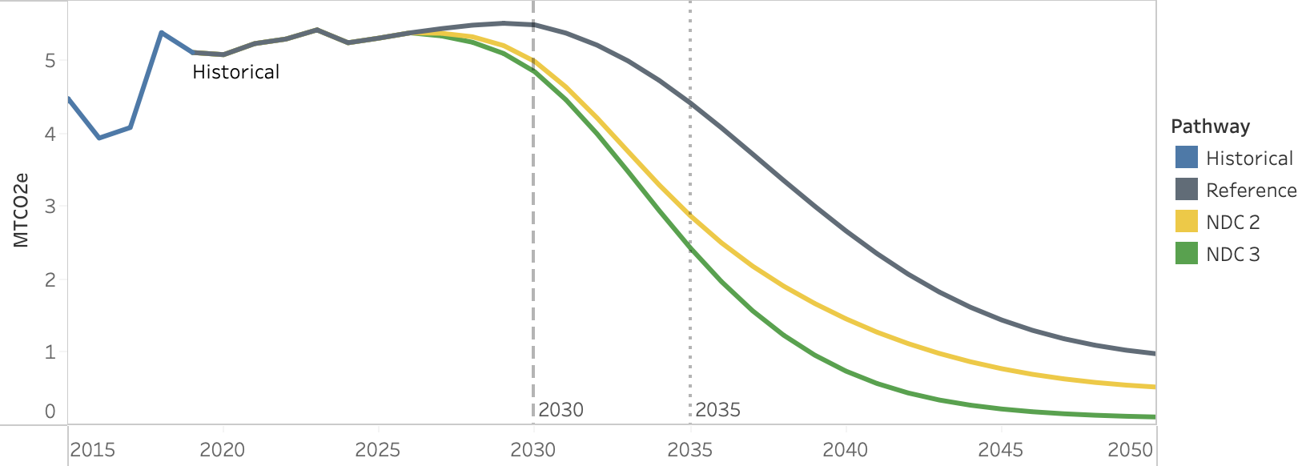
Figure 23. Emissions for Reference (gray), NDC 2.0 (yellow), and NDC 3.0 (green) in commercial and residential buildings (MtCO2e).

4.1.5.3 Transport
The drivers of transport activity reflect the combined effect of underlying socioeconomic growth and the mitigating actions applied to each pathway. Under the Reference pathway, passenger transport demand grows in line with population, income, and urbanization, increasing by approximately 482% from 115.7 billion passenger-kilometers (pkm) in 2023 to 673.3 billion pkm by 2050. This growth is accompanied by a substantial modal shift away from human-powered transport modes, such as walking and cycling, which accounted for roughly half of total passenger travel activity in 2023, toward light-duty road vehicles and public transit as incomes rise and motorization expands. The NDC 2.0 measures applied to passenger transport, including the deployment of at least 200 electric buses in the Greater Kampala Metropolitan Area by 2030, the development of 100 km of non-motorized transport corridors, the deployment of approximately 1,000 high-capacity buses with intelligent transport systems, transit-oriented development reducing motorized travel demand by approximately 5% by 2050, and the development of 61 km of passenger rail services in GKMA, encourage modal shifts toward buses and rail-based transport and reduce dependence on light-duty vehicles. The NDC 3.0 measures extend these interventions through long-term urban planning strategies centered on transit-oriented development and walkable cities, substantially reducing reliance on light-duty vehicles and lowering aggregate passenger demand. As a result, total passenger transport demand in 2050 under NDC 3.0 is projected to be approximately 29% lower than in the Reference pathway (Figure 24).
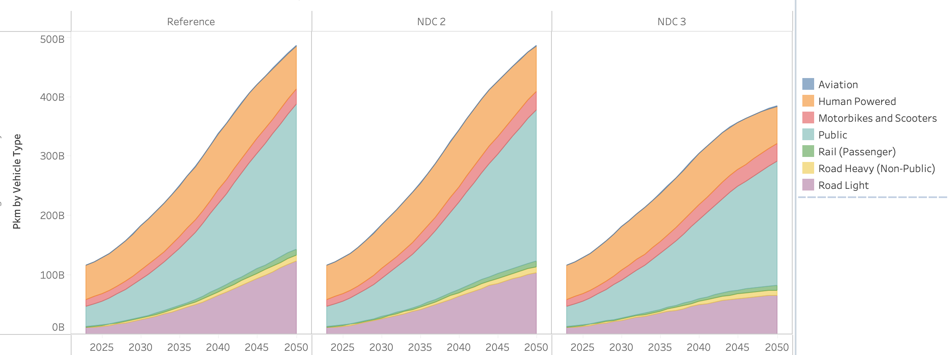
Figure 24. Passenger-kilometer demand (pkm) by transportation type for Reference (left), NDC 2.0 (center), and NDC 3.0 (right)

Freight demand follows a parallel set of dynamics, shaped by GDP growth and the freight-specific mitigating actions specified in Section 4.1.3. Under the Reference pathway, freight demand increases in line with GDP growth, rising from 42.2 megatonne-kilometers (mt-km) in 2023 to 252.4 mt-km by 2050. The NDC 2.0 measures, including the rehabilitation of 634 km of metre-gauge railway by 2026 and freight efficiency improvements through better load factors, shift a portion of freight transport from road to rail while maintaining overall domestic freight demand. The NDC 3.0 measures aim to reduce total freight transport demand through denser urban development, thereby decreasing the distances goods must travel within cities and between distribution hubs (Figure 25).

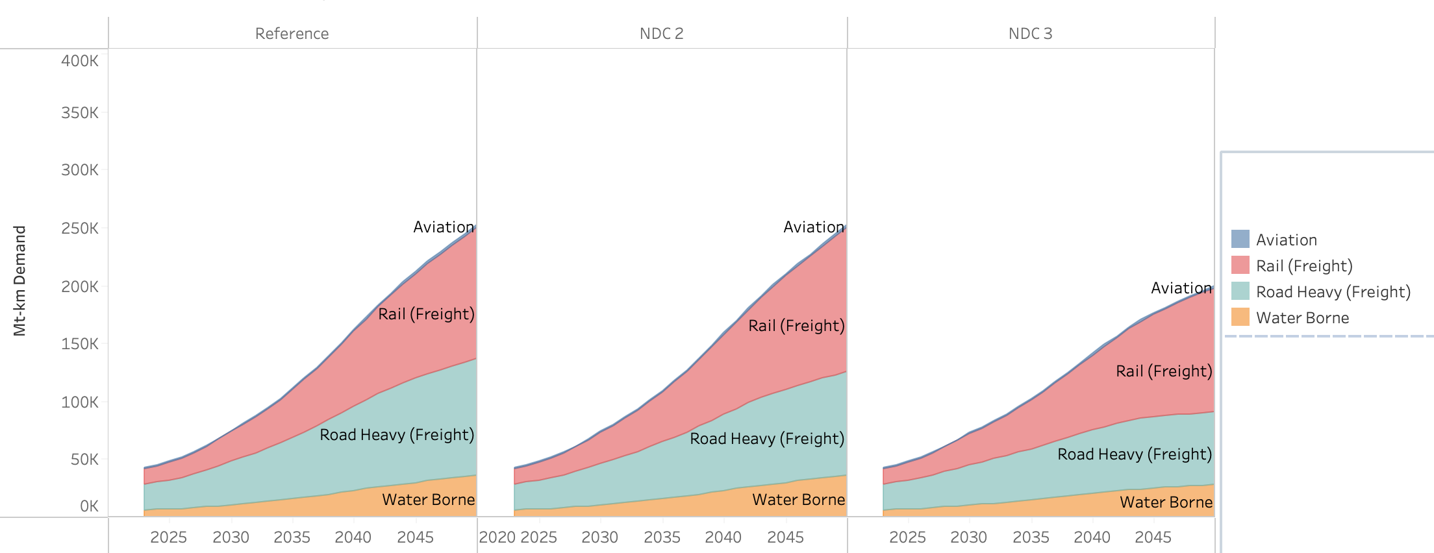
Figure 25. Freight megatonne-kilometer (mt-km) demand by transportation type for Reference (left), NDC 2.0 (center), and NDC 3.0 (right).
The emissions trajectories reflect the interaction of these demand-side dynamics with the vehicle efficiency and fuel-switching measures applied across pathways. The extensive growth in transport activity associated with Vision 2040 is expected to increase emissions significantly relative to historical levels. Under the Reference pathway, emissions grow from 4.45 MtCO₂e in 2025 to 21.86 MtCO₂e by 2050, driven by (a) shifts into powered vehicles arising from income growth, (b) growth in population and economic activity, and (c) increases in per-person travel demands commensurate with socioeconomic growth. The actions included in NDC 2.0 and NDC 3.0 have a significant impact on emissions when compared to the Reference case.

The NDC 2.0 measures, including the GFEI 50×50 vehicle fuel efficiency improvements, the deployment of alternative fuels such as LNG, ethanol, and biodiesel at approximately 1% annual growth, the modal shifts described above, and the rehabilitation and expansion of rail services, reduce emissions to 8.34 MtCO₂e by 2035 and 12.2 MtCO₂e by 2050, compared to 10.44 MtCO₂e and 21.86 MtCO₂e under the Reference at the same points.

The NDC 3.0 measures further compound these reductions through the unconstrained electric vehicle adoption that removes upper-bound constraints on EV penetration, alongside the deeper modal shifts and demand reductions arising from transit-oriented development. Emissions decline to 6.7 MtCO₂e by 2035 and 6.08 MtCO₂e by 2050, approximately 72% below the Reference trajectory at mid-century. The NDC 3.0 trajectory also exhibits a distinct plateau-and-decline pattern, with emissions peaking in the mid-2040s before declining as the cumulative effect of vehicle electrification and demand-side measures progressively outweighs the residual growth in transport activity (Figure 26).

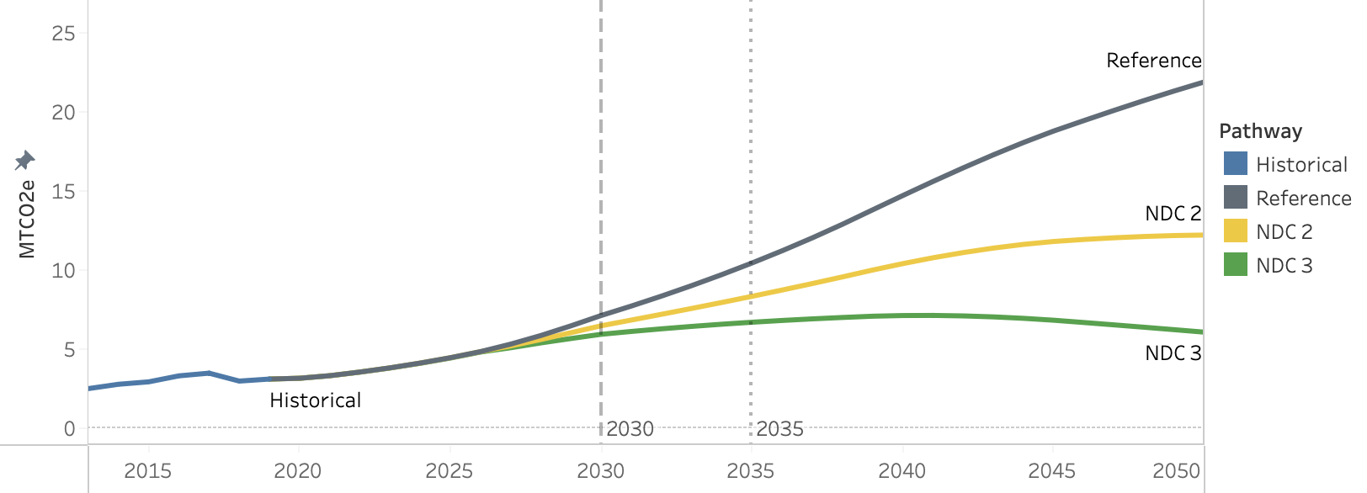
Figure 26. Emissions for Reference (gray), NDC 2.0 (yellow), and NDC 3.0 (green) in electricity and heat generation (MtCO2e).
The cost-benefit profile of the energy transition is shaped by the interaction between the capital required to expand low-carbon electricity supply and end-use technologies, and the externalities avoided across transport, buildings, and fuel combustion. Under NDC 2.0, total capital expenditures in energy reach $1.27 billion in 2035 and peak at $3.25 billion in 2045, driven by the rapid expansion of electricity production infrastructure required to meet the demand growth associated with Vision 2040 and the LCGTP targets. Increases in operations and maintenance costs relative to the Reference add a further $1.5 billion by 2050. The associated benefits arise through three principal mechanisms: the displacement of solid biomass in households reduces indoor air pollution and the health damages it causes; the displacement of fossil fuels in transport, industry, and power production reduces outdoor air pollution; and the modal shift toward public and non-motorised transport reduces traffic congestion and road safety externalities. Indoor air pollution benefits peak at $149 million in 2032, with the magnitude constrained by the fact that the Reference pathway already incorporates a substantial shift away from biomass, leaving a smaller marginal benefit available to NDC 2.0. Outdoor air pollution benefits reach $677 million by 2050. Transport congestion benefits reach $104 million by 2035 and $556 million by 2050, while road safety benefits reach $122 million in 2035 and $742 million by 2050. The combination of these benefits is not sufficient to offset the capital expenditure profile, and net benefits under NDC 2.0 turn negative in the second half of the modelling horizon, reaching a low of approximately –$2.48 billion in 2048 (Figure 27).

Under NDC 3.0, the cost-benefit balance is chnages due to lower capital intensity alongside higher benefits. Capital expenditures peak at $2.35 billion in 2034 before declining to $1.88 billion in 2035 and remaining below $2.14 billion thereafter. This reduction relative to NDC 2.0 is a consequence of the deeper end-use efficiency measures applied across sectors, which lower the grid demand against which generation capacity must be built. The effect is stronger in the buildings sector, where the combined effect of lighting and appliance efficiency improvements and building shell quality cuts commercial and residential electricity demand by approximately 40.8% in 2050, from 639.3 PJ under the Reference to 378.3 PJ under NDC 3.0. The additional electricity load from transportation electrification is partly absorbed by efficiency improvements for electric vehicles, further moderating the infrastructure investment required.

Under NDC 3.0 benefits are larger across all categories. Indoor air pollution benefits peak at $258 million in 2038, and outdoor air pollution benefits reach $887 million by 2050. The deeper modal shift away from light-duty private vehicles toward public transit, rail, and non-motorised transport reduces both the operating costs of the transport service system and the externalities generated by road traffic. System cost savings, which capture the avoided capital and operating costs of vehicle fleets associated with mode shifts, emerge as a distinguishing benefit category under NDC 3.0, reaching $772 million by 2035. Congestion benefits grow to $212 million by 2035 and $936 million by 2050, and road safety benefits rise from $301 million in 2035 to $1.35 billion in 2050. The combined effect is that NDC 3.0 yields positive net annual benefits throughout the modelling period, reaching $2.54 billion in 2040 and $5.14 billion by 2050. The contrast between the two pathways reflect a key mechanism: a more ambitious efficiency package lowers the infrastructure investment required to meet a given service demand, and the resulting capital savings combine with broader externality reductions to produce a more favourable cost-benefit balance under the higher-ambition scenario.

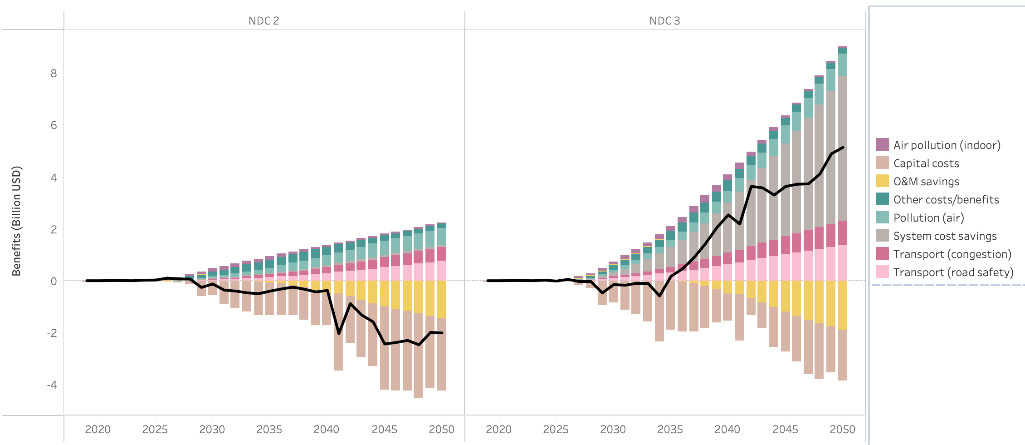
Figure 27. Costs and Benefits in energy for NDC 2.0 (left), and NDC 3.0 (right) in energy, including buildings, transportation, electricity and fuel production, and industrial combustion.

4.2 Industry Sector

4.2.1 Sector Background

Uganda's IPPU sector is dominated by cement production and iron and steel manufacturing, both of which are expanding rapidly in response to population growth, urbanisation, and infrastructure development under NDP IV and Vision 2040. Cement production generates process emissions from the calcination of limestone, independent of energy use, making it a distinct and significant source of GHG emissions. Uganda's cement industry has grown substantially over the past decade, with installed production capacity concentrated in the central and western regions, and demand projected to increase significantly as large-scale infrastructure and housing construction programmes are implemented.

The iron and steel subsector is smaller in absolute terms but is growing, driven by construction demand and the expansion of domestic manufacturing capacity. Both subsectors currently rely heavily on biomass and fossil fuels for industrial heat, presenting opportunities for fuel switching alongside the process emission reductions targeted through the NDC.

Other industrial subsectors including food, beverages and tobacco, chemicals, and machinery and transport equipment contribute to overall industrial energy use but generate relatively limited process emissions and are not the primary focus of IPPU mitigation measures. The Updated NDC (2022) identifies cement and steel as the priority subsectors for IPPU mitigation, with clinker substitution and fuel switching as the principal intervention pathways.

4.2.2 Key Drivers and Assumptions

Industrial production volumes are projected to grow substantially over the modelling period, driven by GDP growth and expanding construction and manufacturing activity. Demand growth for cement and steel is particularly strong, tied directly to Uganda's infrastructure targets under NDP IV. Energy use across all subsectors is disaggregated by fuel type and driven by production volume growth, with the future fuel mix determined through least-cost competition among available alternatives. The following tables summarise the base year assumptions used in the CLEWs and SISEPUEDE models.

Parameter | 2021 Value
Energy use | Biomass: 46.8  Charcoal: 14.1  Coal: 0.0  Natural gas: 0.0  Fuel oil: 0.0  Electricity: 10.7  Diesel: 12.2  Gasoline: 3.5  Kerosene: 1.6  Waste: 0.0  Hydrogen: 0.0
Production volume (Mton) | - Cement: 4.6  - Steel: 0.5
Value added | - Food, beverages and tobacco: 3.8  - Machinery and transport equipment: 0.5  - Chemicals: 0.5  - Other industry: 1.1

4.2.3 Mitigating Actions

All NDC 2.0 measures are carried forward into the NDC 3.0 scenario, with one additional measure applied on top.

- Industrial Process Decarbonization

Mitigation Measure | Scenario | Description
Hydrogen-based DRI in Steel Production | NDC 2.0 & NDC 3.0 | Introduction of hydrogen-based Direct Reduced Iron (DRI) for all new steel capacity after 2035
Clinker Substitution in Cement Production | NDC 2.0 & NDC 3.0 | Reduction of clinker ratio to 90% in cement manufacturing by 2030 through substitution with pozzolana, fly ash, or slag
Enhanced Clinker Substitution | NDC 3.0 only | Further reduction of clinker ratio to 75% by 2030 — more ambitious than the NDC 2.0 target of 90%
- Industrial Energy Use
Mitigation Measure | Scenario | Description
Industrial Energy Efficiency | NDC 2.0 & NDC 3.0 | Improvement in industrial energy efficiency, achieving a 10% reduction in energy use relative to reference by 2025
Industrial Energy Efficiency | NDC 2.0 & NDC 3.0 | Transition toward sustainable biomass, reaching 25% of industrial energy use by 2030 and 40% by 2040
A detailed description of how each mitigation measure is implemented within the two models, including parameter specifications and modelling constraints, is provided in Appendix 2.

4.2.4 CLEWs Results

Under the Reference scenario, IPPU sector emissions rise from 1.91 MtCO₂eq in 2021 to 16.97 MtCO₂eq by 2035 and 38.82 MtCO₂eq by 2050, a more than twenty-fold increase driven by the rapid expansion of coal and natural gas use across cement, steel, and other industrial subsectors.

Under NDC 2.0, energy efficiency improvements and fuel switching progressively reduce both total energy demand and emissions relative to the Reference. Total industrial energy use falls from 220.7 PJ under the Reference to 205.0 PJ by 2035 and from 399.2 PJ to 344.2 PJ by 2050. Coal declines from 54.5 PJ to 40.3 PJ by 2035 and natural gas from 24.7 PJ to 15.8 PJ, replaced by increasing biomass, rising from 54.7 PJ to 65.7 PJ by 2035 and 71.2 PJ by 2050, and hydrogen, which enters the energy mix from 2031 reaching 4.1 PJ by 2035 and 28.2 PJ by 2050. Notably, electricity demand also declines below the Reference despite the same level of industrial output, falling from 57.9 PJ to 50.3 PJ by 2035 and from 149.6 PJ to 131.3 PJ by 2050, reflecting the energy intensity reductions achieved through industrial process efficiency improvements. These combined fuel mix and efficiency changes reduce emissions to 14.25 MtCO₂eq by 2035 and 29.49 MtCO₂eq by 2050, reductions of 2.72 MtCO₂eq and 9.33 MtCO₂eq relative to the Reference at the same points.
Under NDC 3.0, deeper fuel switching and more ambitious efficiency targets accelerate this transition further. Total industrial energy use falls to 203.4 PJ by 2035 and 326.7 PJ by 2050. The most significant change relative to NDC 2.0 is the more aggressive displacement of natural gas, which falls from 15.8 PJ under NDC 2.0 to 4.8 PJ under NDC 3.0 by 2035 and from 53.7 PJ to 24.9 PJ by 2050, with biomass correspondingly reaching 80.7 PJ by 2035 and 86.4 PJ by 2050. Coal also declines more rapidly to 35.3 PJ by 2035 and 39.0 PJ by 2050, while hydrogen follows a similar trajectory to NDC 2.0 at 4.0 PJ by 2035 and 28.2 PJ by 2050. Electricity demand falls to 50.6 PJ by 2035 and 131.6 PJ by 2050, broadly similar to NDC 2.0, confirming that the deeper reductions under NDC 3.0 are driven primarily by the more aggressive displacement of natural gas by biomass rather than by further gains in electricity efficiency. These fuel mix changes reduce emissions to 11.31 MtCO₂eq by 2035 and 22.83 MtCO₂eq by 2050, reductions of 5.66 MtCO₂eq and 15.99 MtCO₂eq relative to the Reference. The divergence between the two NDC scenarios widens progressively over time, confirming that the pace and ambition of industrial fuel switching is the primary determinant of emissions outcomes in this sector.
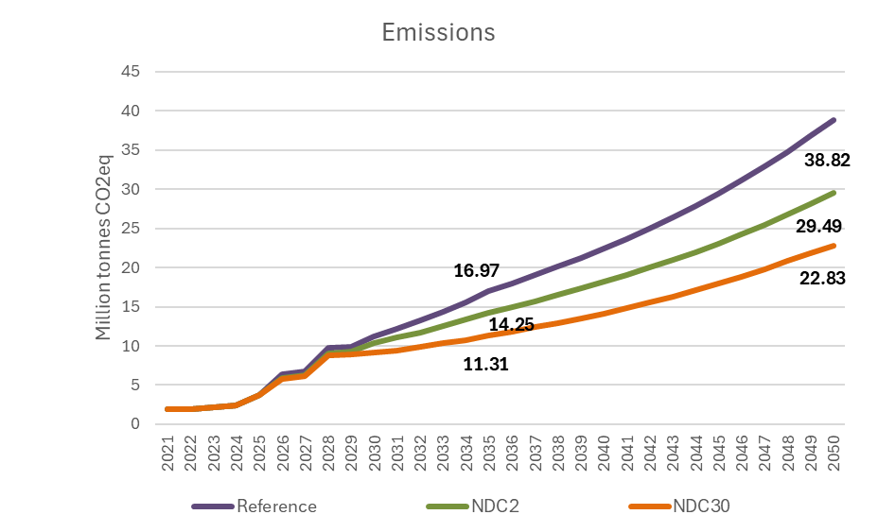
Figure 28. IPPU Sector Emissions by Scenario, 2021–2050 (MtCO₂eq)
The fuel use charts below illustrate how the industrial fuel mix evolves across all three scenarios, showing the progressive displacement of coal and natural gas by biomass and hydrogen under the NDC scenarios and the deeper fossil fuel moderation achieved under NDC 3.0.
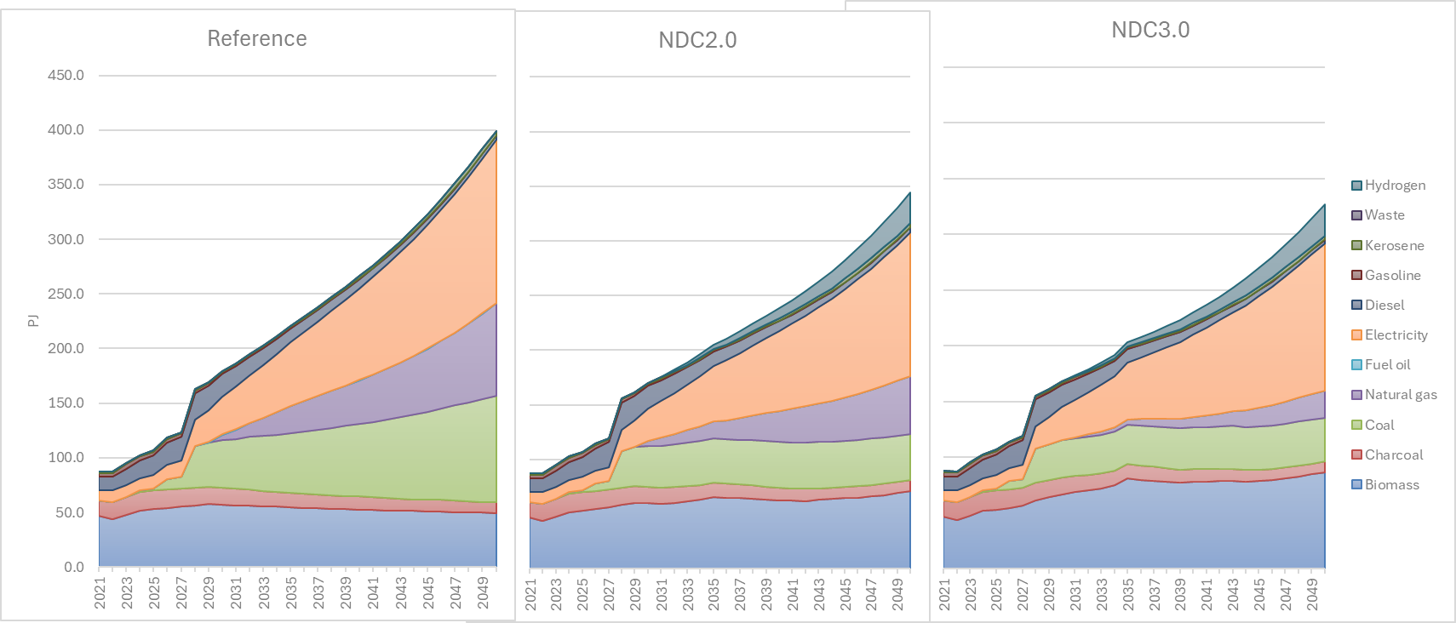
Figure 29. IPPU Sector Fuel Use for the NDC2.0 and NDC3.0 Scenario, 2021–2050 (PJ)
Despite requiring additional capital investment in cleaner technologies, the fuel cost savings more than offset the higher upfront costs, resulting in total system costs that are lower than in the Reference scenario. By 2035, total costs are already below the Reference under both NDC scenarios, reaching $2,123 million under NDC 2.0 and $2,011 million under NDC 3.0 compared to $2,135 million under the Reference, with the gap widening to $5,395 million and $5,071 million against $5,410 million by 2050.

The driver of these savings is the reduction in fuel expenditure. As coal and natural gas are displaced by lower-cost biomass, total fuel costs fall from $3,978 million under the Reference to $3,374 million under NDC 2.0 and $3,161 million under NDC 3.0 by 2035, with the savings deepening further by 2050. The net result is a negative average mitigation cost throughout the modelling period, reaching -$4/tCO₂eq under NDC 2.0 and -$22/tCO₂eq under NDC 3.0 by 2035, confirming that IPPU mitigation is not only consistent with Uganda's industrial development objectives but actively reduces the cost of industrial production, making the transition economically self-financing from the outset.

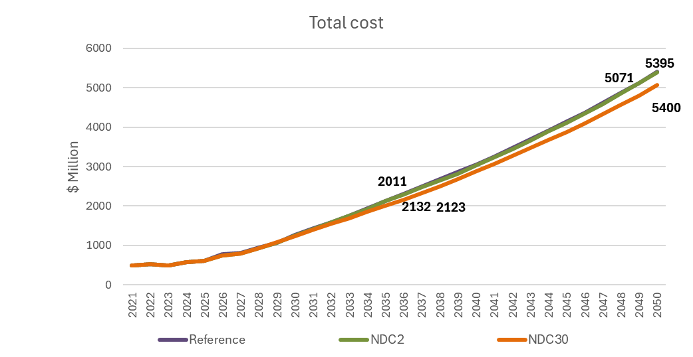
Figure 30. IPPU Sector Total Cost by Scenario ($m), 2021–2050

4.2.5 SISEPUEDE Results

The drivers of industrial energy demand reflect the combined effect of underlying production growth and the mitigating actions applied to each pathway. Strong growth in industrial production, including manufacturing, cement, mining, and metals, drives a substantial increase in the need for energy across all scenarios, in line with the infrastructure and manufacturing expansion envisioned under NDP IV and Vision 2040. Under the Reference pathway, most of this energy is met from combustibles, including fossil fuels and biomass, with total energy demand increasing from 87.8 PJ in 2023 to 136.4 PJ in 2035 and 186.7 PJ in 2050. The Reference pathway also incorporates a shift toward more traditional fossil fuels by 2045, with natural gas representing the most significant point of growth and fuel oil following thereafter.
The NDC 2.0 measures, including the 10% reduction in industrial energy use relative to the Reference by 2025 and the transition toward sustainable biomass reaching 25% of industrial energy use by 2030 and 40% by 2040, moderate this demand expansion in the near term, reducing total energy demand to 117.6 PJ by 2035 and 133.7 PJ by 2050. Clean hydrogen is also introduced post-2035 to help meet growing demands for high-heat energy, particularly in furnace blasters supplying the hydrogen-based Direct Reduced Iron pathway for new steel capacity after 2035. The NDC 3.0 measures push efficiency improvements further and increase electrification across industrial subsectors. Energy demand under this pathway peaks at 114.4 PJ in 2043 and remains effectively flat between 2035 and 2050, with values of 108.2 PJ and 109.2 PJ respectively (Figure 31).
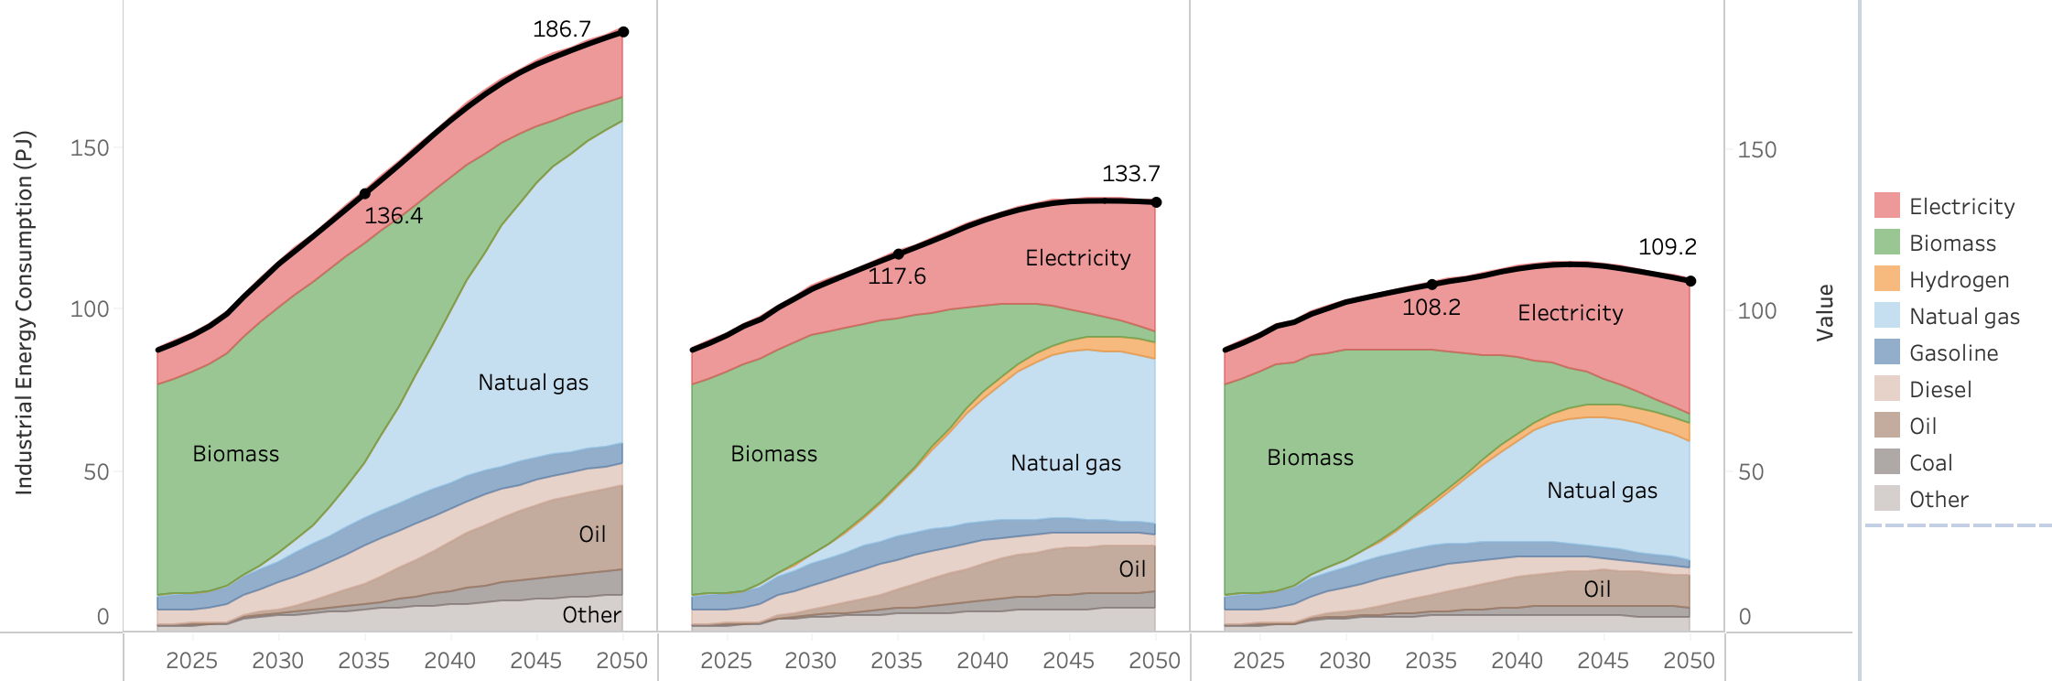
Figure 31. Total fuel consumption in demands in non-energy industries in in the Reference (left), NDC 2.0 (center), and NDC 3.0 (right) pathways (PJ).

The emissions trajectories reflect the interaction of these demand-side dynamics with the fuel-switching and process-decarbonization measures applied across pathways. Under the Reference pathway, the combination of rapid industrial output growth and continued reliance on fossil fuels and biomass produces a sustained rise in emissions, growing from 3.16 MtCO₂e in 2025 to 6.51 MtCO₂e in 2035 and 13.01 MtCO₂e in 2050. The NDC 2.0 measures, combining the energy efficiency improvements, the transition toward sustainable biomass, the clinker substitution reducing the clinker ratio to 90% by 2030, and the hydrogen-based DRI pathway for new steel capacity after 2035, substantially alter this trajectory, reducing emissions to 5.39 MtCO₂e by 2035 and 6.92 MtCO₂e by 2050.
The NDC 3.0 measures compound these reductions through the deeper clinker substitution reducing the ratio to 75% by 2030, together with the introduction of carbon capture in industries with an effectiveness of 90% at the point of installation, expanding from a target adoption rate of 13% by 2035 to 42% by 2050 and 80% by 2070. This additional measure applies to both combustion and process CO₂ emissions and produces a distinctive plateau-and-decline pattern in the NDC 3.0 trajectory, with emissions reaching 4.74 MtCO₂e by 2035, peaking in the mid-2040s, and declining to 4.60 MtCO₂e by 2050, approximately 65% below the Reference at mid-century (Figure 32).
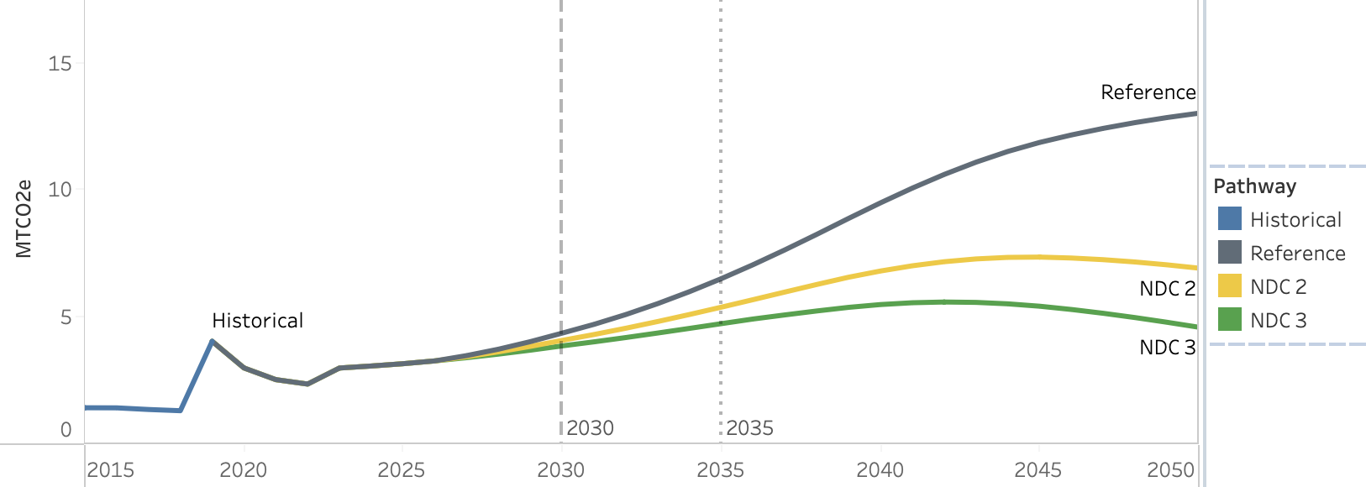
Figure 32. Emissions for Reference (gray), NDC 2.0 (yellow), and NDC 3.0 (green) in industrial (excluding energy industries) combustion (MtCO2e).

The drivers of industrial process emissions reflect the rapid expansion of industrial production required to support infrastructure development and economic growth commensurate with Vision 2040 and NDP IV. Cement is the dominant driver, growing approximately eight-fold from 5.2 Mt in 2025 to 40.2 Mt in 2040 and 65.2 Mt by 2050. Metals production also expands substantially, with steel emerging as a key area of industrial growth and structural change. While most steel production in Uganda today is based on direct reduced iron rather than blast-furnace iron, significant future investments such as the Tororo Steel Mill will introduce blast-furnace-based steel production to Uganda, which is incorporated in the Reference pathway and increases the requirement for coal in coke ovens. Mining activity, including precious and strategic resource metals, nearly doubles between 2025 and 2040, increasing by 88% from 2.5 Mt to 4.7 Mt of total production. Production volumes are treated as exogenous to the mitigation pathways and therefore do not vary across scenarios; the divergence between pathways arises from the process and material composition changes applied to this production (Figure 33).
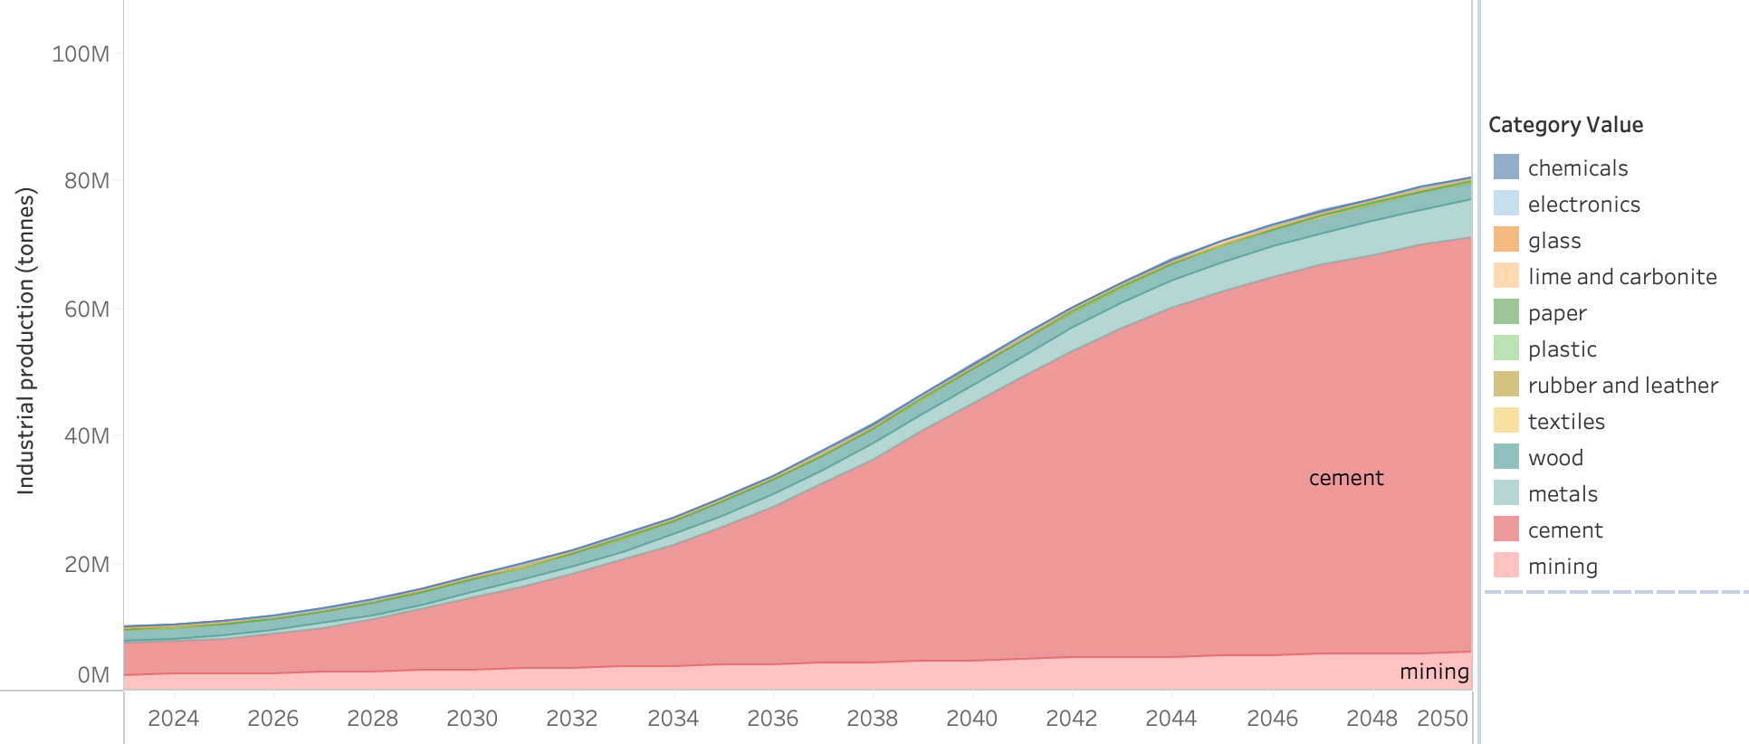
Figure 33. Total industrial production by year and tonnage for key drivers of IPPU.

The emissions trajectories reflect the interaction between the rapid expansion of cement and steel production and the process-decarbonization measures applied across pathways. Under the Reference pathway, IPPU emissions are shaped primarily by two structural shifts in the underlying production system. The first is the introduction of blast-furnace-based steel production through the Tororo Steel Mill, which increases process emissions associated with coke-based metallurgy. The second is the shift of clinker production into Uganda, including the Yaobi cement factory beginning operations in 2027 with a capacity of 6,000 tonnes of clinker per day, which raises domestic process emissions by increasing the share of clinker produced domestically to meet rising cement demand. The combined effect of these structural shifts and the eight-fold expansion of cement production produce a sustained rise in emissions, reaching approximately 16 MtCO₂e by 2050.
The NDC 2.0 measures reduce emissions through the clinker substitution targets, which lower the clinker fraction in cement and moderate the growth rate of domestic clinker production, alongside the introduction of hydrogen-based DRI for new steel capacity after 2035. These measures partially offset the growth in domestic clinker production, reducing emissions to approximately 14 MtCO₂e by 2050. The NDC 3.0 measures compound these reductions through the deeper clinker substitution (with a 2050 target of 70% clinker fraction and a 2070 target of 50%) and the introduction of carbon capture at point of use, which together reduce process emissions by approximately 5.15 MtCO₂e relative to the Reference in 2050. Emissions under NDC 3.0 plateau at approximately 9 MtCO₂e from the mid-2040s onward, around 45% below the Reference trajectory at mid-century (Figure 34).

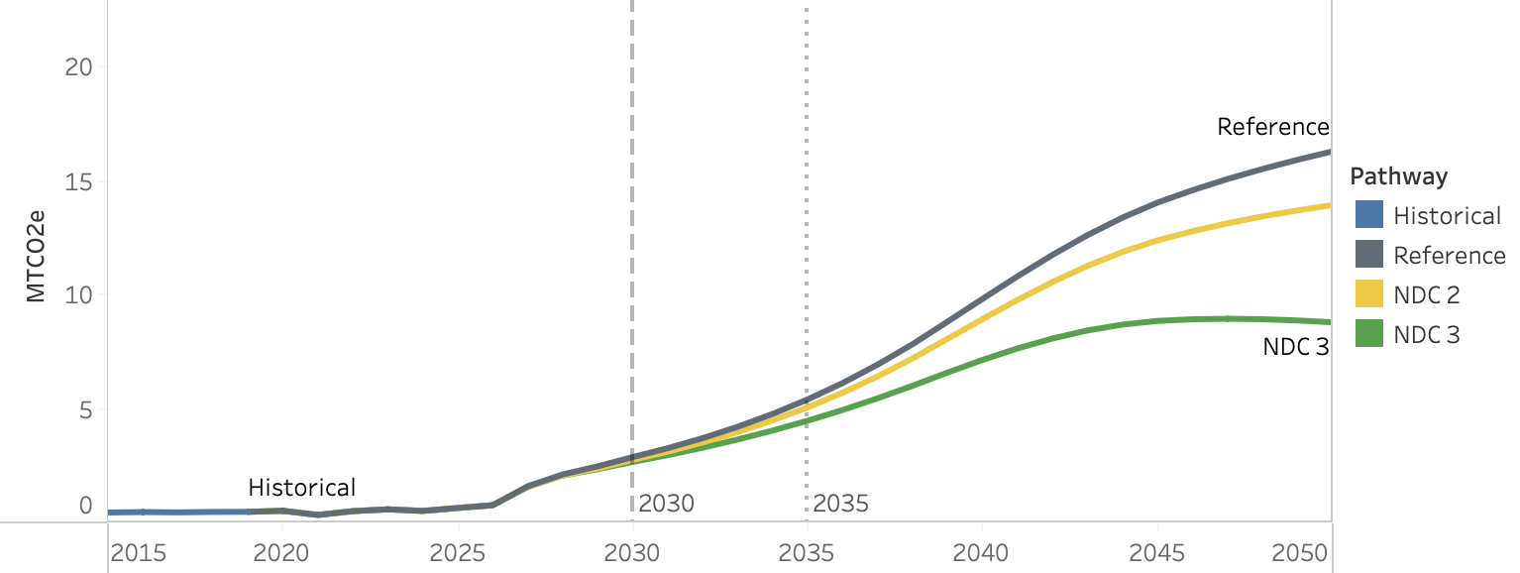
Figure 34. Emissions for Reference (gray), NDC 2.0 (yellow), and NDC 3.0 (green) in industrial procceses and product use (IPPU, MtCO2e).

4.3 Agriculture Sector

4.3.1 Sector Background

Agriculture is the backbone of Uganda's economy, accounting for approximately 26.5% of GDP and 36% of export earnings in FY2024/25 and employing an estimated 68% of the working population. The sector is dominated by smallholder farming systems producing both food crops and livestock, with approximately 80% of Uganda's land classified as arable, though only 35% is currently under cultivation.

The agriculture sector contributes approximately 27% of Uganda's total GHG emissions, making it the second largest emitting sector after land use change and forestry.4 Around 83% of this is from enteric fermentation, with manure management and soils making up the balance.

The livestock subsector is dominated by cattle, concentrated primarily in the cattle corridor covering approximately 40% of the country's land area from Karamoja to the southwest. Enteric fermentation accounts for approximately 75.8% of total livestock GHG emissions, with the grazing system contributing 88.5% of sectoral livestock emissions. Productivity remains low relative to emission intensity, with indigenous breeds dominant across cattle and poultry systems, limiting the efficiency gains achievable through herd management alone.

Agricultural soils represent the second major emissions source, generating nitrous oxide (N₂O) through the application of synthetic and organic fertilisers, manure deposition during grazing, and crop residue management. Uganda's soils are generally fertile, supporting two growing seasons across much of the country, but are increasingly under pressure from land degradation, reduced fallow periods, and climate variability. Emissions from soils are closely tied to land management practices and the expansion of cultivated area under NDP IV agricultural production targets.

The Updated NDC (2022) identifies the agriculture sector as a priority for both mitigation and adaptation, with commitments focusing on livestock breeding improvement, yield increases, and manure management as the principal mitigation pathways.

4.3.2 Key Drivers and Assumptions

Agricultural emissions in Uganda are projected to grow over the modelling period, driven primarily by livestock population growth, expansion of cultivated area, and intensification of crop production in line with NDP IV agricultural development targets. In the livestock subsector, emissions are closely tied to herd size and composition, with enteric fermentation from cattle representing the dominant source. In the soils and crops subsector, emissions are driven by nitrogen inputs and expanding cropland area, both of which are expected to increase as agricultural productivity targets under NDP IV are pursued.

The following tables summarise the base year assumptions used in the CLEWs and SISEPUEDE models.

- Livestock

Parameter | 2021 Value
Livestock population2 | - Cattle population:  - Indigenous: 11.5 million head  - Exotic/crossbreed dairy: 3.1 million head  - Exotic/crossbreed meat: 0.3 million head  - Sheep population: 4.5 million head  - Goat population: 17.9 million head  - Pigs: 7.3 million head  - Chicken: 59.7 million head
Population growth driver | Income elasticity of 1.0 relative to population growth

- Crops

Parameter | 2021 Value
Total crop production2 | 32,380 kt across major crop categories
Crop demand growth driver | Per capita demand grows with population and income, using crop-specific income elasticities ranging from 0.0 (subsistence crops) to 0.8 (rice, driven by urbanisation)

4.3.3 Mitigating Actions

All NDC 2.0 measures are carried forward into the NDC 3.0 scenario, with one additional measure applied on top.
- Climate Smart Agriculture
Mitigation Measure | Scenario | Description
Improved Fertiliser Application | NDC 2.0 & NDC 3.0 | Adoption of improved fertiliser application practices to reduce N₂O emissions from agricultural soils
Rainwater Harvesting and Irrigation | NDC 2.0 & NDC 3.0 | Expansion of irrigation systems to reach 50% of national irrigation potential by 2040
Greenhouse Cultivation of Vegetables | NDC 2.0 & NDC 3.0 | Promotion of greenhouse farming to increase yields, improve resource efficiency, and reduce emissions associated with land expansion.
- Livestock Management
Mitigation Measure | Scenario | Description
Livestock Productivity and Emissions Improvements | NDC 2.0 & NDC 3.0 | Improved cattle breeds and feeds, enhanced water availability, and establishment of fodder agroforestry plantations
Manure Management, Higher Collection Rate | NDC 2.0 & NDC 3.0 | Increased collection rate of livestock manure to reduce direct emissions from manure deposition
Enhanced Livestock Mitigation, Improved Technology Package | NDC 3.0 only | Deployment of more advanced, higher-cost livestock technologies delivering deeper emission reductions through lower emission factors and improved productivity, with higher associated CAPEX and OPEX.

A detailed description of how each mitigation measure is implemented within the models, including parameter specifications and modelling constraints, is provided in the Appendix 2.

4.3.4 CLEWs Results

4.3.4.1 Livestock

The livestock sector plays a central role in Uganda’s rural economy, supporting household incomes, food security, asset accumulation, and agricultural livelihoods across much of the country. Cattle in particular serve multiple functions beyond meat and milk production, including draft power, savings, and resilience against economic shocks. As population and incomes grow, demand for livestock products increases steadily during the full model horizon, driving continued expansion of the sector across all scenarios. Under the Reference scenario, this growth largely reflects an extension of current production systems and historical trends, with only gradual structural change over time. Indigenous cattle continue to dominate the national herd, increasing from 11.5 million head in 2021 to 18.0 million by 2035 and 27.9 million by 2050 (Figure 36). Emissions rise substantially alongside output, increasing from 28.77 MtCO₂eq in 2021 to 43.2 MtCO₂eq by 2035 and 66.37 MtCO₂eq by 2050 (Figure 35).

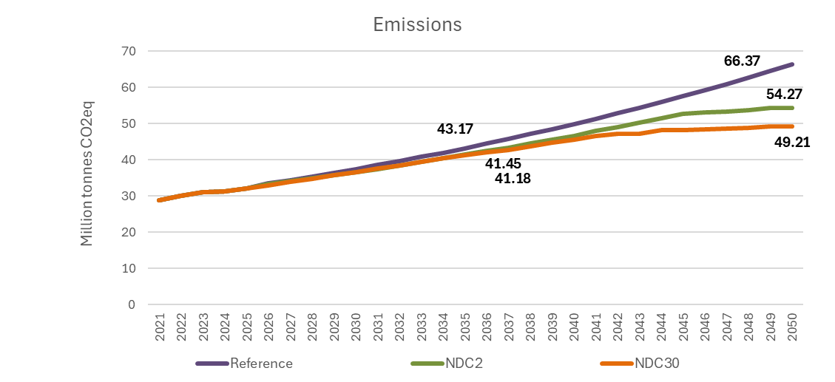
Figure 35. Livestock Sector Emissions by Scenario, 2021–2050 (MtCO₂eq)
The mitigation pathways do not attempt to reduce livestock production or constrain demand growth. Instead, they focus on improving productivity and reducing emissions intensity through gradual changes in herd composition and management practices. The central structural change is the increased adoption of higher-productivity exotic and crossbreed cattle, particularly for dairy and commercial meat production. These breeds produce substantially more milk and meat per animal and can therefore reduce emissions intensity while improving rural productivity and incomes. However, the transition also introduces important trade-offs. Exotic breeds are generally more dependent on higher-quality feed, veterinary services, and improved management systems, and are often more vulnerable to disease, heat stress, drought, and broader climate variability than indigenous breeds that are adapted to local conditions. This means that productivity gains are accompanied by higher operating costs and increased system management requirements.

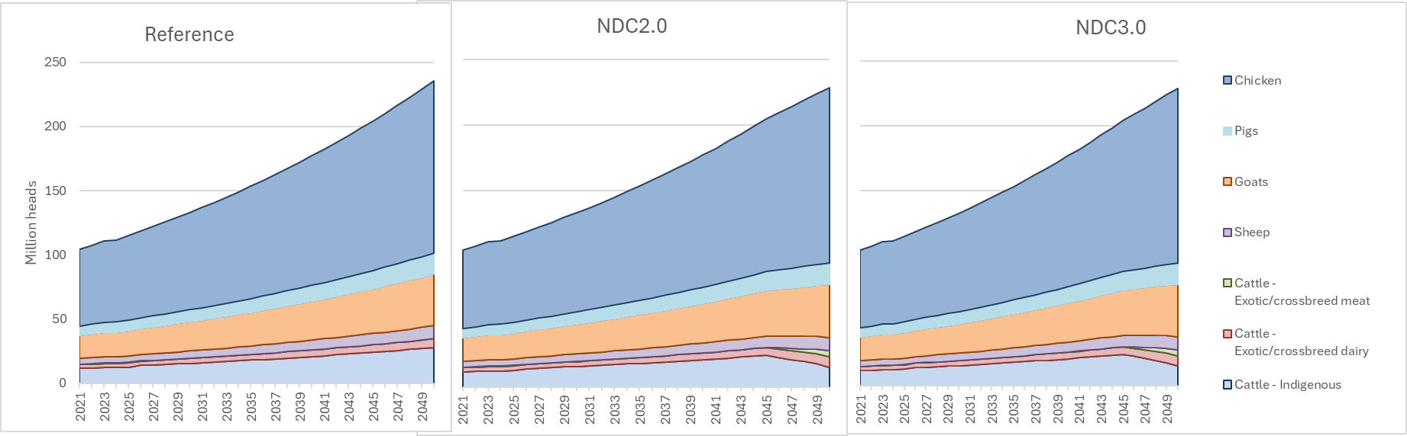
Figure 36. Livestock population by breed under the Reference, NDC2.0 and NDC3.0 scenarios (2021–2050).

Alongside breed improvements, the NDC pathways include a broader package of mitigation measures to achieve moderate reductions in livestock emissions intensity broadly on the order of 20–25% per animal relative to the Reference by mid-century. These measures include improved feed quality and digestibility, fodder agroforestry, better pasture management, improved animal health and fertility management, manure management improvements, and more efficient herd turnover. Collectively, these interventions reduce methane emissions per unit of meat and milk production while supporting higher productivity per animal. However, unlike some mitigation measures in the energy sector that generate direct cost savings over time, most livestock mitigation options are fundamentally cost additive. Improved feeds, veterinary services, breeding systems, supplementary fodder production, and manure management technologies all increase input costs relative to traditional low-input systems.

As a result, the NDC scenarios lead to higher overall system costs and higher costs per animal than the Reference pathway (Figure 37). Under the Reference scenario, the sector remains relatively low-cost, with annual system costs reaching approximately $1.9 billion by 2035 and $2.9 billion by 2050, while average costs per animal remain broadly stable at around $12.4 due to the persistence of extensive low-input production systems. Under NDC 2.0 and especially NDC 3.0, costs rise as producers adopt more input-intensive production practices. Feed costs, breeding costs, animal health expenditures, and management requirements all increase substantially, pushing annual system costs to $3.9 billion under NDC 2.0 and $4.9 billion under NDC 3.0 by 2050. Average costs per animal rise correspondingly to approximately $16.9 under NDC 2.0 and $21.5 under NDC 3.0.

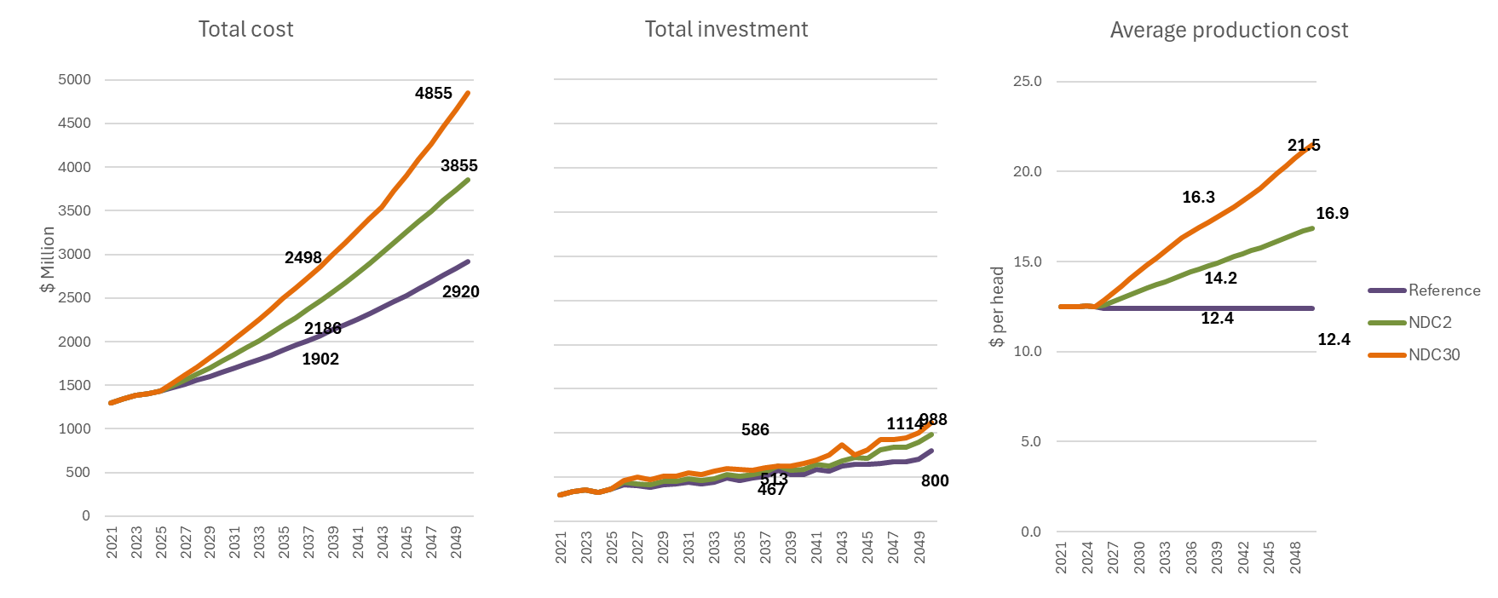
Figure 37. Livestock Sector Total Cost (left), Total Investment (centre) and average costs (right) by Scenario ($m), 2021–2050

These higher costs are partially offset by productivity gains from improved breeds and management systems. A more productive herd requires fewer animals to deliver the same level of output growth, slowing the expansion of total livestock numbers relative to the Reference scenario. Under NDC 2.0 and NDC 3.0, indigenous cattle decline progressively as higher-productivity dairy and meat breeds expand, leading to lower emissions intensity and slower growth in total sector emissions. Under the more ambitious NDC 3.0 pathway, emissions plateau during the early 2040s before declining gradually thereafter, reaching 49.21 MtCO₂eq by 2050 compared to 66.37 MtCO₂eq under the Reference scenario.

The livestock transition should therefore be understood primarily as a productivity and intensification pathway rather than a low-cost mitigation opportunity. Emissions reductions are achieved through a gradual shift from extensive low-productivity systems towards more managed and commercially oriented production systems that require higher levels of investment, inputs, and technical capacity. While these measures can improve productivity, support rural incomes, and moderate emissions growth, they also increase system costs and expose producers to greater climatic and management risks associated with more intensive livestock systems

4.3.4.2 Crops

Crop production and agricultural soil emissions follow a different mitigation pathway from most other sectors in the model. In sectors such as energy, waste, and transport, mitigation measures primarily reduce direct emissions from existing activities. In the crop sector, by contrast, the mitigation package leads to agricultural intensification and land-use efficiency rather than direct emissions reduction. The transition towards higher-productivity agriculture allows Uganda to meet rapidly growing food demand with less cropland expansion, reducing pressure on forests and other natural land systems. As a result, the largest climate benefits of the crop sector interventions occur indirectly through avoided land conversion in the LULUCF sector rather than through reductions in direct crop and soil emissions.

Under the Reference scenario, crop production expands largely through a continuation of current trends, with rising food demand met through a combination of moderate yield improvements and continued cropland expansion. Total cropland increases from 10.9 million hectares in 2021 to 12.1 million hectares by 2035 and 13.1 million hectares by 2050. Direct crop and soil emissions rise correspondingly from 3.6 MtCO₂eq in 2021 to 4.4 MtCO₂eq by 2035 and 6.2 MtCO₂eq by 2050, driven primarily by increasing nitrogen inputs and associated N₂O emissions from managed soils.

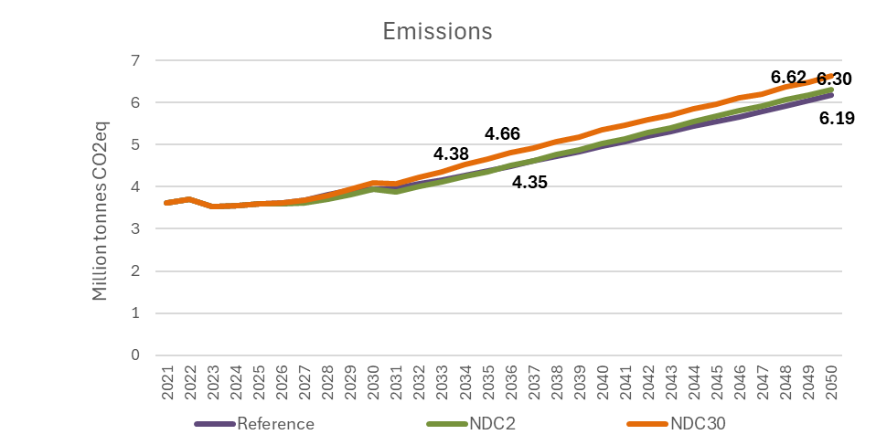
Figure 38. Crops Sector Emissions by Scenario, 2021–2050 (MtCO₂eq)
The NDC pathways accelerate the transition towards more intensive and higher-productivity agricultural systems. Improved irrigation, expanded use of improved seed varieties, increased mechanization, better agronomic practices, and greater use of synthetic fertilizers and organic nutrient inputs all contribute to significantly higher yields per hectare. By 2050, cropland area under both NDC scenarios stabilizes at approximately 11.5 million hectares, compared to 13.1 million hectares under the Reference scenario, reducing land requirements by approximately 1.6 million hectares. This reduction in land expansion represents the principal long-term climate benefit of the crop mitigation package, as lower pressure for agricultural expansion reduces deforestation and land conversion elsewhere in the system.

However, this agricultural intensification also increases direct emissions from the crop sector itself. Higher yields require greater nutrient inputs, particularly synthetic fertilizer application and expanded irrigation systems. Although improved nutrient management and fertilizer application efficiency reduce emissions intensity per unit of production, these gains are offset by the increase in total fertilizer use associated with higher-output agricultural systems. As a result, direct crop and soil emissions remain broadly similar across scenarios and are slightly higher under the NDC pathways than under the Reference scenario. Under NDC 2.0, emissions reach 6.30 MtCO₂eq by 2050, while under NDC 3.0 emissions rise further to 6.6 MtCO₂eq, compared to 6.2 MtCO₂eq under the Reference scenario.

Part of this increase also reflects the transfer of emissions within the agricultural system itself. Under the mitigation pathways, larger quantities of livestock manure are collected and applied to managed soils as organic fertilizer rather than remaining unmanaged within grazing systems. This improves nutrient recycling and can reduce some livestock-related emissions, but it simultaneously increases nitrogen inputs to agricultural soils, shifting a portion of emissions from the livestock sector into the agricultural soils category. In practice, some emissions are therefore redistributed across subsectors.

The NDC pathways should therefore not be interpreted as low-emission crop systems in a narrow accounting sense. Rather, they represent a transition towards more productive, input-intensive, and land-efficient agriculture. The trade-off is explicit: higher fertilizer use and more intensive management practices modestly increase direct agricultural emissions, but these increases are offset at the economy-wide level by avoided land conversion and improved food production efficiency.

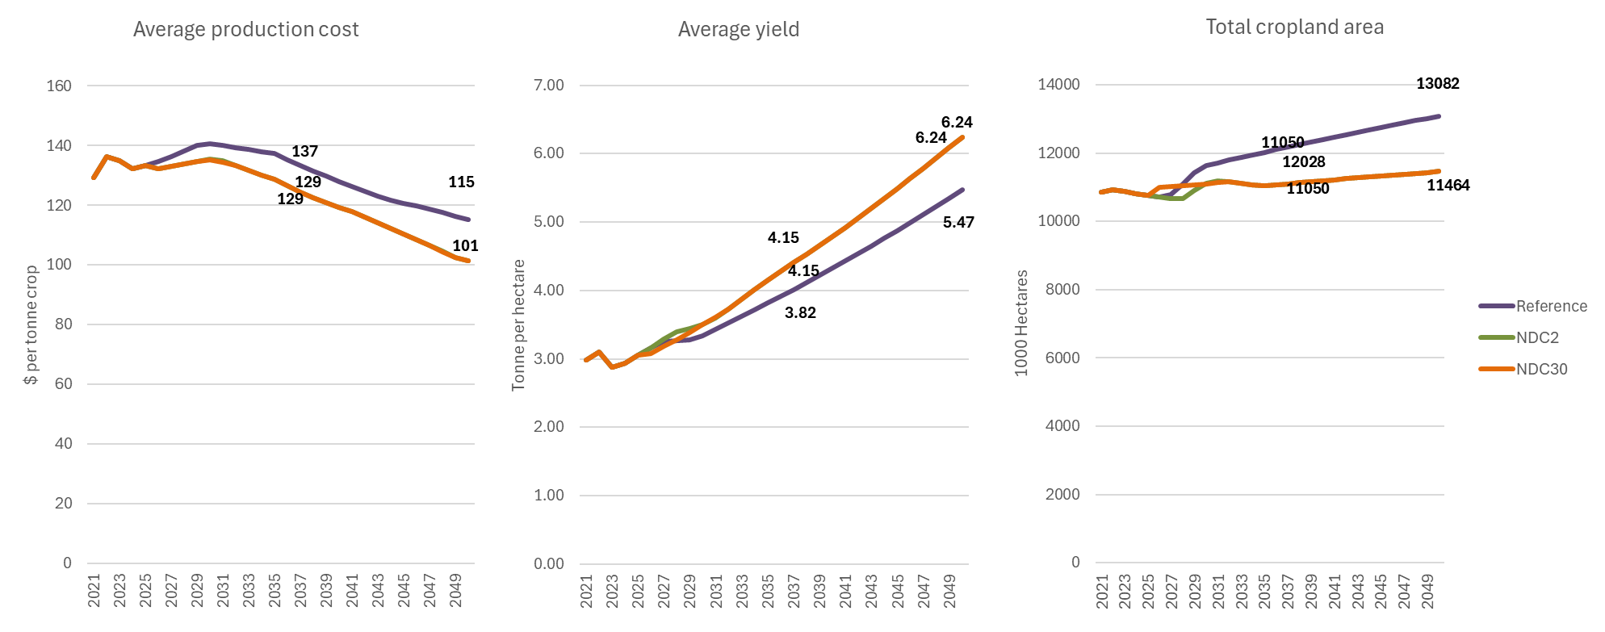
Figure 39. Average crop production cost ($ per tonne, left), average crop yield (centre) and total cropland area by scenario, 2021–2050
The transition lowers production cost and increases income and land rents for farmers. While climate-smart agriculture requires additional investment in irrigation systems, greenhouse infrastructure, improved seeds, mechanization, and nutrient management systems, the resulting productivity gains reduce long-run production costs by increasing output per hectare and lowering the land required to meet future food demand. Total crop sector costs decline from $8.2 billion under the Reference scenario in 2050 to approximately $7.3 billion under both NDC scenarios, while average production costs fall from $115 per tonne to approximately $101 per tonne as yields increase substantially. Average crop yields rise from 5.5 tonnes per hectare under the Reference scenario to 6.2 tonnes per hectare under the NDC pathways by 2050.

The crop mitigation package should therefore be understood primarily as an agricultural productivity and land-efficiency strategy rather than a direct emissions reduction strategy. Its principal benefits arise through higher yields, lower long-run production costs, improved food security, and reduced pressure for agricultural land expansion, with avoided land-use change emissions representing the largest climate benefit of the transition.

4.3.5 SISEPUEDE Results

4.3.5.1 Livestock

The drivers of livestock emissions reflect the combined effect of underlying demand growth for animal-source foods and the mitigating actions applied to each pathway. Cattle are the principal driver of livestock emissions in Uganda, with rising incomes, population growth, and shifting dietary patterns expected to increase total cattle population from approximately 14.5 million head in 2023 to around 42.3 million by 2050 under the Reference pathway. Cattle and other ruminants typically require extensive land for grazing, which can drive deforestation and land conversion, while enteric fermentation produces substantial methane emissions as herd sizes expand. The NDC 2.0 measures, including the livestock productivity and emissions improvements through improved cattle breeds, enhanced feeds, improved water availability, and the establishment of fodder agroforestry plantations, reduce emissions intensity per animal while modestly altering the trajectory of herd expansion. Under this pathway, total cattle population reaches approximately 41.0 million head by 2050. The NDC 3.0 measures extend these interventions through dietary programs that reduce the growth rate of per-capita beef demand by promoting alternative protein sources, alongside the enhanced livestock mitigation package incorporating more advanced and higher-cost technologies. The combined effect reduces total cattle population to approximately 28.0 million head by 2050, around 12 million head below the Reference trajectory, with the largest reductions occurring in the non-dairy segment (Figure 40). Total livestock populations across all species, including poultry, goats, sheep, pigs, and others, follow broadly similar trajectories across the three pathways, since the demand-side and breed-related interventions are concentrated on cattle (Figure 41).

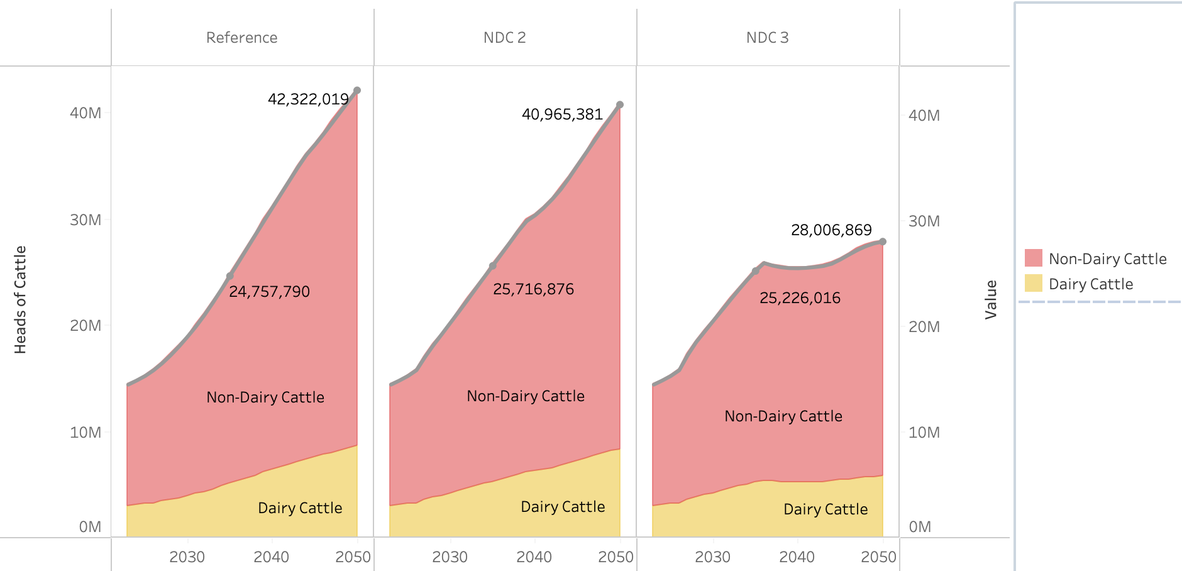
Figure 40. Total population of cattle in Reference (left), NDC 2.0 (center), and NDC 3.0 (right) pathways.
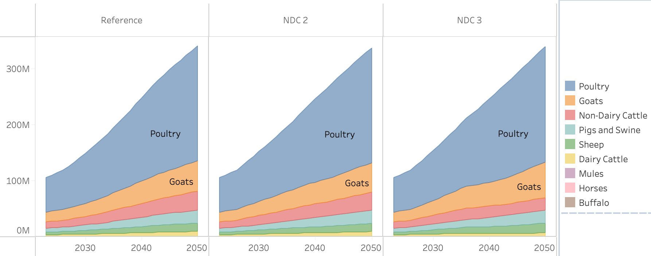
Figure 41. Total population of all livestock in Reference (left), NDC 2.0 (center), and NDC 3.0 (right) pathways.
Manure management practices represent a second key driver of livestock emissions and reflect the differential application of mitigating actions across pathways. Baseline manure management pathways in SISEPUEDE are based on regional averages from the IPCC, with much of the manure currently unmanaged or unavailable for use as a substitute for synthetic fertilizer or as an energy feedstock. The Reference and NDC 2.0 pathways retain broadly similar manure management profiles, with the dominant practices being daily spread, dry lot, paddock pasture range, and solid storage. The NDC 3.0 measures introduce a substantially expanded role for anaerobic digestion and composting, with anaerobic digestion enabling the recovery of methane from biogas for electricity generation and reducing the demand burden on the broader power system. By 2050, anaerobic digestion and composting together account for a substantial share of total manure management, displacing paddock pasture range, solid storage, and dry lot practices (Figure 42).

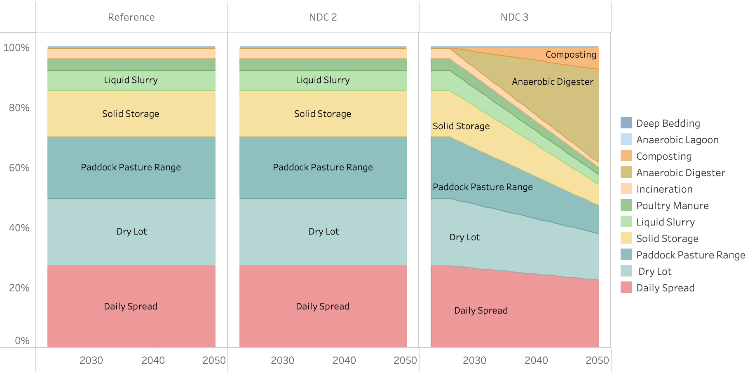
Figure 42. Manure management pathways
The emissions trajectories reflect the interaction of these herd-size and management dynamics with the enteric fermentation and manure management measures applied across pathways. Emissions in the livestock subsector are driven primarily by enteric fermentation from cattle but also include emissions from manure management. Under the Reference pathway, total emissions grow from 28.8 MtCO₂e in 2025 to 47.0 MtCO₂e in 2035 and 80.83 MtCO₂e in 2050, driven by the rapid expansion in livestock numbers consistent with the socioeconomic changes outlined in NDP IV and Vision 2040. The livestock subsector's share of positive emissions rises from 21.1% in 2025 to 27.4% in 2035 and 34.3% by 2050, making it one of the principal sectoral targets for abatement at mid-century. The NDC 2.0 measures, including feed and breed switching and the initial improvements to manure management, reduce methane emissions from enteric fermentation but produce only modest changes in the manure management profile, resulting in emissions of approximately 69 MtCO₂e by 2050. The NDC 3.0 measures compound these reductions through the dietary programs that lower cattle population growth, the expanded manure collection and anaerobic digestion (reaching nearly 70% by 2070), and the enhanced livestock technology package. The increased availability of managed manure also reduces the need for synthetic fertilizers while supporting productivity, reinforcing the land-use and deforestation reductions pursued under both NDC pathways. Emissions under NDC 3.0 plateau at approximately 38 MtCO₂e from the late 2030s onward, broadly stabilizing at around 47% below the Reference trajectory at mid-century. Additional reductions in the longer term could be achieved through advanced measures such as feed additives like seaweed or methanogenic vaccines, though these remain technologically uncertain (Figure 43).

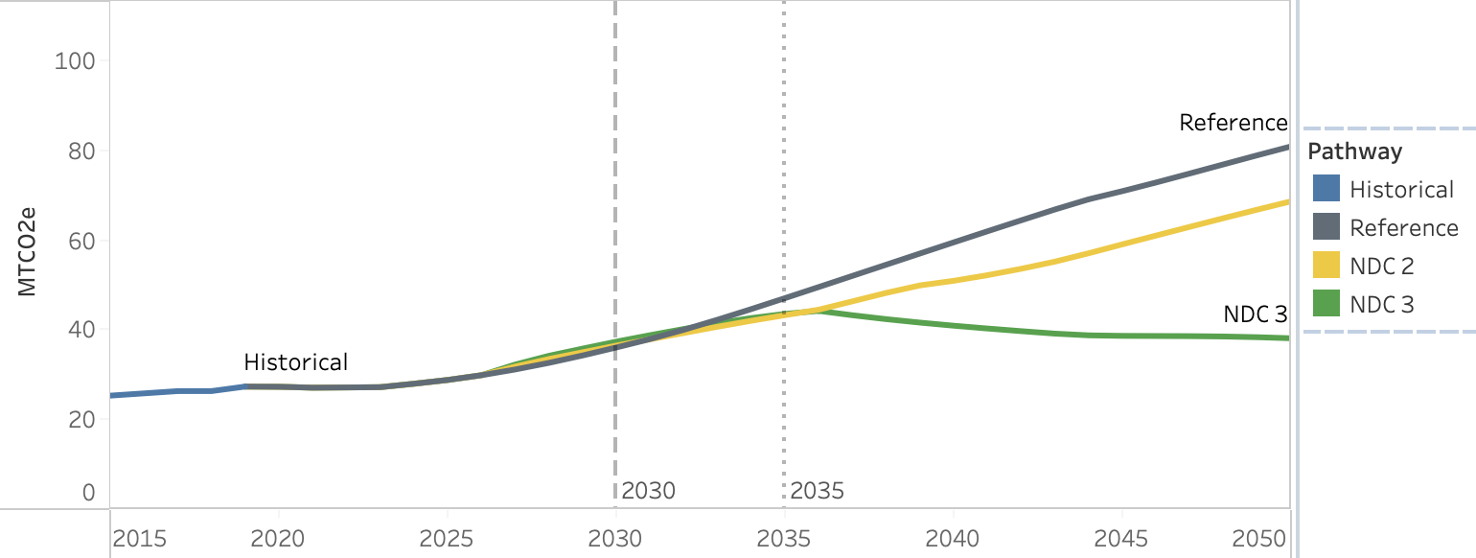
Figure 43. Emissions for Reference (gray), NDC 2.0 (yellow), and NDC 3.0 (green) in industrial the Livestock subsector (MtCO2e).

4.3.5.2 Crops

Crop production in Uganda combines subsistence farming with export-oriented commercial agriculture, with coffee, maize, cocoa, tea, and sugar central to export earnings alongside a wide range of tubers, fruits, cereals, and annual crops supporting domestic food security. The development priorities articulated under NDP IV and Vision 2040 envisage a substantial expansion of industrialized agriculture and food and beverage production, which, combined with the population and income growth assumptions described in Section 4.3.2, underpins the production trajectories represented across all three SISEPUEDE pathways.

Under the Reference pathway, these socioeconomic drivers translate into a rapid expansion of agricultural output, with total crop production in tonnage nearly doubling between 2025 and 2040 before continuing to grow more moderately through 2050 (Figure 44). Achieved largely through area expansion under Reference assumptions, this scale of production growth creates emissions risks through biomass and soil organic carbon loss from land conversion, increased synthetic fertilizer and lime applications, and nitrogen emissions from crop residues left on fields under conservation agriculture.

The NDC 2.0 measures described in Section 4.3.3, including improved fertilizer application, the expansion of rainwater harvesting and irrigation toward 50% of national irrigation potential by 2040, and the promotion of greenhouse vegetable cultivation, restructure this pathway by raising productivity per hectare rather than relying on continued land expansion. Total production under NDC 2.0 follows a broadly similar long-term trajectory to the Reference but is achieved on a smaller agricultural footprint, with crop yields rising substantially across the major categories. The NDC 3.0 measures extend these interventions through more advanced irrigation, drought-resistant seed varieties, and targeted increases in fertilizer use where productivity gains justify them, yielding modestly higher production than both the Reference and NDC 2.0 while requiring even less cropland expansion. NDC 3.0 also introduces dedicated methane reduction measures in rice production, most notably the Alternate Wetting and Drying (AWD) technique.

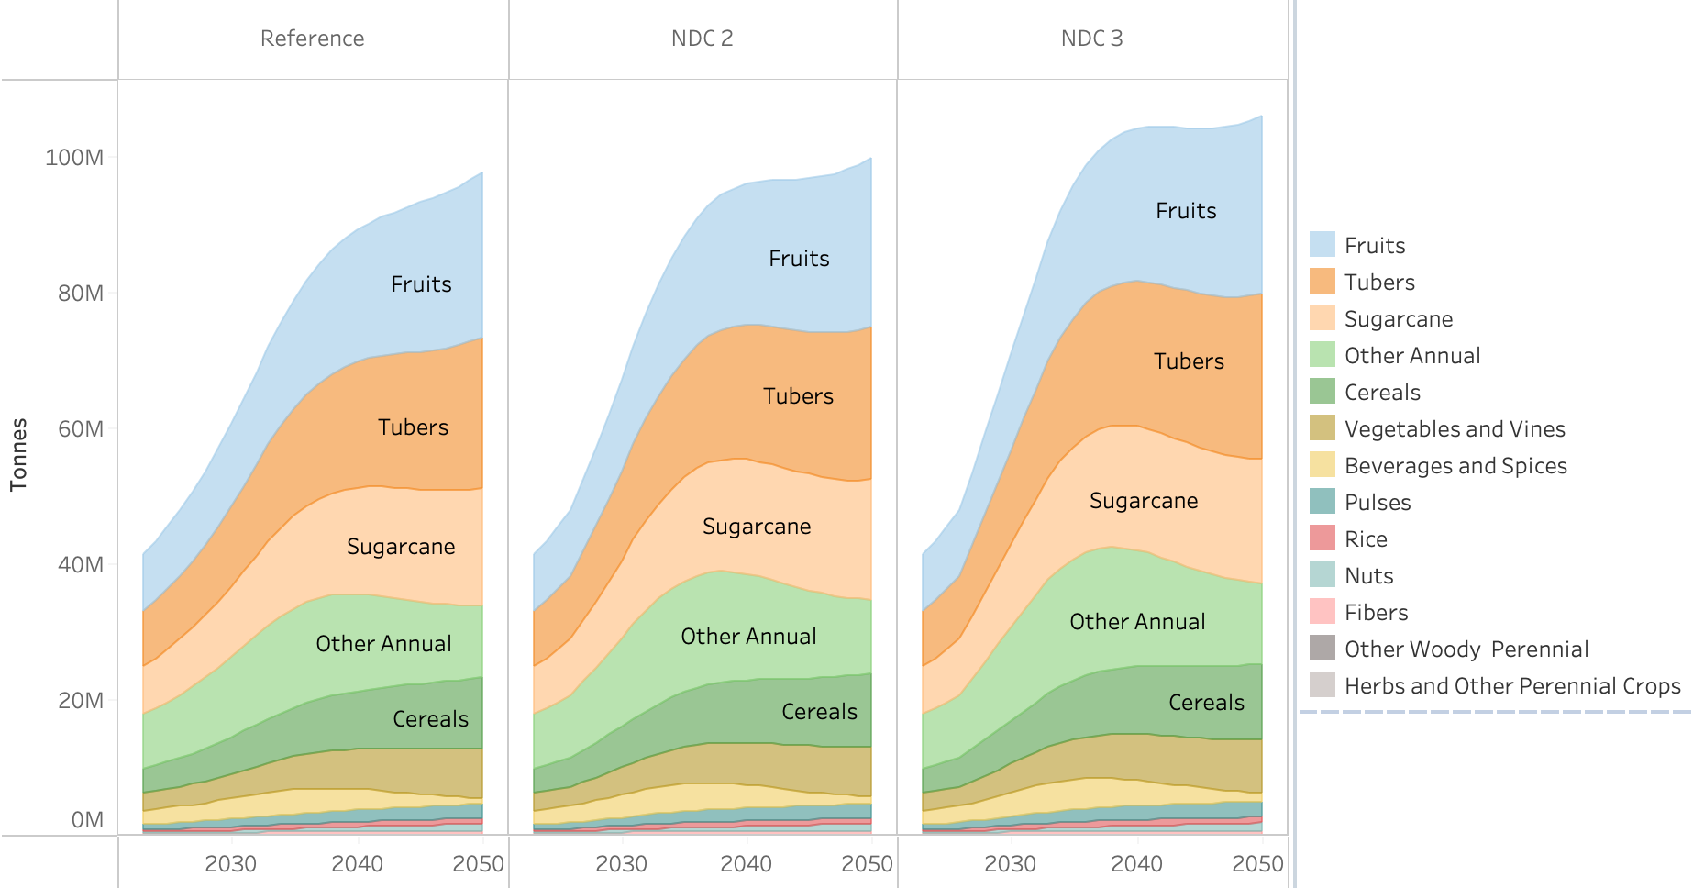
Figure 44. Crop production for Reference (left), NDC 2.0 (center), and NDC 3.0 (right) in total tonnage.
The emissions trajectories reflect the interaction between rapid production growth and these mitigation measures (Figure 45). Emissions from crops and managed soils stand at approximately 2.5 MtCO₂e in 2025 across all pathways and rise progressively under the Reference to 3.5 MtCO₂e by 2035 and 5.4 MtCO₂e by 2050, driven by the increase in nitrogen inputs, lime applications, and residue management associated with expanding production volumes. The NDC 2.0 and NDC 3.0 pathways remain close to the Reference through the mid-2030s before diverging more visibly in the second half of the modeling horizon. The rice methane measures under NDC 3.0 deliver a 9.2% reduction in rice methane emissions by 2035, rising to 24.5% by 2050 and 45% by 2070, accounting for much of the separation between the NDC 3.0 trajectory and the other pathways by mid-century.

A key feature of these results is that productivity increases do not automatically translate into proportional within-sector emissions reductions, because higher yields require greater nitrogen inputs and more intensive residue management. The principal climate benefit of the crop mitigation package is therefore realized outside the Crops subsector, through the avoidance of land conversion enabled by higher yields and reduced pressure for cropland expansion. Under NDC 2.0, deforestation emissions fall to approximately 0.4 MtCO₂e by 2035, and under NDC 3.0 to approximately 1.0 MtCO₂e, with both pathways eliminating deforestation entirely by 2050 and reducing annual emissions by approximately 4 MtCO₂e relative to the Reference at that point. These avoided emissions, reinforced by productivity gains in the livestock subsector, are reported within the Land sector analysis. The additional land freed by agricultural intensification also facilitates the restoration of wetlands and peatlands, a key driver of ecosystem services discussed in the Land sector results.

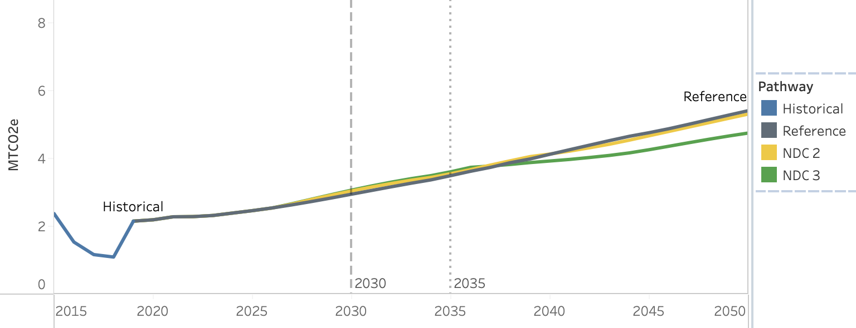
Figure 45. Emissions for Reference (gray), NDC 2.0 (yellow), and NDC 3.0 (green) in industrial the Crops subsector (MtCO2e).
The agricultural transitions described above generate substantial in-sector economic benefits across both the Crops and Livestock subsectors, with the magnitude and composition of those benefits differing markedly between the two NDC pathways (Figure 46). Under NDC 2.0, the dominant source of benefits is the increase in crop value, reflecting the higher tonnage and producer-price-weighted output achieved through irrigation expansion, greenhouse cultivation, and improved agronomic practices. Crop value reaches approximately $2.5 billion per year by 2035 and remains positive throughout the modeling horizon as productivity gains continue to outpace land contraction. Consumer savings, which capture lower household grocery costs from dietary shifts, reduced food waste, and the adoption of conservation agriculture, together with O&M savings from avoided fertilizer expenditures and conservation agriculture input efficiencies, add a further $0.9 billion by 2050. Capital costs remain near zero under NDC 2.0 because the crop-side measures rely primarily on incremental management practices, input substitutions, and modest infrastructure investments that do not generate the large discrete capital outlays associated with sectors such as power or transport.

Under NDC 3.0, the same benefit categories scale substantially, with crop value rising to approximately $4.6 billion per year by 2035, supported by the deeper productivity package combining advanced irrigation, drought-resistant seeds, and targeted fertilizer use. Consumer and O&M savings together reach approximately $1.48 billion by 2050, reflecting the broader adoption of dietary improvements, reduced food waste, and conservation agriculture under the more ambitious pathway. The most visible structural difference between the two pathways, however, lies in the emergence of negative livestock value and capital cost components from the mid-2030s onward. The dietary programs introduced under NDC 3.0 reduce the growth rate of per-capita beef demand and lower total cattle population by approximately 12 million head relative to Reference, producing a corresponding decline in monetized livestock production value. The enhanced livestock technology package and the expanded deployment of manure management infrastructure, including anaerobic digesters, also raise capital requirements, which appear as negative contributions in the cost-benefit accounting. These reductions partially offset the larger crop-side gains by mid-century, narrowing net benefits relative to the early-2030s peak while still delivering positive cumulative outcomes through the late 2040s. The shape of the NDC 3.0 trajectory therefore reflects the explicit trade-off embedded in the more ambitious pathway: deeper emissions reductions and stronger land-use benefits are achieved at the cost of reduced livestock output value and higher capital investment in agricultural transformation.

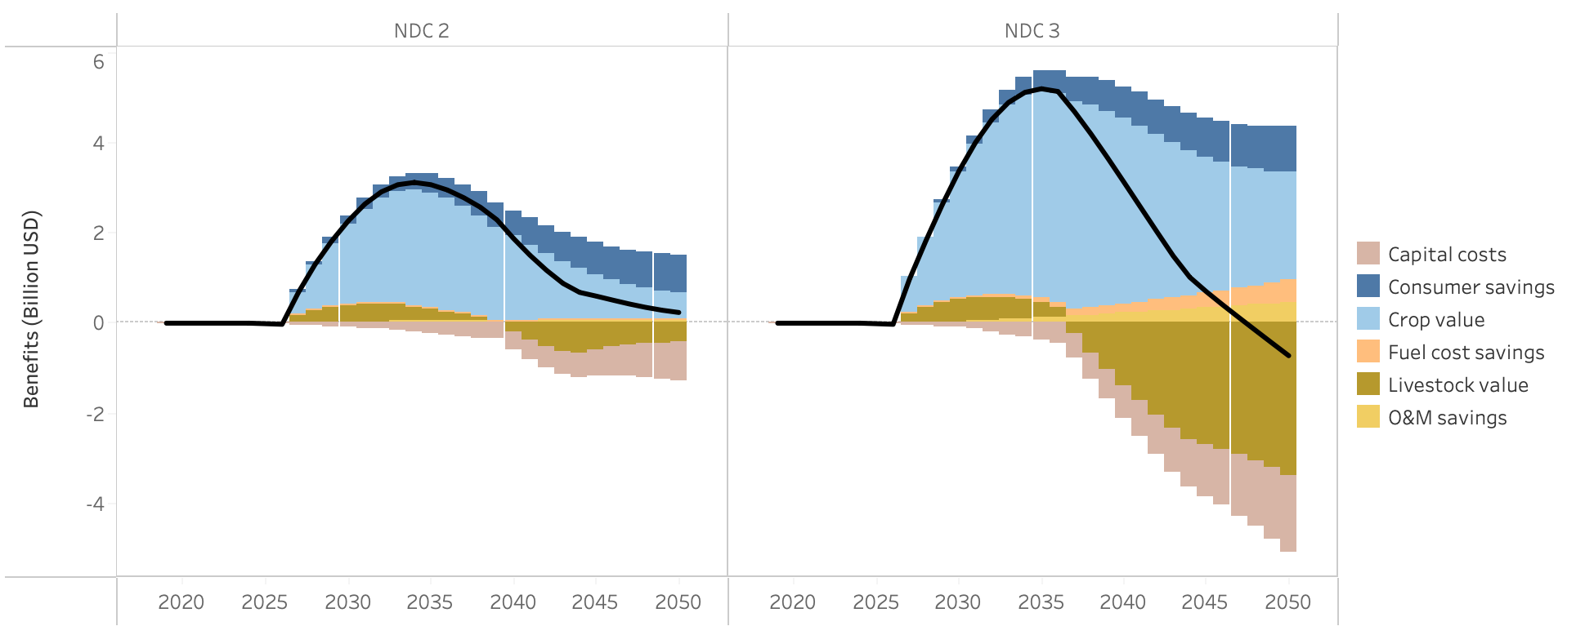
Figure 46. Benefits associated with increases in crop production when compared to Reference pathway for NDC 2.0 (left), and NDC 3.0 (right) in billion USD.

4.4 Land

4.4.1 Sector Background

Land use change and forestry is the single largest source of GHG emissions in Uganda, accounting for approximately 50% of total national emissions.4 This reflects a prolonged and ongoing process of deforestation and land conversion, driven primarily by agricultural expansion, demand for fuelwood and charcoal, and population growth. As of 2020, Uganda had approximately 2.4 million hectares of natural forest, covering around 10% of the country's land area. This represents a dramatic decline from historical levels, with forest cover having fallen from an estimated 45% of land area in the late nineteenth century to its current extent, at an estimated annual deforestation rate of approximately 1% per annum.

Cropland is the dominant land use category, covering approximately 46% of the country, with grasslands, wetlands, and peatlands also under growing pressure from land conversion. Wetlands, which provide critical ecosystem services including flood regulation, water filtration, and carbon storage, have experienced significant drainage and encroachment, with cover estimated at 8.9% of national land area as of 2020. Peatlands represent a particular concern given their high carbon density, though Uganda-specific drainage rates remain uncertain and represent a data gap in the current inventory.

The sector is also central to Uganda's mitigation potential. Land use transformation, through reforestation, protection of remaining forest, and wetland restoration, is identified across both models as the single largest mitigation lever available to Uganda, with NDC 3.0 projections showing near-zero land use change emissions by 2050 under an ambitious restoration scenario. The Updated NDC (2022) includes a range of LULUCF commitments, from tree planting targets to REDD+ participation and charcoal efficiency improvements.

4.4.2 Key Drivers and Assumptions
Land use change in Uganda is driven by competition among land uses, with agricultural expansion and fuelwood demand being the primary forces displacing forest and grassland cover. Deforestation rates are closely tied to population growth and biomass energy demand, both of which are projected to increase substantially over the modelling period. Wetland drainage is treated as a gradual background trend, though the absence of Uganda-specific drainage rate data introduces uncertainty into this component of the model. Sequestration from reforestation is based on IPCC default factors for tropical developing regions. The following table summarises the base year land cover and key emission and sequestration parameters used in the CLEWs and SISEPUEDE models.
- Land Cover
Parameter | 2021 Value
Land cover (thousand km²) | Total land cover is 241.6 thousand km²  - Forests: 27.10  - Cropland: 107.6  - Wetlands: 8.7 permanent (12.8 seasonal)  - Grasslands: 55.7  - Water bodies: 37.0  - Other land: 0.8  - Shrubland: 2.7  - Built up land: 1.9
Reforestation sequestration factor | −1.02 MtCO₂eq per 10³ km²
Land cover in 2050 is not fixed as an input but is determined endogenously through competition among land uses within the model.

4.4.3 Mitigating Actions
All NDC 2.0 measures are carried forward into the NDC 3.0 scenario, with no additional NDC 3.0-specific LULUCF measures beyond enhanced optimisation.
- Sustainable Fuelwood and Charcoal Production
Mitigation Measure | Scenario | Description
Commercial Smallholder and Community Bioenergy Woodlots | NDC 2.0 & NDC 3.0 | Expansion of tree-based bioenergy woodlots to provide a sustainable supply of fuelwood, reducing pressure on natural forests.
Improved Charcoal Kilns Linked to Bioenergy Woodlots | NDC 2.0 & NDC 3.0 | Improvement in charcoal conversion efficiency from approximately 12% in 2020 to 75% by 2030, reducing wood demand per unit of charcoal produced.
Commercial Timber Plantations | NDC 2.0 & NDC 3.0 | Reduces wood demand from natural forests by supplying timber and poles from commercial plantations
- Forest Restoration
Mitigation Measure | Scenario | Description
Natural Forest Regeneration and Restoration | NDC 2.0 & NDC 3.0 | Rehabilitation of 100,000 ha of degraded forest reserves through enrichment planting with indigenous species, the 40-million-tree campaign, and REDD+ strategic interventions

- Wetlands and Peatlands

Mitigation Measure | Scenario | Description
Wetland and Peatland Management | NDC 2.0 & NDC 3.0 | Restoration and protection of wetlands, increasing coverage from 8.9% in 2020 to approximately 12% by 2030
A detailed description of how each mitigation measure is implemented within the CLEWs model, including parameter specifications and modelling constraints, is provided in Appendix 2.

4.4.4 CLEWs Results
The land sector represents the single largest source of emissions in Uganda today, but also the country’s largest long-term mitigation opportunity. Under the Reference scenario, land-use emissions remain high throughout as population growth, agricultural expansion, charcoal demand, timber extraction, and wetland degradation continue to place pressure on forests and natural ecosystems. Emissions increase from approximately 54.2 MtCO₂eq in 2021 to a peak of nearly 68 MtCO₂eq around 2029 before gradually declining to 60.4 MtCO₂eq by 2035 and continuing to fall thereafter as biomass demand starts to drop as the clean cooking transition builds momentum. As biomass stocks are gradually depleted the growing scarcity ends up being a driver for change in itself. Despite this eventual decline, the sector remains a major net emissions source reflecting the continued degradation of natural capital and the unsustainable balance between biomass supply and demand.
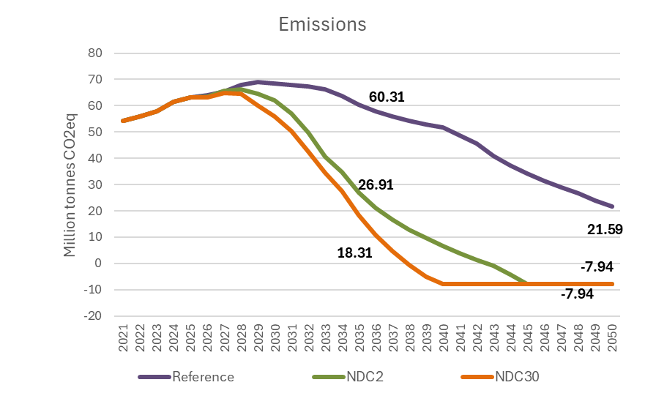
Figure 47. LULUCF Emissions by Scenario, 2021–2050 (MtCO₂eq)
The mitigation pathways fundamentally alter this trajectory through a highly synergistic package of interventions that simultaneously increase the sustainable supply of renewable biomass while sharply reducing demand for wood harvested from natural forests. On the supply side, commercial timber plantations, community and commercial bioenergy woodlots, forest restoration programmes, and wetland rehabilitation expand the stock of managed and restored ecosystems while improving the sustainability of biomass production systems. On the demand side, improved charcoal kilns dramatically increase charcoal conversion efficiency, while clean cooking transitions in the buildings sector reduce overall demand for charcoal and fuelwood. Agricultural intensification measures also reduce cropland expansion pressures by increasing yields on existing agricultural land.
The interaction between these measures is critical. None of the interventions alone would be sufficient to reverse Uganda’s land-use emissions trajectory at national scale. However, together they produce a structural shift in the balance between biomass demand and ecosystem regeneration. Improved charcoal kilns reduce the amount of wood required per unit of charcoal produced, sustainable woodlots and plantations provide alternative biomass supply sources, and cleaner cooking technologies reduce overall consumption of charcoal and fuelwood. Simultaneously, higher agricultural productivity reduces pressure for continued cropland expansion into forests and wetlands. The result is a rapid reduction in deforestation and land degradation pressures across multiple sectors of the economy at the same time.
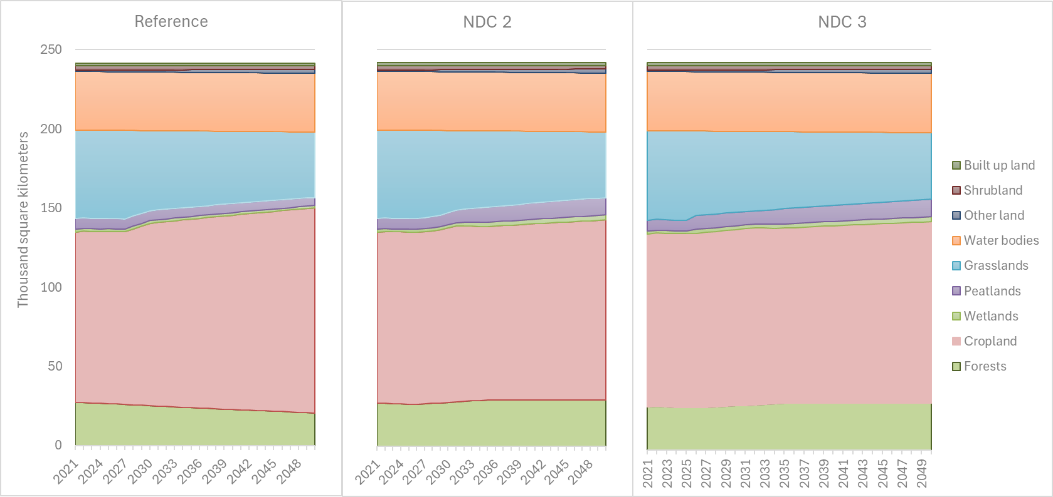
Figure 48. Land use allocation by category under the Reference, NDC 2.0, and NDC 3.0 scenarios (2021–2050) (million hectares)
This combined effect produces an exceptionally large transformation in the national emissions profile. Under NDC 2.0, emissions decline rapidly after 2030, falling to 26.9 MtCO₂eq by 2035, less than half the Reference level, before the sector transitions from a major net emissions source to a net carbon sink in the early 2040s. By 2050, the sector sequesters nearly 8 MtCO₂eq annually. Forest area increases from approximately 2.63 million hectares in 2026 to 2.91 million hectares by 2035, while wetland restoration and protection substantially increase wetland coverage and ecosystem integrity. The NDC 3.0 pathway accelerates this transition further through earlier and more aggressive restoration measures and deeper reductions in biomass demand linked to faster clean cooking adoption. As a result, the sector becomes a net carbon sink approximately five years earlier than under NDC 2.0, reaching net sequestration by the late 2030s and stabilising near -7.9 MtCO₂eq by 2050.
The role of clean cooking is particularly important within this transition. In practice, household biomass demand is one of the principal drivers of forest degradation and charcoal production pressures in Uganda. The rapid expansion of electric cooking, LPG, and improved biomass technologies therefore generates very large indirect mitigation benefits in the land-use sector by reducing unsustainable wood harvesting. This highlights the strong interdependence between the energy and land-use systems: household energy transitions become one of the most important drivers of forest recovery and avoided land-use emissions.
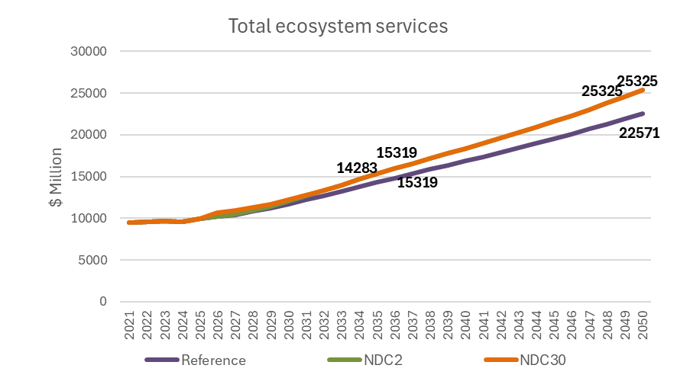
Figure 49. Total ecosystem services under the Reference, NDC2.0, and NDC3.0 scenarios (2021–2050)
Beyond emissions reductions, the mitigation pathways generate ecosystem service benefits of an order of magnitude that vastly exceeds the direct implementation costs of restoration and protection measures. While many of the direct programme costs associated with reforestation, wetland rehabilitation, woodlot development, and ecosystem protection are relatively modest, generally on the order of tens to low hundreds of millions of dollars annually, the resulting ecosystem service benefits are measured in the billions of dollars per year. Under the mitigation scenarios, ecosystem service values rise to approximately $25.3 billion annually by 2050, substantially above the Reference trajectory. These benefits include improved water regulation, reduced soil erosion, biodiversity protection, enhanced climate resilience, flood mitigation and broader support for agricultural productivity and rural livelihoods

4.4.5 SISEPUEDE Results

Land use and land use change are the largest single source of emissions in Uganda today, with deforestation and forest degradation accounting for approximately 48.5% of all positive emissions in 2025 (66.3 MtCO₂e out of total positive emissions of 136.6 MtCO₂e). These emissions are driven primarily by the historical reliance on fuelwood removals as the dominant source of household energy for cooking, much of which is still undertaken using inefficient stoves or open fires. Expansion of croplands and grazing land represents the second principal driver, compounded by the grazing-land degradation, water access constraints, and irrigation gaps identified by the Ministry of Agriculture, Animal Industry, and Fisheries in stakeholder consultations. These dynamics establish the baseline against which the NDC 2.0 and NDC 3.0 measures described in Section 4.4.3 operate.

The NDC 2.0 pathway addresses these drivers through a combination of energy- and land-side interventions. The clean cooking measures described in Section 4.1.3 electrify 50% of residential biomass cooking and 35% of commercial biomass cooking by 2035, while improvements to remaining cookstove and charcoal kiln efficiencies further reduce per-unit biomass demand. On the land side, the natural forest regeneration measure, the 364,000 ha of commercial timber plantations (20% of the REDD+ target) by 2035, and the productivity gains in crops and livestock from Section 4.3.3 collectively reduce pressure for forest conversion. In SISEPUEDE, NDC 2.0 is modeled as aligned with achieving REDD+ afforestation and forest restoration targets no later than 2050, delivering 1.080 million ha of new forest by 2040 and a total forested area of approximately 3.78 million ha. The NDC 3.0 pathway extends these measures with more aggressive electrification, allowing electricity to overtake biomass as the primary energy source in commercial and residential buildings by 2038, and doubles the forest restoration target to 2.16 million ha of new forest by 2050, reaching a total forested area of approximately 4.86 million ha. Most of this additional forested area is converted from croplands, a transition made feasible by the productivity gains in the crops subsector.

These energy- and land-side interventions reshape land allocation across the three pathways (Figure 50). Under the Reference, cropland continues to expand at the expense of secondary forests, unmanaged grasslands, and pastures, reflecting the agricultural expansion assumptions from Section 4.4.2. Under NDC 2.0 and NDC 3.0, cropland area declines as productivity improvements reduce land requirements, freeing space for the expansion of secondary forests, restored wetlands, and shrublands. The NDC 3.0 pathway shows the most pronounced reallocation, with the largest reduction in cropland and the largest expansion of secondary forests by 2050.

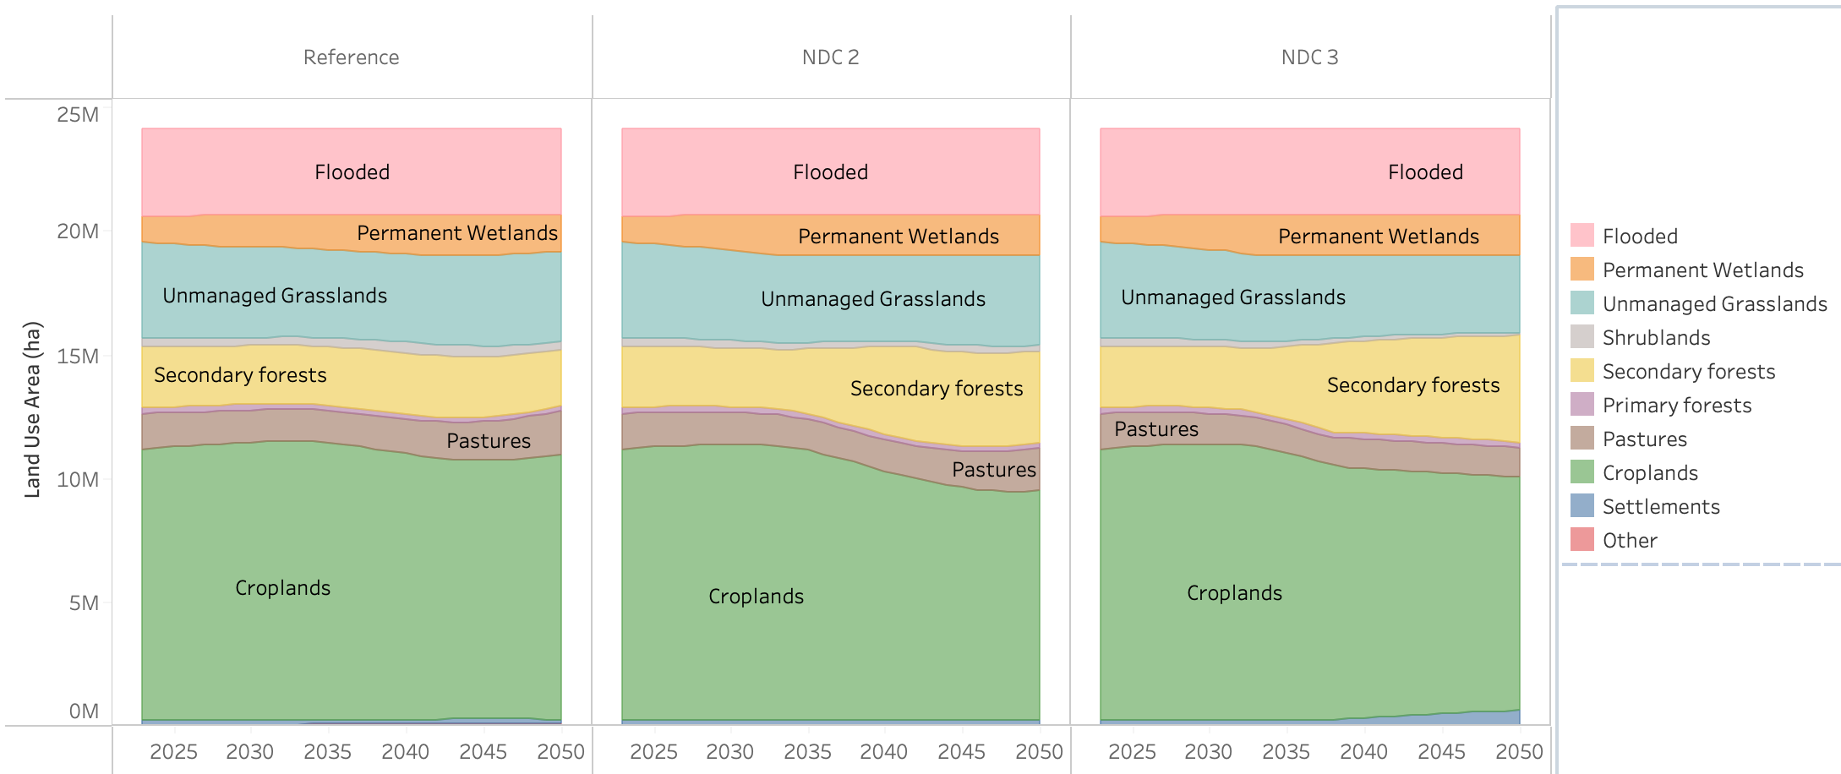
Figure 50. Land use areas by class in Reference (left), NDC 2.0 (center), and NDC 3.0 (right) in million ha.
The land allocation shifts translate directly into the forest sequestration trajectories (Figure 51). Under the Reference pathway, annual forest sequestration remains broadly stable at around 10.2 MtCO₂e per year throughout the modeling period, reaching 10.49 MtCO₂e in 2035 and 10.02 MtCO₂e in 2050. The NDC 2.0 measures deliver an additional 9.5 MtCO₂e of sequestration by 2035, reaching 19.84 MtCO₂e, and an additional 18.8 MtCO₂e by 2050, reaching 28.78 MtCO₂e. NDC 3.0 expands this further to 22.44 MtCO₂e by 2035 and 38.76 MtCO₂e by 2050, an increase of nearly 29 MtCO₂e over the Reference at mid-century and establishing the sequestration capacity required for a potential net-zero pathway by 2070.
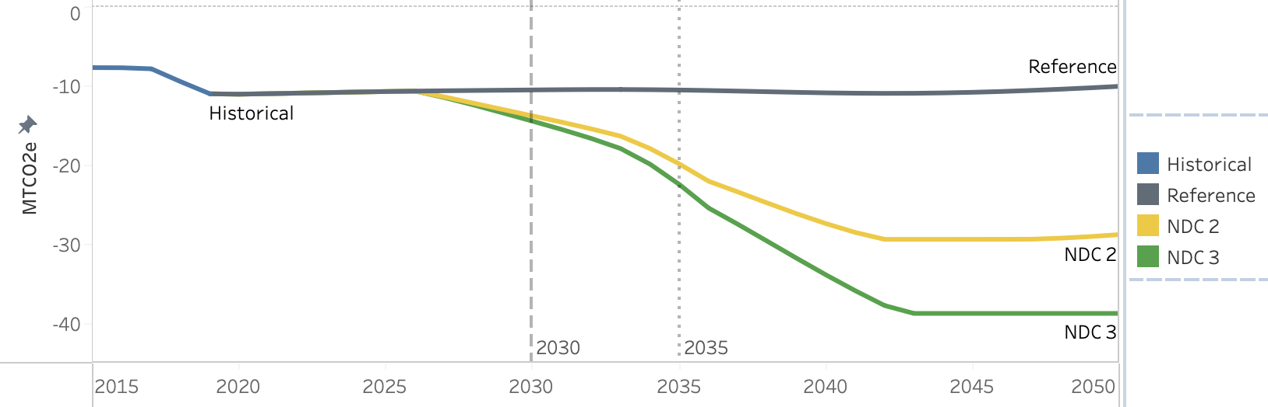
Figure 51. Net emissions for Reference (gray), NDC 2.0 (yellow), and NDC 3.0 (green) due to annual sequestration capacity in forests (MtCO2e).
The combined effect of reduced removals and expanded sequestration is most clearly captured in the cumulative above-ground biomass carbon stock loss (Figure 52). Under the Reference pathway, aggregate carbon loss from 2025 to 2050 reaches approximately 178 Mt C, roughly half of Uganda's above-ground biomass carbon stock. The NDC 2.0 pathway peaks at a substantially lower cumulative loss and gradually reverses through the second half of the modeling horizon as sequestration outpaces removals. The NDC 3.0 pathway improves further, peaking at 75.6 Mt cumulative loss in 2034 before declining to near zero by 2050. Both NDC pathways therefore preserve more than 100 Mt of biomass carbon stock between 2025 and 2050 relative to the Reference, leveraging energy-system transitions to cut removal rates while simultaneously building new sequestration capacity through plantation and restoration.

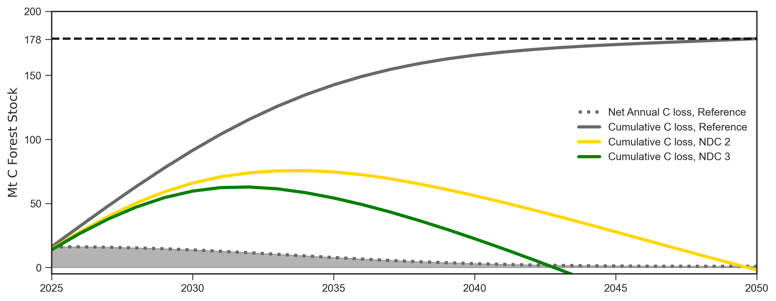
Figure 52. Total above-ground biomass C stock loss estimated for Reference (grey), NDC 2.0 (yellow), and NDC 3.0 (green) in Mt.
Fuelwood removals are the principal driver of these biomass losses (Figure 53). Under the Reference pathway, emissions from removals grow from 66.25 MtCO₂e in 2025 to a peak of 69.4 MtCO₂e in 2029 before declining to 56.91 MtCO₂e in 2035 and 13.67 MtCO₂e in 2050. This decline reflects the clean cooking transitions embedded in NDP IV, Vision 2040, and the 2023 Least Cost Generation Transmission Plan even in the absence of additional NDC measures. Under NDC 2.0, accelerated electrification and improved cookstove efficiency reduce emissions from removals to 37.85 MtCO₂e by 2035 and 6.69 MtCO₂e by 2050. NDC 3.0 delivers a near-complete shift away from fuelwood by mid-century, with emissions declining from a 2026 peak of 67.28 MtCO₂e to 32.51 MtCO₂e by 2035 and 1.96 MtCO₂e by 2050.

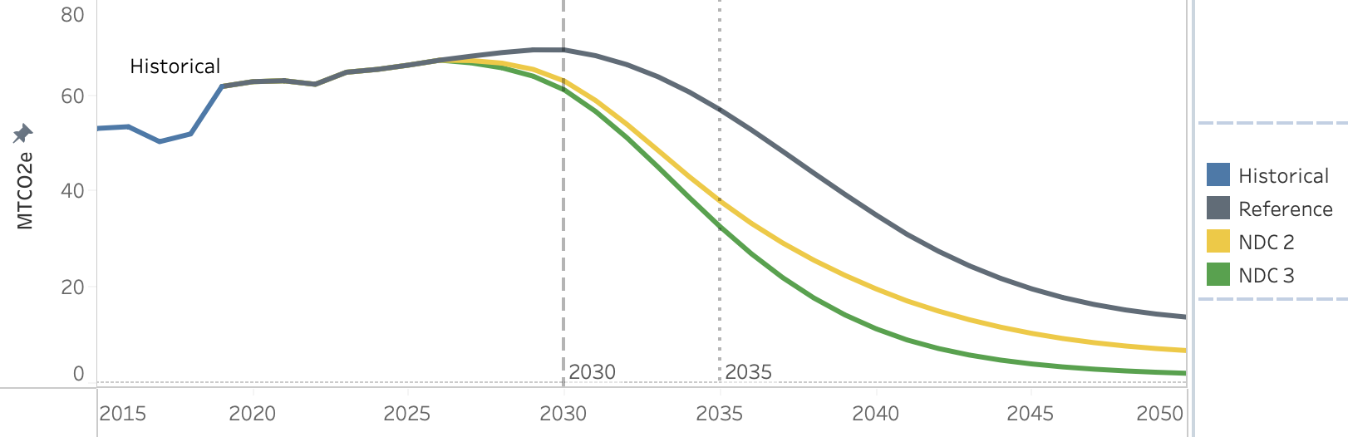
Figure 53. Emissions for Reference (gray), NDC 2.0 (yellow), and NDC 3.0 (green) due to removals for fuelwood and harvested wood products (MtCO2e).
Emissions from deforestation for land use conversion follow a related but distinct dynamic (Figure 54). Historically, between 86% and 89% of forest removals were used for fuelwood between 2015 and 2019, which partially masked the impact of land conversion on emissions accounting. As fuelwood demand falls across the energy system, this fraction declines to 32% by 2050 in the SISEPUEDE baseline, increasing the apparent emissions per unit of forestland converted. Under the Reference pathway, deforestation emissions rise progressively through the second half of the modeling horizon as cropland and pasture expansion continues. Under NDC 2.0 and NDC 3.0, the combination of agricultural productivity gains, livestock intensification, and forest restoration eliminates deforestation by approximately 2046 under NDC 2.0 and by approximately 2042 under NDC 3.0, with annual emissions reduced by approximately 4 MtCO₂e relative to the Reference at mid-century.

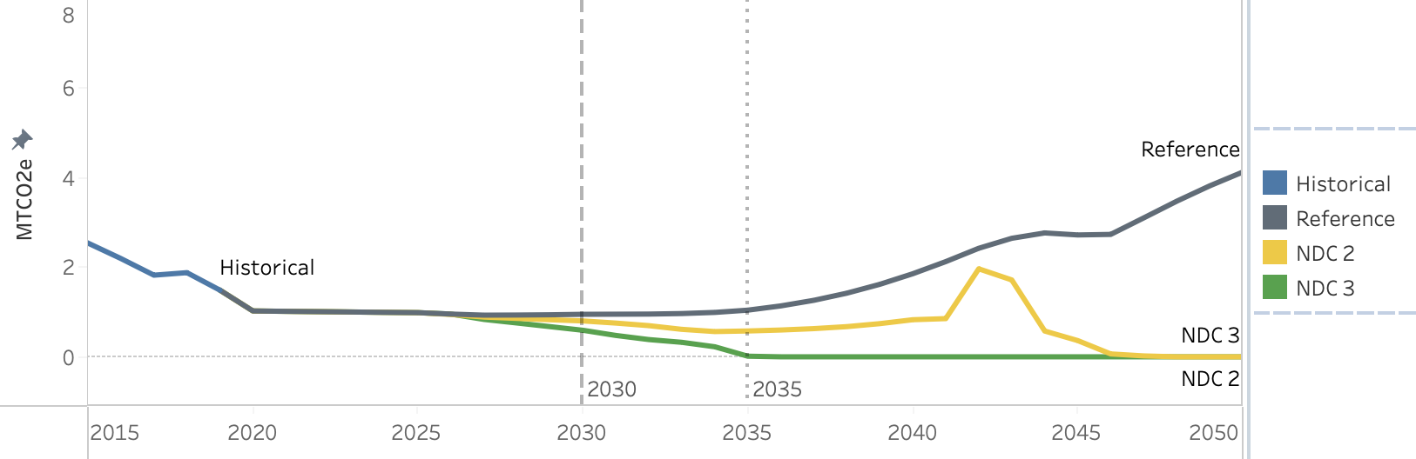
Figure 54. Emissions for Reference (gray), NDC 2.0 (yellow), and NDC 3.0 (green) due to deforestation for land use conversion (MtCO2e).
Wetland and peatland restoration represents a complementary policy priority that operates alongside the forest measures (Figure 55). The NDC 2.0 pathway achieves the target permanent wetland area of approximately 1.64 million ha (around 6.8% of total area), with total wetland and peatland area, including seasonal wetlands, reaching approximately 3 million ha by 2035 under NDC 2.0 and NDC 3.0. The NDC 3.0, on the other hand, in creases the target permanent wetland area to 7.8% of the area of Uganda, or about 1.88 million ha. The composition of seasonal wetlands shifts across pathways, with reduced overlap with croplands under the NDC scenarios reflecting the broader land-efficiency gains achieved through agricultural intensification. The timing differences between pathways have important implications for the cumulative ecosystem service benefits realized over the modeling horizon, with earlier restoration under NDC 3.0 generating larger net benefits by mid-century.

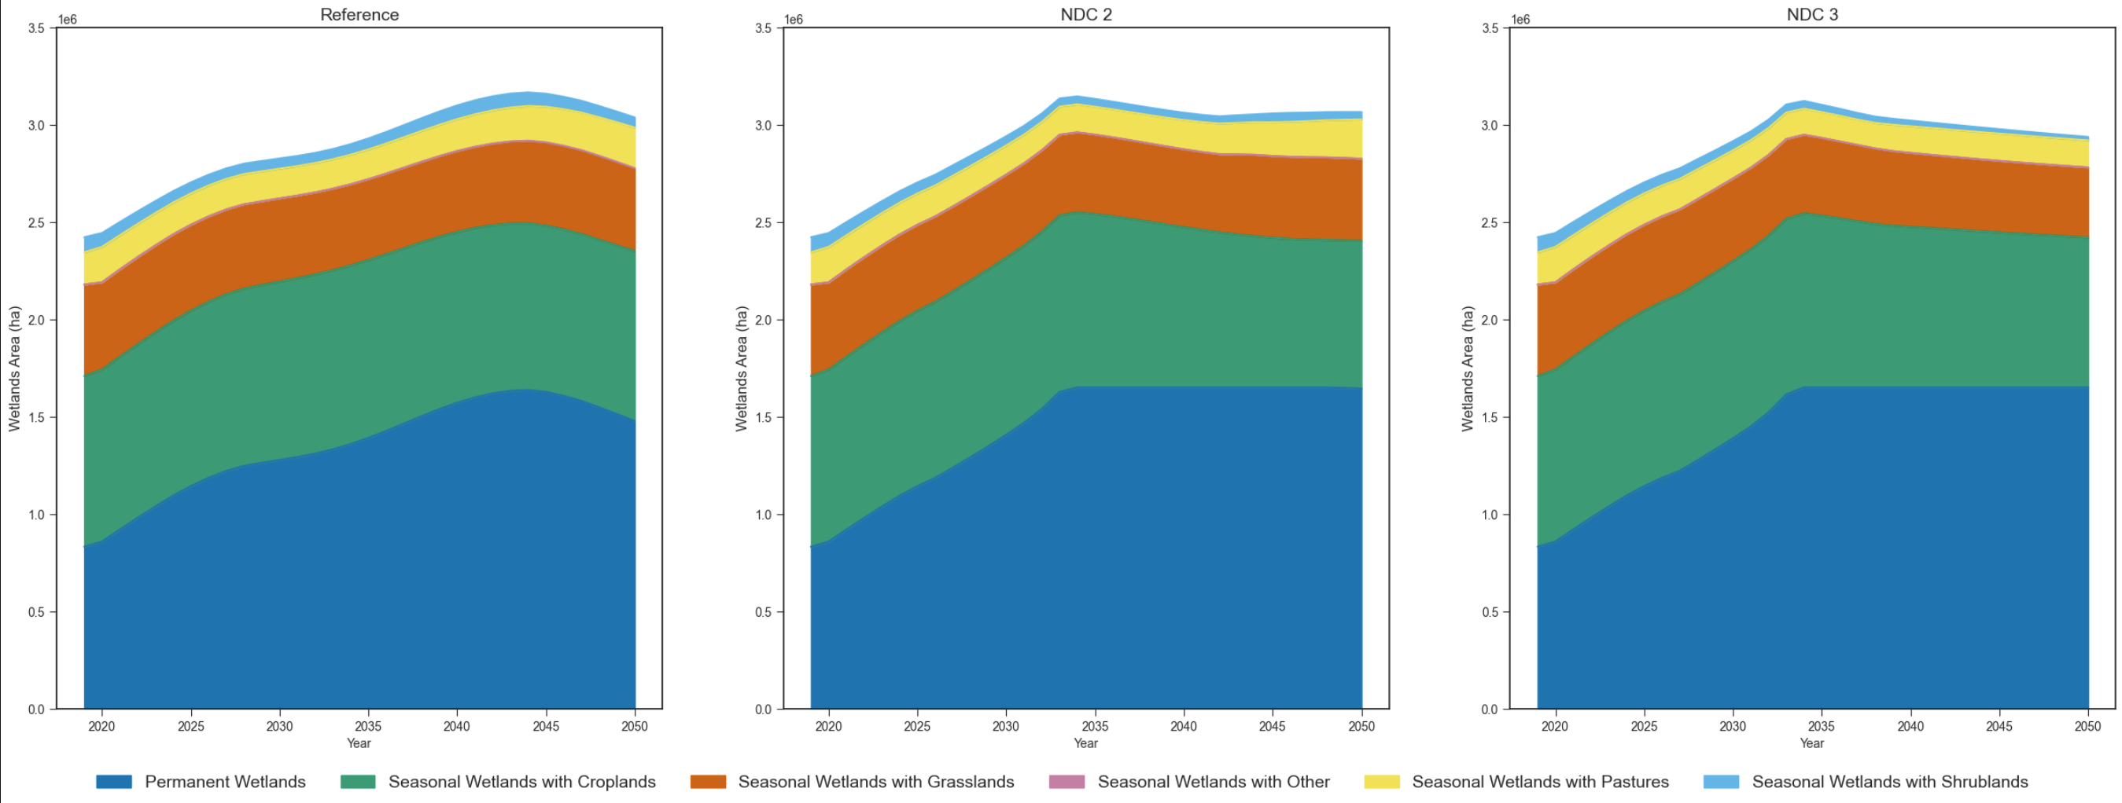
Figure 55. Total permanent and seasonal wetlands area for Reference (left), NDC 2.0 (center), and NDC 3.0 (right) in million ha.
The land-use transitions described above generate substantial monetized benefits across both NDC pathways, with the timing, composition, and net trajectory of those benefits differing markedly between NDC 2.0 and NDC 3.0 (Figure 56). Under both pathways, benefits are dominated by ecosystem services from wetland restoration, which peak at approximately $3.15 billion in 2033 under NDC 2.0 and $3.11 billion in 2034 under NDC 3.0. Wetlands provide some of the highest-value ecosystem services of any land-use class worldwide, including fish availability, water provision for crops and livestock, papyrus production, and flood regulation, and the achievement of the Ministry of Water and Environment's wetland restoration target by 2035 under both pathways accelerates the accrual of these benefits relative to the Reference. Forest ecosystem services represent a second important benefit stream, growing progressively as afforestation and forest restoration scale up, reaching $440 million by 2050 under NDC 2.0 and $799 million under NDC 3.0, with the higher value under NDC 3.0 reflecting the doubled forest restoration target described in Section 4.4.3.

The most distinctive structural feature of the cost-benefit profile is the V-shaped trajectory visible in both pathways and particularly pronounced under NDC 3.0. This pattern is driven by short-term losses in grassland ecosystem services as land is reallocated to meet the afforestation and reforestation targets. Under NDC 3.0, these grassland losses bottom out at approximately $2.26 billion in 2042 before reversing as the newly established forests mature and as the broader land-use system stabilizes, with grassland ecosystem services contributing positively again by mid-century and reaching $1.462 billion by 2050. Capital costs associated with reforestation and restoration also appear as negative contributions during the transition years, particularly under NDC 3.0 where the scale of forest establishment is largest. Reductions in land pollution from lower fertilizer demand provide a smaller but consistently positive contribution, reaching $8.8 million by 2050 under NDC 3.0 and peaking at $1.5 million in 2044 under NDC 2.0.

The net effect of these dynamics is a divergent trajectory between the two pathways by 2050. Under NDC 2.0, net benefits remain positive throughout the modeling horizon but decline progressively after the mid-2030s peak as the wetland restoration gains stabilize and grassland conversion costs accumulate, reaching approximately $2 billion by 2050. Under NDC 3.0, the deeper short-term reductions in grassland ecosystem services give way to substantially larger long-term gains as the land-use system reaches its new equilibrium, with net benefits reaching approximately $3.8 billion by 2050. The land-sector cost-benefit profile therefore reflects an explicit intertemporal trade-off under the more ambitious pathway: short-term ecosystem service losses associated with rapid forest establishment are followed by substantially larger long-term benefits as the restored land systems begin delivering their full ecosystem service value.

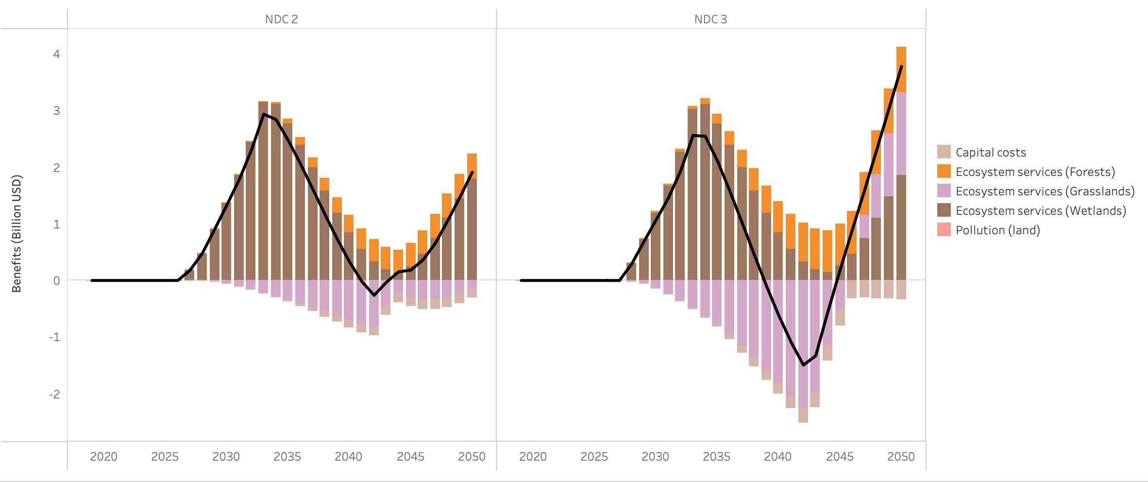
Figure 56. Costs and benefits associated with land use and land change in NDC 2.0 (left), and NDC 3.0 (right) in billion USD.
The Land sector in SISEPUEDE therefore acts as the central integrating system for Uganda's long-term decarbonization. Its emissions trajectory is determined less by direct land-sector policies in isolation than by the combined effect of clean cooking adoption in the buildings sector, productivity improvements in crops and livestock, and the deliberate scaling of forest restoration and wetland rehabilitation. The result is a sector that transitions from the largest single source of national emissions today to a substantial and growing net carbon sink by 2050 under NDC 3.0, providing the sequestration capacity required to offset residual emissions from hard-to-abate sources elsewhere in the economy.

4.5 Waste Sector

4.5.1 Sector Background

Uganda's waste sector is under increasing pressure from rapid population growth, urbanisation, and rising incomes, all of which are driving higher rates of waste generation with limited corresponding expansion in collection and treatment infrastructure. On the solid waste side, Kampala generates between 2,000 and 2,500 tonnes of waste per day, of which only an estimated 50% is formally collected, with the remainder openly dumped or burned. Waste composition is dominated by organic matter, with approximately 43% classified as biodegradable, and there is currently no systematic separation at source or significant diversion to controlled disposal facilities.

On the liquid waste side, access to centralised sewerage remains extremely limited. Only around 1% of urban Greater Kampala Metropolitan Area (GKMA) residents are connected to a centralised sewage system, with the vast majority relying on pit latrines, septic tanks, and private pit-emptying services. No biogas capture or wastewater treatment systems are currently operational at scale nationally. Both subsectors therefore represent significant sources of uncontrolled methane emissions, as well as major public health and environmental risks, making waste management a priority area for both mitigation and development co-benefits under the NDC.

4.5.2 Key Drivers and Assumptions

Waste generation across both subsectors is driven primarily by population growth, with rising incomes and urbanisation influencing per capita generation rates and waste composition over time. In the absence of Uganda-specific national data for several parameters, IPCC low-income defaults and proxy estimates from the GIZ Uganda 2023 Sector Brief were applied, with assumptions documented transparently. The following tables summarise the base year assumptions used in the CLEWs and SISEPUEDE models.
- Liquid Waste
Parameter | 2021 Value
Total wastewater generation2 | 611.23 kt BOD/year
Treatment system mix | 80% unmanaged/latrine; 12% septic; 4% anaerobic; 4% aerobic
Biogas capture at treatment | 0% — assumed zero
- Solid Waste
Parameter | 2021 Value
Total MSW generated2 | 25.39 Mt/year (population 45.91 million)
Per capita waste generation | 0.55 kg/person/day
Waste composition | 43% biodegradable; 42% mixed fines; 6% plastics; 3% animal waste; 3% sanitary waste; 2% paper/cardboard; 1% other
Formal collection rate | - 42% (municipal, domestic, industrial; based on Kampala data)  - 4% (textiles, metals, plastics, e-waste; informal recyclers/artisans)
Landfill gas/biogas capture | 0% — assumed zero
Emission factor — unmanaged dump | 73.7 kg CH₄/tonne
Emission factor — managed landfill24 | 65.0 kg CH₄/tonne
Emission factor — open burning24 | 5.0 kg CH₄/tonne
Emission factor — composting24 | 1.0 kg CH₄/tonne
Emission factor — anaerobic digestion24 | 0.3 kg CH₄/tonne

4.5.3 Mitigating Actions
All NDC 2.0 measures are carried forward into the NDC 3.0 scenario, with one additional measure applied on top.
Mitigation Measure | Scenario | Description
Expansion of Sewer and Wastewater Treatment Coverage | NDC 2.0 & NDC 3.0 | Increase wastewater treatment coverage from 15% in 2020 to 90% by 2050, shifting wastewater from untreated discharge to controlled treatment systems and reducing methane and nitrous oxide emissions
Solid Waste Collection Coverage | NDC 2.0 & NDC 3.0 | Increase solid waste collection from 30% in 2020 to 40% by 2035, reducing open dumping and enabling diversion of waste to controlled disposal, recycling, and recovery pathways.
Enhanced Solid Waste Collection Coverage | NDC 3.0 only | Further increase solid waste collection to 50% by 2035, enabling higher levels of controlled disposal, recycling, and resource recovery compared to NDC 2.0.
A detailed description of how each mitigation measure is implemented within the two models, including parameter specifications and modelling constraints, is provided in the Appendix 2.

4.5.4 CLEWs Results

4.5.4.1 Solid Waste

Without intervention, solid waste emissions grow from 7.95 MtCO₂eq in 2021 to 14.10 MtCO₂eq by 2035 and 27.59 MtCO₂eq by 2050 as Uganda's rapidly expanding urban waste stream, dominated by organic material disposed of through open dumping and burning, grows unchecked. In the Reference scenario there is a moderate increase in the waste collection rate, but no additional action or incentive to improve waste disposal. The health and environmental costs compound accordingly, with the external costs of unmanaged waste reaching to $2.3 Billion by 2050.

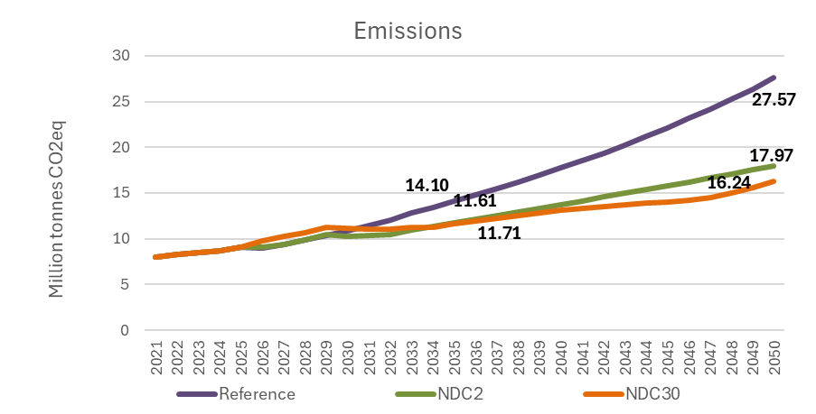
Figure 57. Solid Waste Sector Emissions by Scenario, 2021–2050 (MtCO₂eq)
Expanding formal waste collection coverage from 30% to 40% by 2035 (NDC 2) and disposing collected waste to sanitary landfills with methane capture requires building collection networks, transfer infrastructure, and landfill capacity. This investment raises total waste management costs from $229 million under the Reference to $323 million under NDC 2.0 by 2035, and from $537 million to $949 million by 2050, increasing the average disposal cost per tonne from $14.58 to $21.34 by 2035 and from $17.58 to $34.49 by 2050. In return, the measure transforms the disposal mix progressively from 2026: sanitary landfill expands from zero to 6.8 MtCO₂eq by 2035 and 24.9 MtCO₂eq by 2050, while unmanaged landfills decline and are effectively eliminated by 2033. Methane capture begins generating negative emission offsets from 2030, reaching -3.2 MtCO₂eq by 2035 and -11.6 MtCO₂eq by 2050. Emission from dumping peaks at 8.0 MtCO₂eq by 2035 before declining to approximately 4.7 MtCO₂eq by 2050 as collection coverage improves, while open burning remains negligible at 0.1 MtCO₂eq throughout the period. The net effect is a substantial reduction in emissions driven by the shift from unmanaged disposal to controlled landfill systems with methane recovery.
Raising the collection target to 50% by 2035 requires a more intensive and front-loaded infrastructure investment, increasing total costs from $229 million under the Reference to $389 million under NDC 3.0 by 2035, and to $1,131 million by 2050, with the average disposal cost per tonne rising from $14.58 to $25.71 by 2035 and $41.08 by 2050. The more ambitious deployment accelerates the transformation of the disposal mix: open burning is eliminated entirely, unmanaged landfills are eliminated by 2034, and sanitary landfill expands rapidly from zero to 8.7 MtCO₂eq by 2035 and 30.5 MtCO₂eq by 2050. Methane capture deepens to -4.1 MtCO₂eq by 2035 and -14.2 MtCO₂eq by 2050, compared to -3.2 MtCO₂eq and -11.6 MtCO₂eq under NDC 2.0 at the same points. Dumping declines from its peak to 7.0 MtCO₂eq by 2035 before falling steadily to zero by approximately 2048, compared to residual dumping of 4.7 MtCO₂eq remaining under NDC 2.0 by 2050. Emissions briefly increase in the early years as expanded collection captures previously unmanaged waste streams, before declining progressively as methane capture scales up and uncontrolled disposal pathways are eliminated.
The disposal mix charts below illustrate how each scenario transforms the treatment pathway over time, from uncontrolled dumping and burning under the Reference toward sanitary landfill with methane capture under both NDC scenarios, with NDC 3.0 achieving a faster and more complete transition.
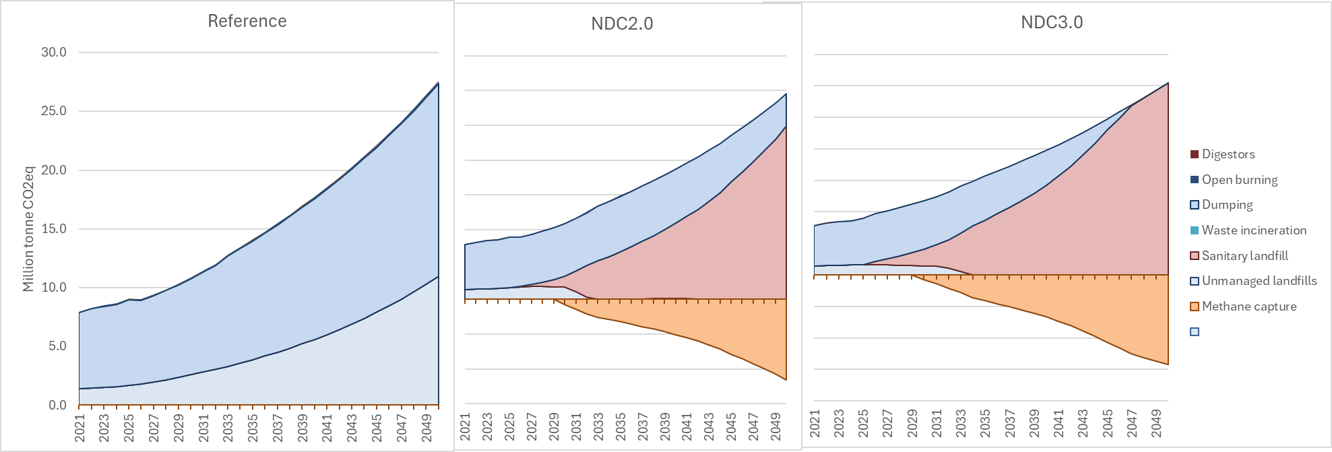
Figure 58. Solid Waste Emissions by Treatment Pathway by Scenario, 2021–2050 (MtCO₂eq)
Expanding collection systems and developing controlled disposal infrastructure raises direct waste management costs above the Reference. By 2035, total system costs reach $229 million under the Reference, $323 million under NDC 2.0, and $389 million under NDC 3.0, rising to $537 million, $949 million, and $1,131 million respectively by 2050. The average disposal cost per tonne increases from $14.58 under the Reference to $21.34 under NDC 2.0 and $25.71 under NDC 3.0 by 2035, and from $17.58 to $34.49 and $41.08 respectively by 2050, reflecting the transition from low-cost unmanaged disposal toward formal waste management systems.

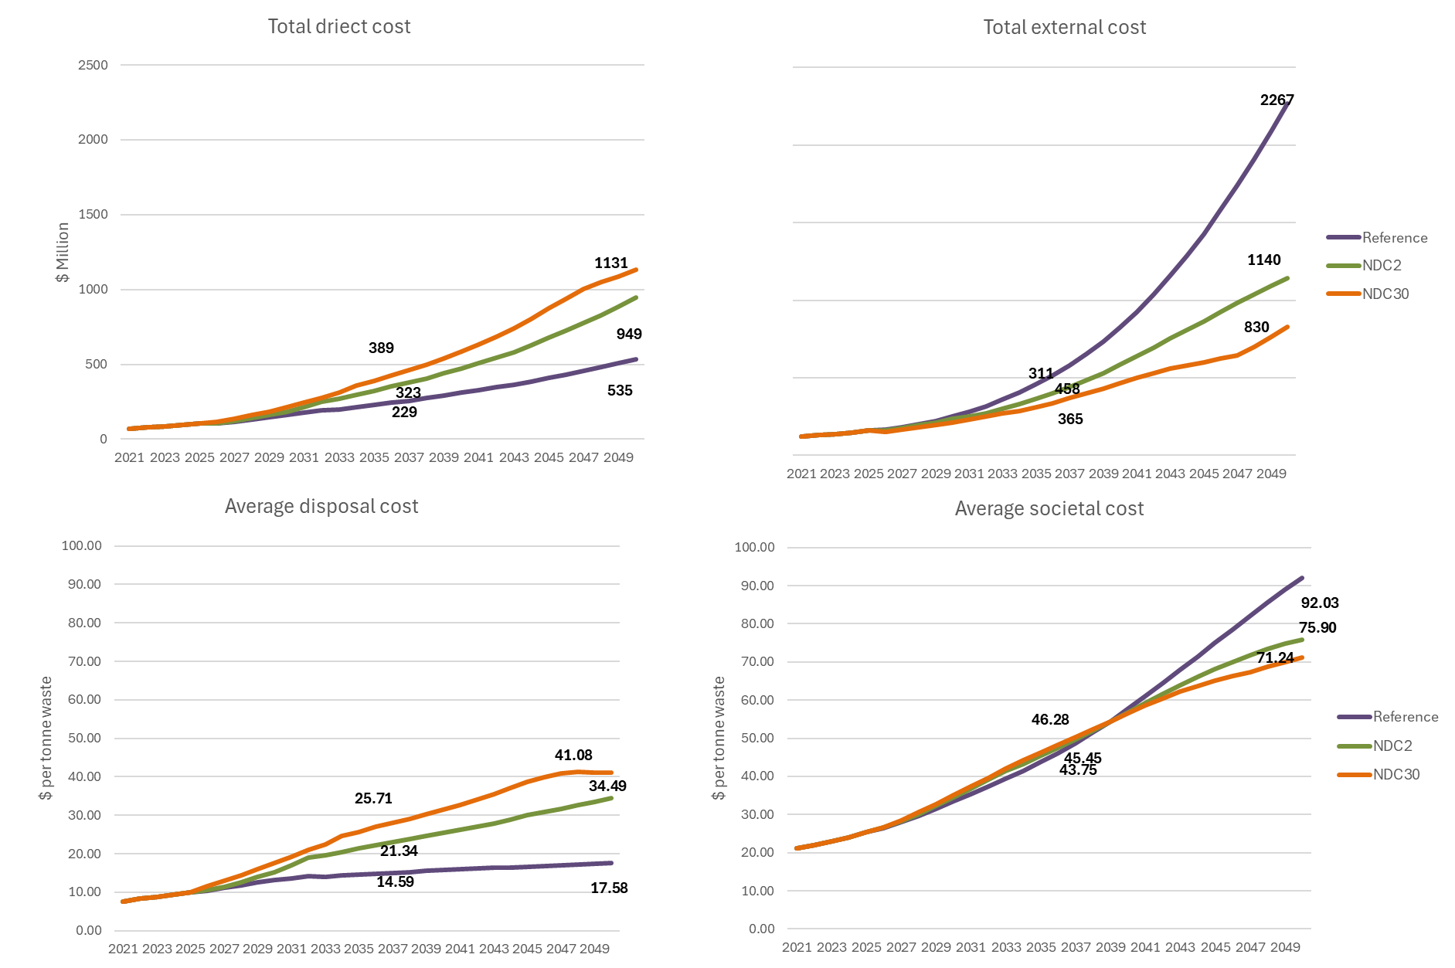
Figure 59. Solid waste sector costs by scenario, 2021–2050, total direct cost ($ million, top left), total external cost ($ million, top right), average disposal cost ($ per tonne waste, bottom left), and average societal cost ($ per tonne waste, bottom right)
However, this increase in direct cost is more than offset by substantial reductions in external costs. These external costs represent the air pollution, public health burden, and environmental degradation associated with open dumping, uncontrolled burning, and unmanaged disposal. Under the Reference scenario, external costs escalate to $2,267 million by 2050 as growing waste volumes continue to be managed through uncontrolled pathways. Under NDC 2.0, external costs fall to $365 million by 2035 and $1,140 million by 2050, as improved collection progressively eliminates the most harmful disposal practices. NDC 3.0 delivers deeper reductions, with external costs falling to $311 million by 2035 and $830 million by 2050, reflecting the faster and more complete elimination of open burning and unmanaged dumping under the more ambitious scenario.

4.5.4.2 Liquid Waste
Uganda’s current sanitation system remains heavily dependent on unmanaged or poorly managed disposal pathways, including pit latrines, septic systems, and open discharge, resulting in substantial health burdens associated with waterborne disease, groundwater contamination, and environmental degradation. Rapid population growth and urbanisation place increasing pressure on already limited sanitation infrastructure, causing both waste volumes and associated environmental damages to rise steadily until mid-century under the Reference scenario.
Under the Reference pathway, liquid waste emissions increase from 6.42 MtCO₂eq in 2021 to 9.40 MtCO₂eq by 2035 and 14.24 MtCO₂eq by 2050. This growth is driven primarily by the continued dominance of unmanaged sanitation systems as population and wastewater generation increase faster than formal sewer and treatment infrastructure expansion. Latrines and open disposal pathways remain the dominant waste management route throughout much of the modelling horizon, while centralized sewer systems expand only gradually and remain insufficient to keep pace with rapidly growing demand. The result is not only rising emissions, but also escalating health and environmental damages associated with untreated wastewater and poor sanitation access.
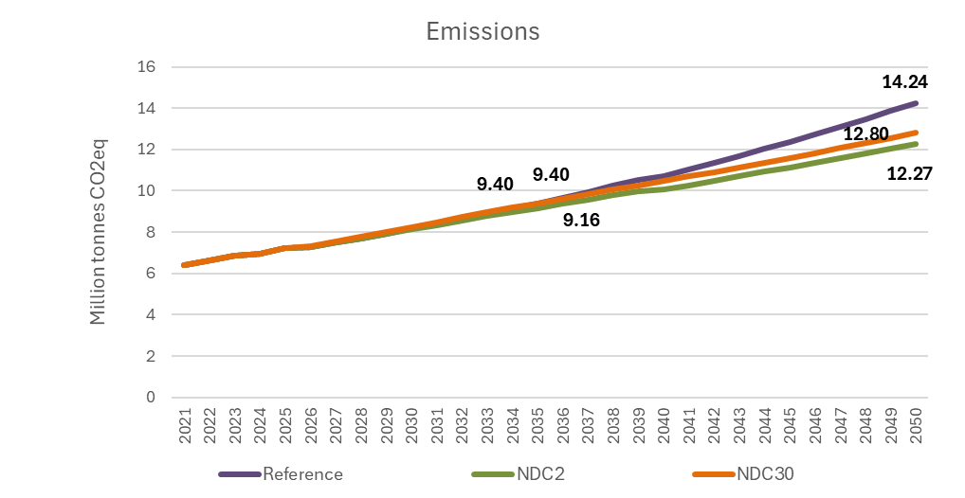
Figure 60. Liquid waste sector emissions by scenario, 2021–2050 (million tonnes CO₂eq)
The central intervention under both NDC pathways is therefore the large-scale expansion of sewer networks and wastewater treatment systems. The mitigation scenarios progressively shift households and businesses away from unmanaged sanitation and towards formal collection and treatment infrastructure. This transition substantially improves sanitation coverage, wastewater handling, and environmental protection, even though the direct greenhouse gas benefits are relatively modest compared to the scale of investment required.
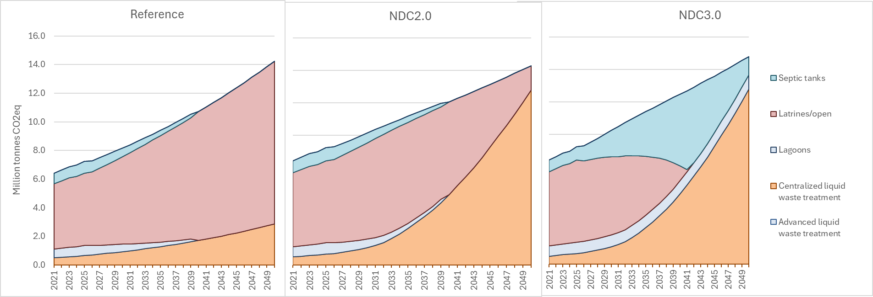
Figure 61. Liquid Waste Emissions by Treatment Pathway by Scenario, 2021–2050 (MtCO₂eq)
Under NDC 2.0, centralized treatment expands steadily over time, progressively displacing latrines and unmanaged disposal pathways. Under NDC 3.0, this transition occurs more rapidly and comprehensively, with accelerated sewer expansion and earlier reductions in unmanaged sanitation. However, the resulting greenhouse gas outcomes are somewhat counterintuitive. In the near term, the faster formalisation of sanitation systems increases the use of intermediate treatment pathways such as septic tanks and anaerobic lagoons which have lower health and environmental costs, but higher GHG emissions, before full sewer connectivity is achieved. Because septic systems also generate methane emissions, this creates a temporary increase in emissions from formal waste management systems that partially offsets the reductions from declining latrine use. As a result, total emissions under NDC 3.0 initially remain similar to the Reference scenario despite much larger investments and major improvements in sanitation outcomes.
This highlights an important characteristic of the liquid waste sector: greenhouse gas emissions are not the primary metric by which the interventions should be evaluated. On a per-tonne CO₂ basis, both the direct costs and societal benefits of wastewater investments are extremely large relative to many other mitigation measures in the economy. The principal justification for sewer expansion and wastewater treatment lies in the reduction of disease burden, environmental contamination, and associated social and economic damages rather than in direct emissions reductions alone.
The infrastructure requirements associated with this transition are substantial. Expanding sewer systems and wastewater treatment facilities across a rapidly urbanising population requires very large long-term capital investments, pushing direct system costs far above the Reference trajectory. By 2050, total system costs rise to more than $8 billion under both NDC pathways compared to approximately $1.6 billion under the Reference scenario, reflecting the scale of infrastructure construction, network expansion, and treatment capacity required. However, these investments also improve the efficiency and effectiveness of wastewater management over time, reducing average treatment costs per unit of wastewater handled relative to the Reference scenario.
Most importantly, the transition generates very large reductions in external health and environmental costs. Under the Reference scenario, external costs associated with unmanaged, including diarrhoeal disease, groundwater pollution, environmental contamination, and broader public health impacts, rise from approximately $1.1 billion in 2021 to more than $10 billion annually by 2050. Under the NDC pathways, expanding sewer access and formal treatment systems sharply reduce these damages, with external costs falling to approximately $1.9 billion under NDC 2.0 and $1.2 billion under NDC 3.0 by 2050.
The NDC 3.0 pathway differs from NDC 2.0 not only in the speed of infrastructure expansion, but also in the treatment of these external benefits within the modelling framework itself. Under NDC 3.0, monetized health and environmental benefits are incorporated directly into the optimisation process, allowing the model to weigh avoided disease burden and environmental damages against the higher direct infrastructure costs. This results in a more aggressive transition towards formal sanitation systems because the the long-term societal benefits substantially are weighted against the additional direct expenditures.
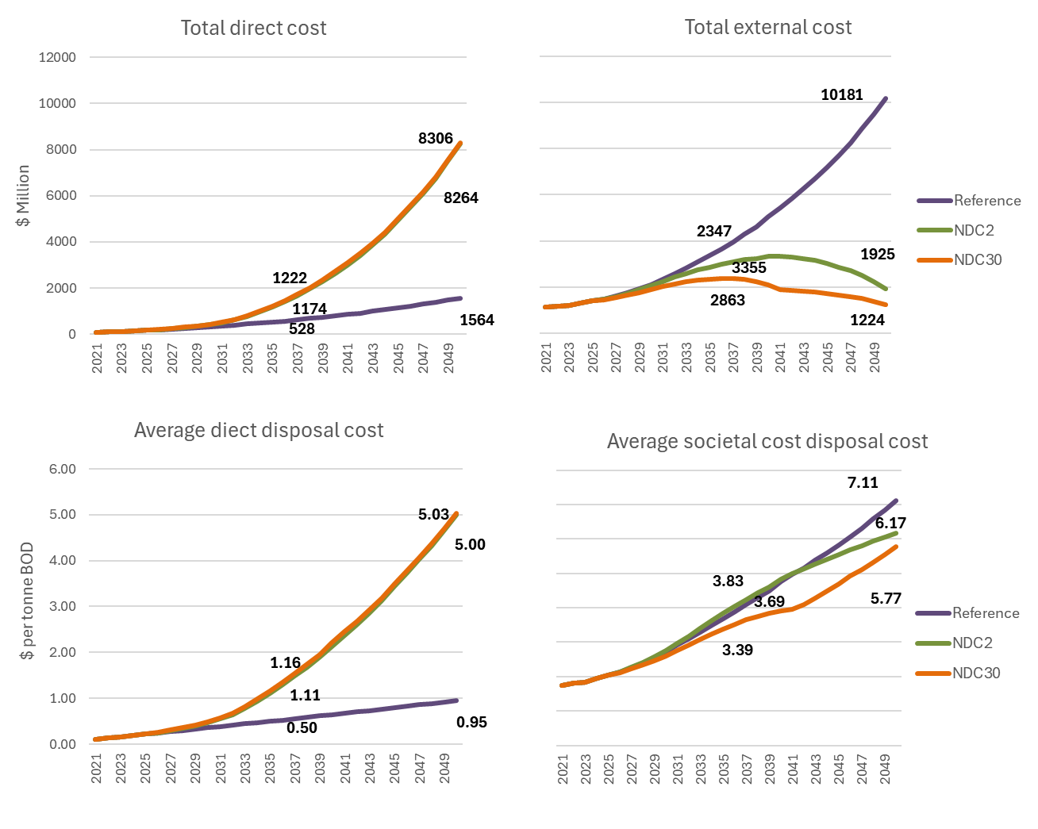
Figure 62. Liquid waste sector costs by scenario, 2021–2050, total direct cost ($ million, top left), total external cost ($ million, top right), average disposal cost ($ per tonne waste, bottom left), and average societal cost ($ per tonne waste, bottom right)

The liquid waste sector is fundamentally a public health and environmental management challenge rather than primarily a climate mitigation sector. The liquid waste transition should therefore be understood primarily as a sanitation and public health investment with climate co-benefits rather than as a conventional low-cost mitigation strategy. While the direct emissions reductions are relatively modest, the broader societal benefits associated with improved sanitation access, lower disease burden, cleaner water systems, and improved environmental quality are extremely large and economically justified over the long term.

4.5.5 SISEPUEDE Results

4.5.5.1 Solid Waste

Solid waste generation in Uganda is shaped by the combined effect of population growth, urbanization, and the rapid industrial expansion envisaged under NDP IV and Vision 2040, as described in Section 4.5.2. Under the Reference pathway, total solid waste generation grows from 15.6 Mt in 2025 to 24.9 Mt by 2035 and 43.5 Mt by 2050, reflecting the cumulative effect of these socioeconomic drivers (Figure 63). Food waste remains the predominant source throughout the modelling horizon, rising from 7.5 Mt in 2025 to 10.1 Mt by 2035 and 14.5 Mt by 2050, consistent with the food consumption increases associated with population and income growth. Chemical and industrial waste expands rapidly between 2030 and 2040, in line with the manufacturing, cement, steel, and mining production trajectories described in Section 4.5 of the Industry sector, growing from 4.7 Mt in 2025 to 9.2 Mt in 2035 and 20.7 Mt by 2050, at which point it becomes the largest single source of solid waste in the country.

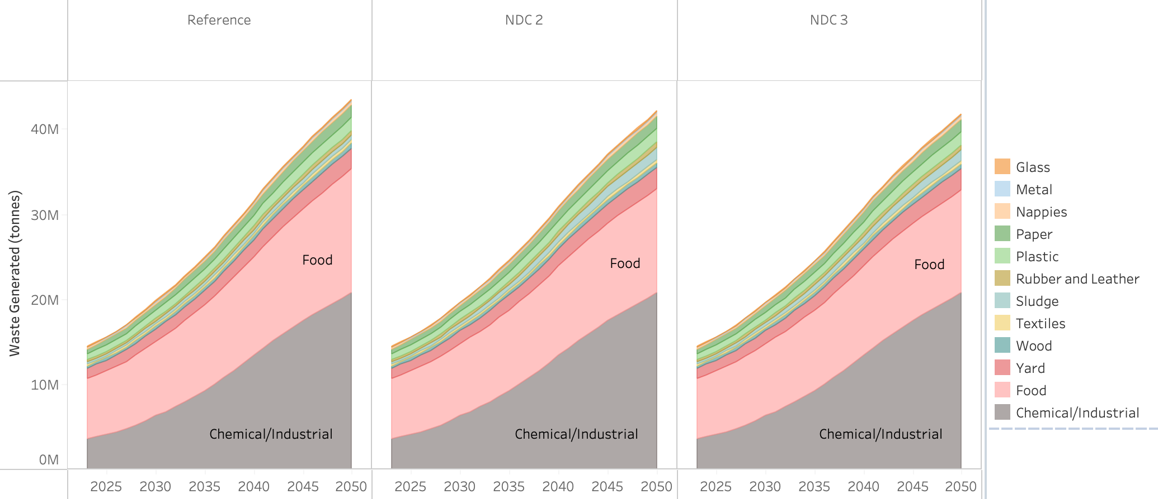
Figure 63. Solid waste generation by Reference (left), NDC 2.0 (center), and NDC 3.0 (right) pathways.
The mitigating actions described in Section 4.5.3 operate primarily on the treatment side rather than on waste generation itself. Under NDC 2.0, total waste generation declines only modestly relative to the Reference, with small reductions in consumer food waste under the Green Cities Management program. NDC 3.0 extends these reductions and introduces additional measures to reduce food loss along the agricultural supply chain, a major source of global food waste, but the overall scale of waste generation remains broadly comparable across pathways. The principal lever for emissions reduction in both NDC pathways is therefore the transition of waste away from unmanaged disposal toward formal collection, controlled landfill, recycling, composting, and anaerobic digestion (Figure 64). Under the Reference pathway, the share of unmanaged waste remains stable at around 60% throughout the modelling horizon. Under NDC 2.0, the expansion of collection coverage from 30% to 40% by 2035 reduces the unmanaged share from 59.4% in 2026 to 42.9% in 2035 and 21.5% by 2050, with the recovered waste redirected primarily to managed landfills and, to a smaller extent, to recycling, composting, and anaerobic digestion.

The NDC pathways integrate anaerobic digestion and landfill gas capture, which converts a previously uncontrolled methane source into a low-carbon energy stream. Anaerobic digestion is valuable in rural and off-grid contexts, including schools and hospitals, and provides cross-sector linkages to the energy system through biogas generation. Under NDC 2.0, biogas capture at landfills reaches 17.4% by 2035 and 46.3% by 2050. NDC 3.0 follows the same collection trajectory as NDC 2.0 but achieves higher capture rates at anaerobic facilities, reaching 19.4% by 2035, 52% by 2050, and 95% by 2070. The enhanced NDC 3.0 collection target of 50% by 2035 also accelerates the elimination of unmanaged disposal relative to NDC 2.0.

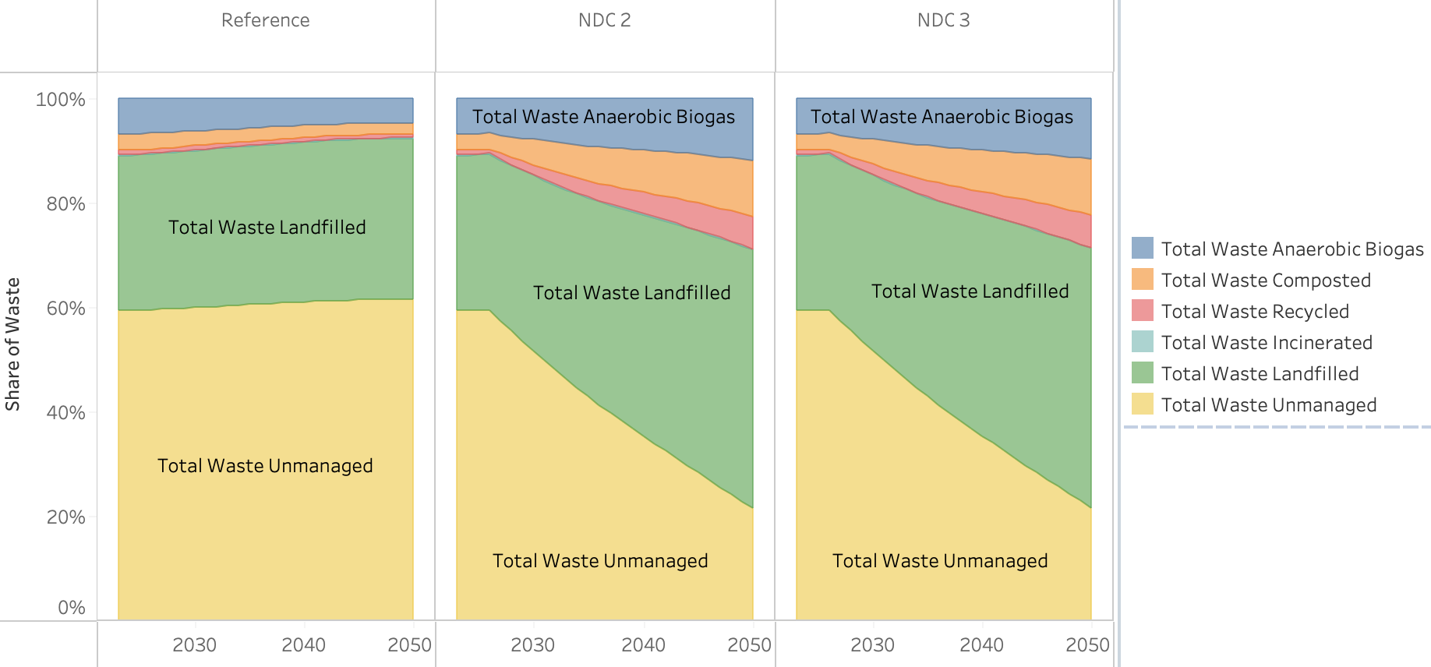
Figure 64. Solid waste treatment pathway shared for Reference (left), NDC 2.0 (center), and NDC 3.0 (right) pathways.
The emissions trajectories reflect the interaction between rising waste generation and the shift toward controlled treatment with methane recovery (Figure 65). Under the Reference pathway, emissions grow from 9.7 MtCO₂e in 2025 to 13.61 MtCO₂e in 2035 and 20.86 MtCO₂e in 2050, driven by the continued dominance of unmanaged disposal and open dumping across a rapidly expanding waste stream. Under NDC 2.0, emissions are reduced to 11.9 MtCO₂e by 2035 and 11.0 MtCO₂e by 2050, with the trajectory peaking in the late 2030s before declining as the cumulative effect of collection expansion and biogas capture outpaces the underlying growth in waste volumes. NDC 3.0 achieves slightly deeper reductions, reaching 11.75 MtCO₂e by 2035 and 10.45 MtCO₂e by 2050, with the additional gains arising primarily from the higher biogas capture rates rather than from differences in collection coverage. The difference between the two NDC pathways reflects the fact that both rely on the same fundamental shift from unmanaged to managed treatment, with the marginal NDC 3.0 measures concentrated in the methane recovery component of the system.

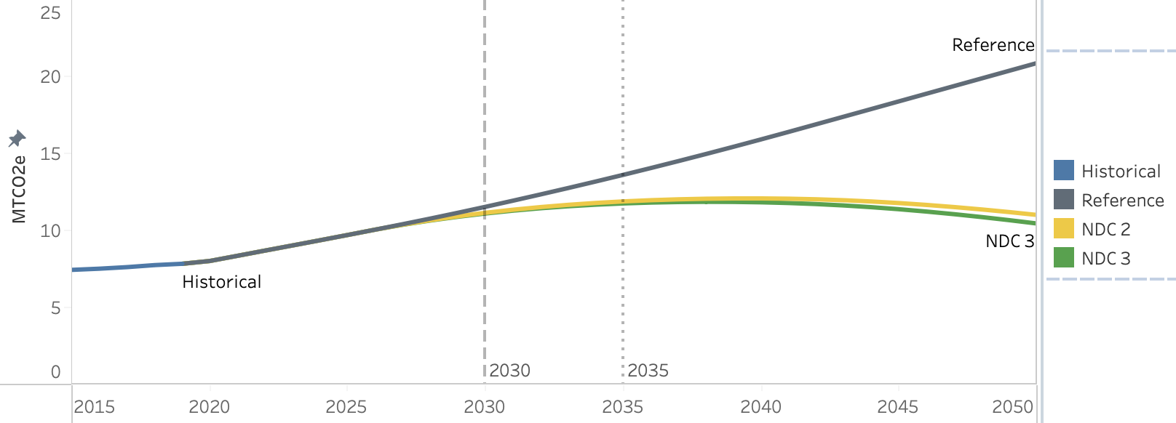
Figure 65. Solid waste treatment emissions for Reference (gray), NDC 2.0 (yellow), and NDC 3.0 (green) pathways, MtCO2e.
The cost-benefit profile of the solid waste transition is shaped by the interaction between the capital requirements of expanded collection and treatment infrastructure and the avoided externalities associated with the displacement of open dumping. Under NDC 2.0, capital costs of $297 million by 2035 and $1.17 billion by 2050 are required to extend formal collection and to expand managed disposal capacity beyond Reference levels. These investments result in benefits through two mechanisms operating on the same waste stream: the diversion of waste away from open dumping eliminates the environmental damages embedded in unmanaged disposal, while the reduction in food waste creates consumer savings from the value of food that would otherwise have been discarded. The first mechanism delivers environmental pollution benefits of $528 million by 2035 and $2.05 billion by 2050, and the second delivers consumer savings of $435 million by 2035 and $1.67 billion by 2050. Net benefits therefore reach $676 million by 2035 and $2.59 billion by 2050, with the cost-benefit balance turning positive from the outset of the implementation period (Figure 66).

The NDC 3.0 measures alter this balance through both the scale and the composition of the intervention. Capital costs rise to $390 million by 2035 and $1.99 billion by 2050, reflecting the more rapid expansion of collection coverage and the additional infrastructure required for methane capture at anaerobic digesters and landfills. The pollution and consumer-savings benefits remain broadly comparable to NDC 2.0 because they are driven by the same diversion of waste from open dumping and the same food-waste reduction targets, reaching $531 million and $434 million in 2035 and $2.05 billion and $1.66 billion in 2050 respectively. The distinguishing feature of NDC 3.0 is fuel cost savings as a third benefit stream, generated by the imputed value of biogas recovered from anaerobic digesters and landfills and used in energy production. This benefit category is absent from NDC 2.0, which lacks the methane recovery infrastructure required to realise it, and is therefore the principal mechanism through which the higher capital outlay of NDC 3.0 is offset.

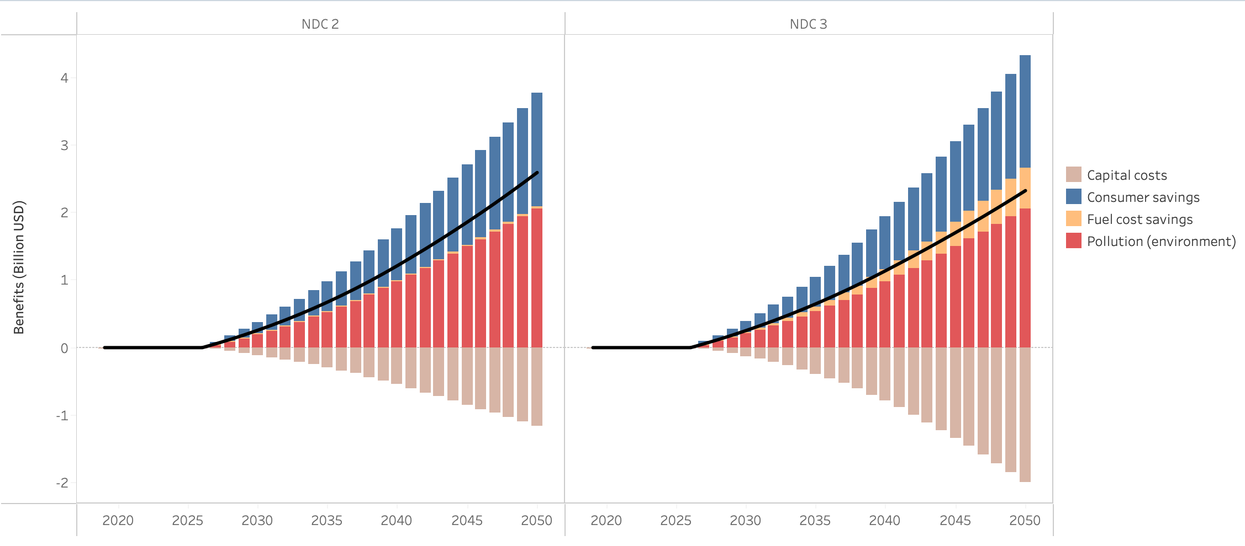
Figure 66. Costs and benefits associated with solid waste collection in NDC 2.0 (left) and NDC 3.0 (right) in billion USD.

4.5.5.2 Wastewater Treatment

The drivers of wastewater treatment emissions reflect the combined effect of underlying socioeconomic growth and the mitigating actions applied to each pathway. Wastewater treatment is treated in this analysis as a critical development goal, providing health and environmental benefits in line with the UN Sustainable Development Goals, with Uganda's current sanitation profile heavily dependent on basic or unimproved services including pit latrines, open defecation, and sewerage without treatment. Under the Reference pathway, the composition of treatment services remains broadly unchanged across the urban, rural, and industrial segments through 2050, with urban areas continuing to rely on a mixture of unimproved latrines, septic systems, secondary anaerobic treatment, and improved latrines, rural areas dependent on unimproved latrines complemented by a septic share, and industrial wastewater managed predominantly through untreated discharge with sewerage. The NDC 2.0 measures specified in Section 4.5.3, principally the expansion of sewer and wastewater treatment coverage from 15% in 2020 to 90% by 2050, raise rural coverage of improved (improved latrine) or safe (septic) sanitation to 51% by 2035 and 72% by 2050 and urban coverage to 65% by 2035 and 80% by 2050. Much of this expansion is delivered through increases in secondary anaerobic and aerobic treatment, alongside advanced aerobic capacity in urban areas, which cannot be used to produce biogas. The NDC 3.0 measures deliver comparable aggregate coverage targets but include growth in advanced anaerobic treatment in urban contexts, providing a source for biogas-derived energy (Figure 67).

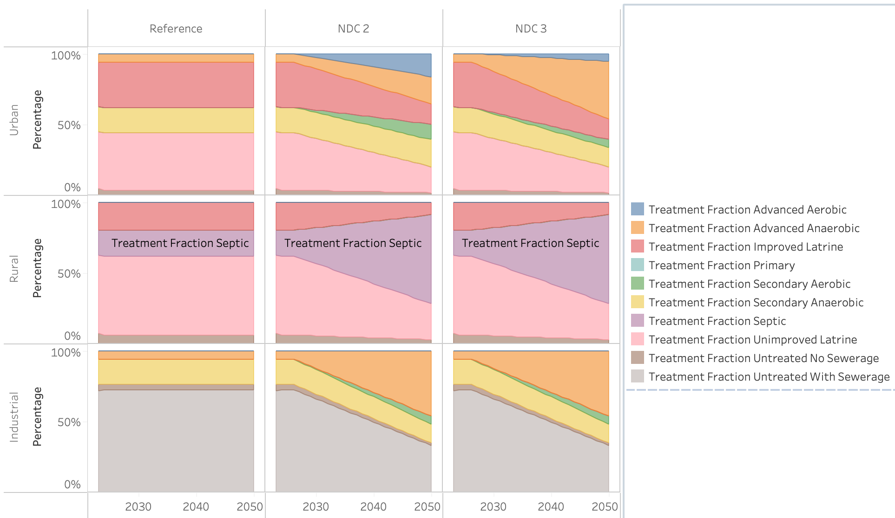
Figure 67. Wastewater treatment shares in Reference (left), NDC 2.0 (center), and NDC 3.0 (right) pathways.
The emissions trajectories reflect the interaction of these treatment-share dynamics with the growth in wastewater volumes across pathways. Under the Reference pathway, emissions grow from 7.71 MtCO₂e in 2015 to 13.15 MtCO₂e in 2035 and 23.97 MtCO₂e in 2050, an increase of approximately 211% over the period, driven by the combined effect of population and economic growth on wastewater generation against a static treatment composition. The NDC 2.0 measures, including the expansion of septic systems and secondary anaerobic and aerobic treatment, reduce emissions by approximately 1 MtCO₂e to 12.15 MtCO₂e by 2035 and by 3.51 MtCO₂e to 19.48 MtCO₂e by 2050, compared to 13.15 MtCO₂e and 23.97 MtCO₂e under the Reference at the same points. The near-term differentiation is limited because the initial expansion of formal treatment partly substitutes one methane-emitting pathway for another, with septic systems and secondary anaerobic treatment displacing unimproved latrines.

The NDC 3.0 measures further compound these reductions through the deployment of advanced anaerobic treatment in urban areas, which captures methane that would otherwise be emitted and directs it toward biogas production. Emissions decline to 11.86 MtCO₂e by 2035 and 15.33 MtCO₂e by 2050, approximately 9.8% and 36% below the Reference trajectory at the same points. The NDC 3.0 trajectory also exhibits a plateau pattern from the mid-2040s onward as the treatment composition approaches its long-term configuration, while emissions under NDC 2.0 continue to rise with wastewater volumes (Figure 68).

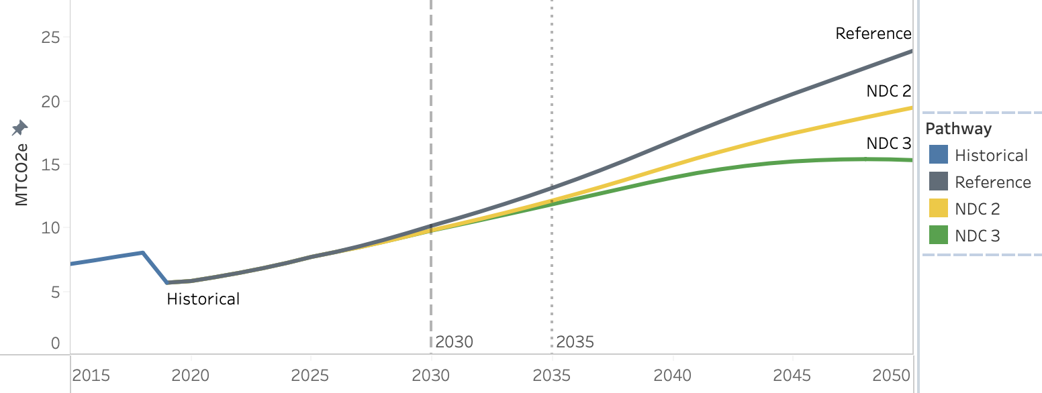
Figure 68. Wastewater treatment emissions for Reference (gray), NDC 2.0 (yellow), and NDC 3.0 (green) pathways, MtCO2e.
The cost-benefit profile of the wastewater treatment transition is shaped by the interaction between the capital requirements of expanding sewer and treatment infrastructure and the avoided externalities associated with displacing unmanaged sanitation. Under NDC 2.0, capital costs of $1.76 billion by 2035 and $8.12 billion by 2050 are required to extend coverage of improved and safely managed sanitation services and to expand secondary anaerobic, secondary aerobic, and advanced aerobic treatment capacity. These investments are recovered through two mechanisms operating on the wastewater stream: the removal of nitrogen, phosphorus, and oxygen-demanding contaminants reduces the environmental and human damages that would otherwise arise from their discharge into water bodies, while the expansion of safely managed sanitation reduces the burden of sanitation-related disease. The first mechanism delivers water pollution benefits of $1.06 billion by 2035 and $8.31 billion by 2050, with the magnitude driven by the aerobic and advanced aerobic processes that dominate the NDC 2.0 urban mix and that remove nitrogen and phosphorus efficiently. The second delivers human health benefits of $1.99 billion by 2035 and $7.34 billion by 2050. Net benefits reach $1.29 billion by 2035 and $7.53 billion by 2050 (Figure 69).

The NDC 3.0 measures change this balance between costs and benefits through both the scale and the composition of the intervention. Capital costs rise to $2.23 billion by 2035 and $11.48 billion by 2050, reflecting the expanded coverage targets and the additional infrastructure required for advanced anaerobic treatment and methane capture in urban areas. Human health benefits remain unchanged from NDC 2.0 at $1.99 billion by 2035 and $7.34 billion by 2050, because the underlying expansion of safely managed sanitation coverage is comparable across the two pathways. Water pollution benefits, by contrast, fall to $670 million by 2035 and $3.11 billion by 2050. This reduction is a direct consequence of the substitution of advanced anaerobic for advanced aerobic treatment in the urban mix: anaerobic processes are optimised for biogas recovery rather than nutrient removal and therefore remove less nitrogen and phosphorus per unit of wastewater treated, lowering the monetised value of avoided water pollution. The same compositional shift introduces fuel cost savings as a third benefit stream, generated by the imputed value of biogas recovered from advanced anaerobic facilities in urban centres and reaching $200 million by 2035 and $1.65 billion by 2050. Net benefits under NDC 3.0 therefore reach $640 million by 2035 and $620 million by 2050, lower than under NDC 2.0 because the increase in capital expenditure and the reduction in water-pollution benefits outweigh the new fuel cost savings.

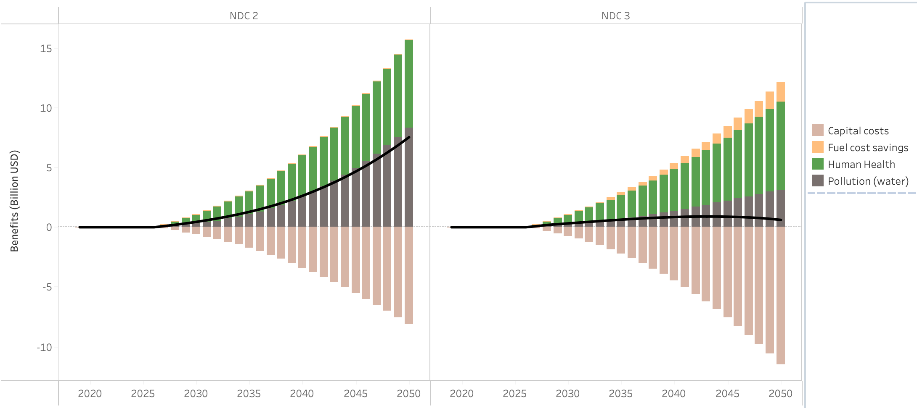
Figure 69. Costs and benefits associated with wastewater treatment in NDC 2.0 (left) and NDC 3.0 (right) in billion USD.

5. Conclusions
The modelling analyses with the CLEWs and SISEPUEDE frameworks demonstrate that Uganda’s NDC pathways are closely aligned with to the country’s broader development agenda. Population growth, urbanisation, industrialisation, rising incomes, and expanding demand for energy, transport, housing, food, sanitation, and infrastructure all place upward pressure on emissions. Under the Reference scenario, total national GHG emissions increase from approximately 105 MtCO₂eq in 2015 to around 157–171 MtCO₂eq by 2035 and approximately 198–204 MtCO₂eq by 2050 across the two model trajectories. This pathway illustrates that Uganda’s economic transformation, if pursued without additional mitigation, would lead to sustained emissions growth across most major sectors, even as land-use emissions begin to moderate over time due to resource constraints and changes in biomass availability.
The mitigation scenarios demonstrate that Uganda alter this trajectory while continuing to pursue rapid economic development. Under NDC 2.0, total national emissions reach approximately 126 MtCO₂eq by 2035 and 131 MtCO₂eq by 2050 under CLEWs, representing reductions of approximately 45 MtCO₂eq and 73 MtCO₂eq respectively relative to the Reference scenario. These reductions are driven primarily by land-sector transformation, clean cooking adoption, improved charcoal production, forest and wetland restoration, transport efficiency, industrial fuel switching, and improved waste management. The land use sector provides the largest single contribution to mitigation, with land-use emissions falling from approximately 60 MtCO₂eq under the Reference scenario to around 27 MtCO₂eq under NDC 2.0 by 2035, before transitioning to a net carbon sink by the 2040s. Outside the land sector, emissions reductions are meaningful but more gradual, reflecting the continued growth in mobility, industrial production, livestock systems, waste generation, and electricity demand.
The NDC 3.0 Candidate scenario represents a more ambitious and structurally transformative pathway. Total national emissions peak in the late 2020s before declining through much of the 2030s, reaching approximately 114 MtCO₂eq by 2035 and 111 MtCO₂eq by 2050 under CLEWs. This corresponds to reductions of approximately 57 MtCO₂eq by 2035 and 93 MtCO₂eq by 2050 relative to the Reference scenario, and around 12 MtCO₂eq and 20 MtCO₂eq deeper than NDC 2.0 in those same years. The additional reductions arise from earlier and deeper land-sector recovery, accelerated clean cooking adoption, stronger industrial fuel switching, faster transport electrification and modal shift, and a more complete decarbonisation of electricity supply. The land-use sector becomes a net sink earlier under NDC 3.0, around 2038, compared with approximately 2043 under NDC 2.0. By 2050, the depth of the sink is broadly similar across the two mitigation pathways, but the earlier transition under NDC 3.0 produces larger cumulative mitigation benefits.
The results indicate that the additional measures included in the SISEPUEDE NDC 3.0 Candidate scenario could place Uganda on a pathway broadly consistent with long-term net-zero objectives, provided that emissions reductions continue beyond 2050 and that remaining hard-to-abate sources, particularly livestock, industrial processes, residual fossil fuel use, and waste emissions, are addressed. However, this pathway requires substantially higher levels of investment, implementation capacity, and cross-sector coordination than the Reference or NDC 2.0 pathways. In particular, rapid electrification of households, transport, and industry must be accompanied by large-scale investment in low-carbon generation, transmission, distribution, clean cooking technologies, transport systems, and land restoration.
Key insights emerging from the analysis:
- Clean cooking and biomass transition: The transition away from traditional biomass and charcoal is one of the most important mitigation and development priorities across the scenarios. Clean cooking directly reduces household and institutional exposure to indoor air pollution, improving health outcomes and freeing time for education and income-generating activities. Its largest climate benefit, however, occurs outside the buildings sector. By reducing demand for fuelwood and charcoal, clean cooking lowers pressure on forests and woodlands, reduces unsustainable biomass extraction, and supports the land sector’s transition toward a net carbon sink. This makes clean cooking a central cross-sector intervention linking household energy access, public health, forest conservation, and long-term mitigation.

- Transport measures deliver large development benefits as well as emissions reductions: Uganda’s transport demand grows rapidly under all scenarios due to rising incomes, urbanisation, freight activity, and structural economic transformation. Without intervention, this growth increases petroleum use, congestion, road safety risks, local air pollution, and import dependence. Public transport improvements, rail investment, non-motorised transport infrastructure, vehicle efficiency standards, and electric vehicle adoption reduce emissions while improving economic productivity, urban accessibility, air quality, and road safety. Under the NDC pathways, transport emissions fall substantially relative to the Reference scenario by 2050, with the deeper reductions under NDC 3.0 driven particularly by faster electrification of heavier vehicle segments and stronger modal shift. The development case for transport investment is therefore at least as important as the mitigation case.

- Sanitation and waste management provide high development value, even where direct GHG reductions are more moderate: Expanding wastewater treatment coverage and modernising solid waste systems produce major public health and environmental benefits, particularly in rapidly urbanising areas. Solid waste mitigation reduces methane emissions through improved collection, sanitary landfill, and methane capture, while liquid waste measures improve sanitation outcomes and reduce exposure to untreated wastewater. The direct GHG impacts of wastewater measures are relatively modest compared with their health and environmental benefits, but the broader development returns are substantial. These sectors should therefore be understood as development priorities with important climate co-benefits, rather than as mitigation measures justified only on a cost-per-tonne CO₂eq basis.

- Livestock emissions remain the largest persistent long-term challenge: Livestock becomes a dominant emission source by mid-century across all scenarios. Under the Reference scenario, livestock emissions rise to more than 65 MtCO₂eq by 2050. NDC 2.0 reduces this to approximately 52.6 MtCO₂eq, while NDC 3.0 reduces it further to approximately 47.3 MtCO₂eq through more ambitious herd transition and mitigation measures. However, even under the most ambitious pathway assessed, livestock remains a major residual emissions source. This indicates that long-term mitigation goals will require more explicit and sustained action on livestock productivity, breed transition, feed quality, animal health, manure management, and potentially other enteric fermentation reduction measures. Without deeper livestock mitigation, progress in energy, transport, waste, and land restoration will not be sufficient to fully stabilise Uganda’s long-term emissions trajectory.

- Electrification is central to Uganda’s development and mitigation strategy, particularly in buildings, transport, and industry. However, new generation investment will need to be in clean technologies to ensure that this also leads to emission reductions. Strengthening clean power investment, grid infrastructure, and system reliability is therefore essential to ensure that electrification delivers its full climate and development benefits. Implementing the current Energy Policy will achieve this.
- The NDC 3.0 Candidate scenario establishes a stronger long-term transition pathway: The NDC 3.0 Candidate scenario does more than deepen emissions reductions relative to NDC 2.0; it changes the timing and structure of the transition. Earlier land-sector recovery, faster clean cooking adoption, deeper industrial fuel switching, accelerated transport electrification, and lower-carbon electricity supply allow national emissions to peak earlier and decline through much of the 2030s. This represents a more durable decoupling of emissions from economic growth. However, achieving this pathway will require a major scaling up of investment, institutional coordination, implementation capability, and climate finance. The scenario should therefore be understood as technically promising but dependent on strong enabling conditions, including financing, infrastructure delivery, policy enforcement, stakeholder coordination, and long-term planning capacity.

Overall, the analysis shows that Uganda’s climate and development objectives are strongly interlinked. Many of the measures that reduce emissions also improve health, productivity, energy access, urban mobility, sanitation, ecosystem services, and economic resilience. The strongest mitigation opportunities are not isolated technical interventions, but system transitions: clean cooking linked to forest conservation, electrification linked to clean power expansion, transport modernisation linked to urban productivity, and waste infrastructure linked to public health. The central challenge for NDC 3.0 is therefore not only to identify higher-ambition mitigation measures, but to mobilise the finance, institutions, and implementation systems needed to deliver these transitions at national scale.

Appendices

Appendix 1. Development co-benefits assumptions and parameters

Development  Co-benefit | Covered Sectors | Fuel/Technology | Starting Value (2021) | Unit
Congestion | Transport | Cars | 30 | $m/ 10⁹ km
 |  | 2/3 wheelers | 12 | $m / 10⁹ km
 |  | Minibuses | 52.2 | $m / 10⁹ km
 |  | Buses | 82.5 | $m / 10⁹ km
 |  | Light trucks | 60 | $m / 10⁹ km
 |  | Medium trucks | 90 | $m / 10⁹ km
 |  | Heavy trucks | 120 | $m / 10⁹ km
Local Air Pollution | Transport | Gasoline | 0.2 | $m / PJ
 |  | Diesel | 0.58 | $m / PJ
Accidents | Transport | Cars | 14.7 | $m / 10⁹ km
 |  | 2/3 wheelers | 172.2 | $m / 10⁹ km
 |  | Minibuses | 22.9 | $m / 10⁹ km
 |  | Buses | 11.8 | $m / 10⁹ km
 |  | Light trucks | 22.3 | $m / 10⁹ km
 |  | Medium trucks | 25 | $m / 10⁹ km
 |  | Heavy trucks | 27.8 | $m / 10⁹ km
Health and Sanitation Impacts from Liquid Waste Disposal | Liquid waste | Advanced aerobic | 0.04 | $m/kTon BOD
 |  | Centralized aerobic | 0.06 | $m/kTon BOD
 |  | Aerobic lagoon | 0.2 | $m/kTon BOD
 |  | Latrines | 1.4 | $m/kTon BOD
 |  | Septic tanks | 0.7 | $m/kTon BOD
Environmental Costs from Liquid Waste Disposal | Liquid waste | Advanced aerobic | 0.03 | 10⁶/kTon
 |  | Centralized aerobic | 0.05 | 10⁶/kTon
 |  | Aerobic lagoon | 0.3 | 10⁶/kTon
 |  | Latrines | 0.6 | 10⁶/kTon
 |  | Septic tanks | 0.45 | 10⁶/kTon
Waste Management | Solid waste | Dumping | 14.7 | $m/MTon
 |  | Open burning | 22.1 | $m/MTon
 |  | Unmanaged landfill | 8.8 | $m/MTon
 |  | Sanitary landfill | 5.2 | $m/MTon
 |  | Composting | 2.2 | $m/MTon
 |  | Digestors | 2.2 | $m/MTon
Indoor Air Pollution | Buildings | Biomass | 4.9 | $m / PJ
 |  | Charcoal | 3.2 | $m / PJ
 |  | Electricity | 0.34 | $m / PJ
 |  | LPG | 0.97 | $m / PJ
Ecosystem Services | LULUCF | Peatlands | 67 | 10⁶/10³ km²
 |  | Wetlands | 67 | 10⁶/10³ km²
 |  | Forest Land | 90 | 10⁶/10³ km²
 |  | Cropland | 43 | 10⁶/10³ km²
 |  | Grassland | 21 | 10⁶/10³ km²
 |  | Shrubland | 25.5 | 10⁶/10³ km²

Appendix 2. Implementation of Mitigation Measures in the CLEWs Model

Sector | Mitigation Measure | Scenario | Description | CLEWs Implementation
Energy | Reduction in T&D Losses | NDC 2.0 & NDC 3.0 | Reduces transmission and distribution losses in line with national targets | Adjustment of output activity ratios (OAR) for transmission and distribution technologies over time
Energy | Renewable Energy Generation | NDC 2.0 & NDC 3.0 | Introduces additional low-carbon generation sources (e.g. geothermal, landfill gas) | Introduction of new generation technologies with defined activity and capacity
Energy | Power Sector Technology Targets | NDC 3.0 | Enforces minimum deployment of renewable technologies | Application of upper-bound demand/capacity constraints (UDC) on generation technologies to enforce capacity targets
Energy | Industrial Energy Efficiency | NDC 2.0 & NDC 3.0 | Achieves a 10% reduction in industrial energy use relative to reference by 2025 | Introduce parallell technologies with lower input activity ratios (IAR) and higher capital costs
Energy | Industrial Fuel Switching | NDC 2.0 & NDC 3.0 | Increases biomass share in industrial energy use | Application of UDCMultiplierActivity constraints to shift fuel shares toward biomass technologies
Energy (Buildings) | Lighting Energy Efficiency | NDC 2.0 & NDC 3.0 | Deployment of efficient lighting technologies (e.g. LEDs), targeting 75% reduction from reference by 2030 | Reduction in input activity ratios (IAR) of lighting technologies over time
Energy (Buildings) | Residential Cooling Efficiency | NDC 2.0 & NDC 3.0 | Improves efficiency of residential cooling appliances | Reduction in input activity ratios (IAR) of cooling technologies over time
Energy (Buildings) | Clean Cooking (Residential) | NDC 2.0 & NDC 3.0 | Reduces reliance on biomass through electrification and LPG adoption | Application of UDCMultiplierActivity constraints to shift fuel shares across cooking technologies
Energy (Buildings) | Clean Cooking (Commercial) | NDC 2.0 & NDC 3.0 | Promotes improved stoves, LPG, and electric cooking in institutions | Application of UDCMultiplierActivity constraints to shift fuel shares in commercial cooking technologies
Transport | Vehicle Fuel Efficiency Improvements | NDC 2.0 & NDC 3.0 | Improves fuel economy over time | Reduction in input activity ratios (IAR) of transport technologies and increase in capital costs
Transport | Alternative Fuels Deployment | NDC 2.0 & NDC 3.0 | Introduces LNG, ethanol, and biodiesel | Application of fuel share constraints through UDCMultiplierActivity across fuel types
Transport | Electric Bus Deployment | NDC 2.0 & NDC 3.0 | Deploys electric buses in urban systems | Introduction of electric bus technologies with defined activity levels
Transport | Non-Motorised Transport | NDC 2.0 & NDC 3.0 | Reduces motorised transport demand through walking and cycling | Shift in transport activity from motorized to non-motorized transport through AnnualDemand parameter and forced inclusion of related capital expenditure
Transport | Transit-Oriented Development | NDC 2.0 & NDC 3.0 | Reduces travel demand through urban planning measures | Lower transport activity through AnnualDemand parameter and forced inclusion of related capital expenditure
Transport | Freight Rail Rehabilitation | NDC 2.0 & NDC 3.0 | Shifts freight transport from road to rail | Reallocation of activity across freight transport technologies
Transport | Public Transport Efficiency | NDC 2.0 & NDC 3.0 | Improves load factors and reduces vehicle-km | Adjustment of activity efficiency parameters for transport technologies
Transport | Freight Load Factor Improvement | NDC 2.0 & NDC 3.0 | Improves efficiency of freight operations | Increase in transport efficiency through activity parameter adjustments and forced inclusion of related capital expenditure
Transport | Passenger Rail Expansion | NDC 2.0 & NDC 3.0 | Expands passenger rail services | Introduction of rail transport technologies with defined activity levels
Transport | Unconstrained EV Adoption | NDC 3.0 | Allows EV uptake beyond policy limits | Removal or relaxation of upper-bound constraints (UDC) on EV technologies
IPPU | Hydrogen-based DRI in Steel Production | NDC 2.0 & NDC 3.0 | Introduces hydrogen-based steel production for new capacity | Introduction of constraint to stop investment in non-hydrogen based primary steel production after 2035
IPPU | Clinker Substitution | NDC 2.0 & NDC 3.0 | Reduces clinker ratio in cement production | Reduction in InputActivityRatio of clinker for cement production
IPPU | Enhanced Clinker Substitution | NDC 3.0 | Further reduces clinker ratio | Reduction in InputActivityRatio of clinker for cement production
AFOLU (Agriculture) | Improved Fertiliser Application | NDC 2.0 & NDC 3.0 | Reduces N₂O emissions from soils | Reduced InputActivityRatio for fertilizer use on cropland
AFOLU (Agriculture) | Irrigation Expansion | NDC 2.0 & NDC 3.0 | Expands irrigation coverage | Relaxation on growth bounds for irrigation and high input agricultural technologies
AFOLU (Agriculture) | Greenhouse Cultivation | NDC 2.0 & NDC 3.0 | Promotes controlled agriculture systems | Adjustment in production systems reducing land expansion pressure
AFOLU (Livestock) | Livestock Management Improvements | NDC 2.0 & NDC 3.0 | Improves breeds, feed, and productivity | Reduction in emission factors and per animal cost factors
AFOLU (Livestock) | Manure Management | NDC 2.0 & NDC 3.0 | Increases manure collection rates | Application of activity share constraints for manure management systems
AFOLU (Livestock) | Enhanced Livestock Technology Package | NDC 3.0 | Applies advanced livestock technologies | Reduction in emission factors and per animal cost factors
LULUCF | Bioenergy Woodlots | NDC 2.0 & NDC 3.0 | Expands sustainable biomass supply | Higher output of biomass per unit of tree covered area
LULUCF | Improved Charcoal Kilns | NDC 2.0 & NDC 3.0 | Improves charcoal production efficiency | Forced transition to improved earthen mounds and brick beehives
LULUCF | Commercial Timber Plantations | NDC 2.0 & NDC 3.0 | Reduces pressure on natural forests | Higher output of biomass per unit of tree covered area
LULUCF | Forest Restoration | NDC 2.0 & NDC 3.0 | Restores degraded forests | Increase in carbon sequestration parameters
LULUCF | Wetland and Peatland Restoration | NDC 2.0 & NDC 3.0 | Restores wetlands and peatlands | Increase annual targtes for wetland and peatland landcover
Waste (Solid) | Solid Waste Collection Expansion | NDC 2.0 & NDC 3.0 | Increases collection coverage | Application of UDCMultiplierActivity constraints on WSTGEN (COLWST) controlling collection shares
Waste (Solid) | Enhanced Waste Collection | NDC 3.0 | Further increases collection rates | Higher UDCMultiplierActivity constraints relative to NDC 2.0
Waste (Solid) | Sanitary Landfill Deployment | NDC 2.0 & NDC 3.0 | increased collection and formal disposal | Reallocation of waste flows across disposal technologies
Waste (Solid) | Methane Capture | NDC 2.0 & NDC 3.0 | Captures landfill gas emissions | Introduction of methane recovery technologies with emission offsets
Waste (Liquid) | Wastewater Treatment Expansion | NDC 2.0 & NDC 3.0 | Expands treatment coverage to 90% | Application of UDC constraints increasing share of treated wastewater over time

Appendix 3: SISEPUEDE Mitigation Measures and Implementation Levels, NDC 2 and NDC 3

Display Sector | Name | Description | Implementation Units Description | NDC 2 |  |  | NDC 3
 |  |  |  | 2035 | 2050 | 2070 | 2035 | 2050 | 2070
Agriculture | Reduce supply chain losses | Reduce waste food waste in the agricultural (crop) supply chain (pre-consumer). | Fractional reduction in food waste in supply chain | 0.000 | 0.000 | 0.000 | 0.083 | 0.262 | 0.500
Agriculture | Expand conservation agriculture | Decrease soil organic carbon loss in croplands and leave crop residues (reduce fraction removed and burned) | Fraction of crop classes that adopt conservation agriculture (per crop specified) | 0.133 | 0.355 | 0.650 | 0.152 | 0.477 | 0.650
Agriculture | Improve crop productivity | Increase crop yield, primarily through irrigation and management practices. | Fractional increase in crop productivity (mass/area) | 0.061 | 0.164 | 0.300 | 0.143 | 0.381 | 0.700
Agriculture | Improve rice management | Reduce CH4 emissions from rice production by 45% due to improved management and reduced flooding. | Fractional reduction in methane emitted from rice production | 0.000 | 0.000 | 0.000 | 0.092 | 0.245 | 0.450
Forestry | Increase Reforestation | Increases probability of input land use classes being converted to secondary forests. | Increases transition probabilities into secondary forests and sets minimum area for secondary forests (ha) | 3,778,419 | 3,778,419 | 3,778,419 | 4,858,419 | 4,858,419 | 4,858,419
Forestry | Increase Sequestration | Increase annual sequestration in forests with better forest management, removal of litter, etc. | Fractional increase in sequestration. Negative numbers can be used to reduce it. | 0.72 | 0.85 | 0.85 | 0.765 | 0.85 | 0.85
Forestry | Stop deforestation | Halt deforestation of primary and secondary forests | Target minimum transition probability for forest classes remaining that class (closer to 1 means less loss). Note that this cannot reduce the transition probability, only increase it. | 0.35999 | 0.95999 | 0.99999 | 0.89999 | 0.99999 | 0.99999
Land Use | Decrease loss of land use classes (applied to wetlands) | Halt loss of a specified land use class; similarly to Decrease Deforestation, it increases the probability of a class transitioning into itself. | Target minimum transition probability for land use class remaining that class (closer to 1 means less loss). Is not set to allow decreases in probability. | 0.9999 | 0.9999 | 0.9999 | 0.9999 | 0.9999 | 0.9999
Land Use | Expand silvopasture | Increase the use of silvopasture by increaasing the average sequestration factor associated with pastures. This transformer models silvopasture as a fraction of pastures with planted forests. Since the magnitude is a fraction of area, the average sequestration factor is estimated as m*f, where m is the magnitude (prevalence) and f is the secondary forest sequestration factor. | Fraction of pasture under silvopasture. Applies secondary forest carbon sequestration factors to silvopasture area. | 0.09 | 0.100 | 0.100 | 0.09 | 0.24 | 0.25
Livestock | Improve manure management for cattle and pigs | 95% of manure from cattle (dairy and non-dairy) and pigs is treated. Under default conditions, the manure treated is sent to the following pathways:  37.5% to Anaerobic Digestion  12.5% to Composting  25.0% to Daily Spread  12.5% to Deep Bedding  12.5% to Solid Storage | Fractions of cattle and pig manure managed by each LSMM management pathway. Can specify any target pathway. Note that a 0 only indicates no change from baseline. | 0.000 | 0.000 | 0.000 | 0.205 | 0.545 | 1.000
Livestock | Improve manure management for other animals | 95% of manure from all other animals is treated. The manure treated is sent to the following pathways:  37.5.% to Composting  12.5% to Dry Lot  25.0% to Daily Spread  25.0% to Solid Storage | Fractions of non cattle, pig, or poultry manure managed by each LSMM management pathway. Can specify any target pathway. | 0.000 | 0.000 | 0.000 | 0.205 | 0.545 | 1.000
Livestock | Improve manure management for poultry | 95% of manure from poultry (chickens) and pigs is treated. The manure treated is sent to the following pathways:  100% to Poultry Management | Fractions of poultry manure managed by each LSMM management pathway. Can specify any target pathway. | 0.000 | 0.000 | 0.000 | 0.184 | 0.491 | 0.900
Livestock | Increase biogas capture at anaerobic decomposition facilities | Increase the fraction of biogas that is captured at manure treated at anaerobic livestock manure treatment facilities | Target minimum fraction of biogas that is captured from manure management facilities with anaerobic decomposition (including lagoons) | 0.000 | 0.000 | 0.000 | 0.193 | 0.515 | 0.945
Livestock | Increase livestock productivity | Increase inferred livestock carrying capacity by 20% | Fractional increase in livestock productivity | 0.031 | 0.082 | 0.150 | 0.102 | 0.273 | 0.500
Livestock | Reduce enteric fermentation | Reduce enteric fermentation through feed switching, methanogenic vaccines, and other processes. | Fractional reduction in enteric fermentation across all classes | 0.135 | 0.150 | 0.150 | 0.114 | 0.399 | 0.530
Cross-sectoral | Change diets | Includes a reduction in the demand for red meat and allows for changes to different crop demands. | Fractional target minimum fractional reduction in average per-capita consumption. | 0.000 | 0.000 | 0.000 | 0.006 | 0.189 | 0.300
Cross-sectoral | Industrial carbon capture and sequestration | Implements carbon capture at industrial facilities, affecting both INEN and IPPU emissions. Specify a minimum target fraction of industrial facilities using carbon capture (prevalence) and target effectiveness of carbon capture at those faciltiies. | Minimum target fraction of industrial facilities using carbon capture (prevalence) and target effectiveness of carbon capture at those faciltiies. | 0.000 | 0.000 | 0.000 | 0.120 | 0.377 | 0.720
Electricity and Fuel Production | Clean hydrogen | Set a target for clean hydrogen production. | Fraction of hydrogen coming from electrolysis. | 0.000 | 0.000 | 0.000 | 0.158 | 0.498 | 0.950
Electricity and Fuel Production | ENTC: 95% of electricity is generated by renewables in final time period | Set a target for renewable electricity. Includes minimum targets for specific renewable energy technologies. | Implement a target production share from renewables (renewable technologies are specified in input file). Additinoally, can implement minimum shares from specific technology. | 0.194 | 0.518 | 0.950 | 0.158 | 0.498 | 0.950
Electricity and Fuel Production | Reduce transmission losses | Decrease transmission losses by upgrading electrical transmission infrastructure. | Target maximum fraction of electricity transmitted that is lost through inefficient or insufficient electricity infrastructure. | 0.118 | 0.071 | 0.060 | 0.112 | 0.055 | 0.040
Fugitive Emissions | Minimize leaks | Decrease leaks in fugitive emissions from the distribution, transmission, and transportation of fuels. Default reduction is 80%. | Fractional reduction in CO2, CH4, and N2O leaks from fugitive emissions in distribution, transmisison, and production. | 0.000 | 0.000 | 0.000 | 0.900 | 0.900 | 0.900
Industrial Energy | Fuel switch high- and low-temp thermal processes | Transformations for both (and/or) low and high-heat should be implemented using this transformer. | Fraction of high heat processes switched to alternative fuels. High heat is switched to hydrogen, while low heat is electrified. | 0.143 | 0.381 | 0.700 | 0.184 | 0.491 | 0.900
Industrial Energy | Maximize industrial energy efficiency | Increase the energy efficiency of industrial production processes. Default value is 30%. | Fractional improvement in average industrial technology efficiency. | 0.020 | 0.055 | 0.100 | 0.081 | 0.218 | 0.400
Residential and Commercial | Increase appliance efficiency | Increase the efficiency of electrical appliances in residential and commercial buildings through technological advances (e.g., efficiency programs and regulations). Default is 50%. | Fractional increase in the efficiency of electrical appliances in buildings (residential and commercial/municipal). | 0.16875 | 0.1875 | 0. 1875 | 0.171 | 0.455 | 0.550
Residential and Commercial | Increase heat efficiency | Increase the efficiency of heat technologies in residential and commercial buildings through technological advances (e.g., efficiency programs and regulations). Default is 20%. | Fractional increase in the efficiency of heat delivery technologies in buildings (residential and commercial/municipal). Non-electric efficiencies are capped at 1. | 0.123 | 0.200 | 0.200 | 0.123 | 0.200 | 0.200
Residential and Commercial | Reduce end-use demand for heat energy | Reduce the demand for heat energy (cooking and heating) in residential and commercial buildings through insulation, building improvements, or other changes. Default value is 50%. | Fractional change in heat demand in buildings. | 0.008 | 0.026 | 0.050 | 0.062 | 0.373 | 0.400
Residential and Commercial | Fuel switch heating and cooking | Shift heating and cooking energy to other fuels through technology switching. Default is to shift 95% to electricity (HBLE), while NDC includes a shift to LPG (only 10% addiional over baseline assumption) | Fraction of total biomass energy in reference switched to electricity (top) and lpg (bottom) | 0.231  0.257 | 0.300  0.300 | 0.300  0. 300 | 0.269  0.434 | 0.745  0.600 | 0.750  0.600
Transportation | Electrify light duty road transport | Shift light-duty fuels to less carbon-intensive sources. Default is to shift 70% to electricity.  Includes shift to alternative fuels in NDC 2. | Minimum target fraction of light duty vehicles fueled by electricity. Can be used to explore other fuel shifts through a dictionary. | 0.110 | 0.262 | 0.500 | 0.184 | 0.728 | 0.900
Transportation | Electrify rail | Shift rail (freight and passenger) fuels to less carbon-intensive sources. Default is to shift 25% to electricity. | Minimum target fraction of rail fueled by electricity. Can be used to explore other fuel shifts through a dictionary. | 0.232 | 0.446 | 0.500 | 0.134 | 0.150 | 0.150
Transportation | Fuel switch maritime | Shift maritime (boats and ships) fuels to less carbon-intensive sources. Default is to shift 70% to hydrogen.Includes bunkers. | Minimum target fraction of maritime transportation fueled by hydrogen. Can be used to explore other fuels, such as ammonia, through a dictionary. | 0.000 | 0.000 | 0.000 | 0.102 | 0.272 | 0.500
Transportation | Fuel switch medium duty road transport | Shift medium-duty fuels to less carbon-intensive sources. Default is to shift 70% to electricity. | Minimum target fraction of medium duty transportation fueled by electricity. Can be used to explore other fuel shifts through a dictionary. | 0.184 | 0.491 | 0.900 | 0.061 | 0.163 | 0.300
Transportation | Increase electric transportation energy efficiency | Increase the efficiency of electricity vehicles (e.g., reduce KWh/km). Default is 25%. | Fractional increase in electric vehicle efficiency against the final time period. | 0.000 | 0.000 | 0.000 | 0.083 | 0.262 | 0.500
Transportation | Increase non-electric transportation energy efficiency | Increase the efficiency of non-electric vehicles (e.g., increase km/l). Default is 25%. | Fractional increase in non-electric vehicle efficiency against the final time period | 0.164 | 0.436 | 0.800 | 0.205 | 0.545 | 1.000
Transportation | Increase occupancy for private vehicles | Increase the occupancy of light duty vehicles; e.g., through carpooling . Default value is 25%. | Fractional increase in the average occupancy rate of private vehicles. | 0.000 | 0.000 | 0.000 | 0.042 | 0.131 | 0.250
Transportation | Mode shift freight | Mode shift some percentage of freight demand to other modes. Default is to shift 20% from aviation and road to rail. | Fraction of freight demand shifted from aviation and road transport to rail. Additional mode shifts can be explored through a dictionary. | 0.000 | 0.000 | 0.000 | 0.051 | 0.136 | 0.025
Transportation | Mode shift passenger vehicles to others | Mode shift some percentage of day-to-day passenger demand to other modes. Default is to shift 30% from light-duty cars to e-mobility, walking and biking, and public transportation. | Fraction of passenger demand shifted from light-duty road PKMT to other forms (default is human powered and light-weight mobility). Additional mode shifts can be explored through a dictionary. | 0.061 | 0.164 | 0.300 | 0.123 | 0.327 | 0.600
Transportation | Mode shift regional passenger travel | Mode shift some percentage of regional passenger demand to other modes. Default is to shift 10% of aviation and 20% of regional light-duty demands to passenger rail. | Fraction of regional passenger demand shifted from light-duty road and aviation PKMT to heavy-duty road. | 0.000 | 0.000 | 0.000 | 0.113 | 0.300 | 0.300
Transportation | Reduce demand for transport | Reduce demand for transportation through better planning and infrastructure. Default is 25%. | Fractional reduction in aggregate transportation demand by TRDE demand type (e.g., public_private, regional, or freight) | 0.000 | 0.000 | 0.000 | 0.067 | 0.210 | 0.400
IPPU | Reduce cement clinker | Reduces use of clinker in cement production | Target maximum fraction of clinker iin use in cement production. | 0.102 | 0.273 | 0.500 | 0.083 | 0.262 | 0.500
IPPU | Reduce Nitrous Oxide emissions | Decrease the emission of N2O in industrial processes through technological change, leak control, and discontinuation of use. Default value is 10%. | Fractional reduction in N2O emission factors per production quantity. | 0.000 | 0.000 | 0.000 | 0.020 | 0.055 | 0.100
IPPU | Reduce other fluorinated compounds | Includes SF6, NF3, HCFCs, and others | Fractional reduction in other FCs emission factors per production quantity. | 0.000 | 0.000 | 0.000 | 0.020 | 0.055 | 0.100
IPPU | Reduce use of HFCs | Decrease the emission of HFCs in industrial processes through technological change, leak control, and discontinuation of use. Default value is 10%. | Fractional reduction in HFC emission factors per production quantity. | 0.020 | 0.055 | 0.100 | 0.020 | 0.055 | 0.100
IPPU | Reduce use of PFCs | Decrease the emission of PFCs in industrial processes through technological change, leak control, and discontinuation of use. Default value is 10%. | Fractional reduction in PFC emission factors per production quantity. | 0.000 | 0.000 | 0.000 | 0.020 | 0.055 | 0.100
Solid Waste | Biogas for energy production | Increase the fraction of biogas that is collected that is used for energy | Target minmum fraction of captured biogas that is used for energy production. | 0.000 | 0.000 | 0.000 | 0.194 | 0.518 | 0.950
Solid Waste | Consumer food waste reduction | Reduce the amount of food waste generated per capita | Fractional reduction in per capita food waste generated relative to final time period. Note that, in the baseline, consumer food waste production is elastic to gdp/growth. | 0.061 | 0.164 | 0.300 | 0.061 | 0.164 | 0.300
Solid Waste | Incineration for energy production | Increases the fraction of waste incinerated that is used for energy. Default fraction is 85%. | Target minmum fraction of waste that is incinerated that is used for energy. | 0.000 | 0.000 | 0.000 | 0.205 | 0.545 | 1.000
Solid Waste | Increase biogas capture | Increase fraction of biogas captured from landfills and anaerobic digesters | Minimum target fraction of anaerobic solid waste disposal facilties (landfills and digesters) with biogas capture. | 0.174 | 0.464 | 0.850 | 0.194 | 0.518 | 0.950
Solid Waste | Increase composting and biogas | Increase the fraction of yard, food, and sludge waste that is treated by anaerobic digesters or compost | Fractional targets of organic waste treated via composting and anaerobic digesters. Can specify different fractions. | 0.194 | 0.518 | 0.950 | 0.194 | 0.518 | 0.950
Solid Waste | Increase landfilling | Increase fraction of waste that is otherwise untreated (i.e., post recycling, composting, etc.) that is sent to landfills | Target fraction of waste **that is not otherwise recycled (including composting for organics)** that is sent to landfills. | 0.205 | 0.545 | 1.000 | 0.205 | 0.545 | 1.000
Solid Waste | Increase recycling | Increases the magnitude of recyclable waste that is recycled--food and yard waste are included in this transformation and sent to composting. The default is 95%. | Target fraction of waste that is recycled (organic and yard waste are composted). | 0.194 | 0.518 | 0.950 | 0.194 | 0.518 | 0.950
Wastewater Treatment | Improved industrial wastewater treatment | Increase the treatment of industrial wastewater. The default pathway will send 80% of industrial wastewater to anaerobic tertiary treatment; 10% to secondary aerobic; and 10% to secondary anaerobic. | Target minimal fractional mix of wastewater treatment pathways at industrial facilities. Can specify any target pathway. | 0.205 | 0.545 | 1.000 | 0.167 | 0.524 | 1.000
Wastewater Treatment | Improved rural wastewater treatment | Increase the treatment of rural wastewater. The default pathway will send 100% of rural wastewater to septic tanks. | Target minimal fractional mix of wastewater treatment pathways in rural areas. Can specify any target pathway. | 0.205 | 0.545 | 1.000 | 0.205 | 0.545 | 1.000
Wastewater Treatment | Improved urban wastewater treatment | Increase the treatment of urban wastewater. The default pathway will send 30% of industrial wastewater to anaerobic tertiary treatment; 30% to aerobic tertiary treatment; 20% to secondary aerobic; and 20% to secondary anaerobic. | Target minimal fractional mix of wastewater treatment pathways in urban areas. Can specify any target pathway. | 0.205 | 0.545 | 1.000 | 0.205 | 0.545 | 1.000
Wastewater Treatment | Increase biogas capture | Capture biogas at wastewater treatment facilities. Default capture level is 85%. | Minimum target fraction of anaerobic wastewater treatment facilities with biogas capture. | 0.000 | 0.000 | 0.000 | 0.184 | 0.490 | 0.900
Wastewater Treatment | Increase septic compliance | Increase compliance of septic tanks when in use; compliance reduces emissions from leaking, overflows, and static wastewater. | Minimum target fraction of septic tanks under full compliance. | 0.184 | 0.491 | 0.900 | 0.184 | 0.491 | 0.900

Ministry of Energy and Mineral Development (MEMD), National Energy Policy for Uganda, Kampala: Government of Uganda, 2023. Available at https://nrep.ug/document/energy-policy-for-uganda-2023/ .
Uganda Bureau of Statistics (UBOS), Uganda National Household Survey 2021/22, Kampala: UBOS, 2021. Available at: www.ubos.org
Electricity Regulatory Authority (ERA), Electricity Supply Industry Performance Report 2024, Kampala: ERA, 2024.
Ministry of Water and Environment (MWE) (2023). Uganda's National Greenhouse Gas Inventory Report 1995–2019. Government of Uganda, Climate Change Department.
Ministry of Water and Environment (MWE), Uganda's Second Biennial Update Report to the UNFCCC, Kampala: Government of Uganda, 2023.
Ministry of Energy and Mineral Development (MEMD) (2025). Least-Cost Electricity Generation and Transmission Plan FY2025/26–FY2039/40. Government of Uganda.
Least Cost Electricity Generation and Transmission Plan (FY2025/26 – FY2039/40)
Deutsche Gesellschaft für Internationale Zusammenarbeit (GIZ). (2023). Final data compilation report: Data collection for climate change mitigation potential analysis and scenario development in Uganda’s transport sector. https://changing-transport.org/wp-content/uploads/2023_Final_Data_Compilation_Report.pdf
Ministry of Water and Environment (MWE), Uganda's Updated Nationally Determined Contribution, Kampala: Government of Uganda, 2022.
UBOS Statistical Abstract 2021; Industry GDP projections
Uganda Bureau of Statistics (UBOS), Statistical Abstract 2023, Kampala: UBOS, 2023.
Food and Agriculture Organisation of the United Nations (FAO), Uganda at a Glance, Rome: FAO, 2024. Available at: www.fao.org/uganda
Kiggundu, L. et al., Greenhouse Gas Emissions from Uganda's Cattle Corridor Farming Systems, Agricultural Systems, Vol. 174, 2019.
Ministry of Water and Environment (MWE), Uganda's Updated Nationally Determined Contribution, Kampala: Government of Uganda, 2022.
Food and Agriculture Organisation of the United Nations (FAO), Uganda's Forestry Sector Vision, Rome: FAO.
Ministry of Water and Environment (MWE), Uganda's Second Biennial Update Report to the UNFCCC, Kampala: Government of Uganda, 2023.
GIZ, Uganda Sector Brief — Waste and Recycling, Kampala: Deutsche Gesellschaft für Internationale Zusammenarbeit, 2023.
Intergovernmental Panel on Climate Change (IPCC), 2006 IPCC Guidelines for National Greenhouse Gas Inventories, Volume 5: Waste, Geneva: IPCC, 2006. Africa region BOD per capita default: 37 g/person/day.
Local team assumption — no Uganda-specific national data available at time of modelling.
No Uganda-specific national data available at time of modelling.
Intergovernmental Panel on Climate Change (IPCC), 2006 IPCC Guidelines for National Greenhouse Gas Inventories, Volume 5: Waste, Geneva: IPCC, 2006. Per capita MSW generation rate default for low-income countries: 0.29 t/cap/year.
IFC/KCCA, Kampala Waste PPP Project Preliminary Information Memorandum, Kampala: International Finance Corporation and Kampala Capital City Authority, March 2020, p.17; and GIZ, Sector Brief Uganda: Waste and Recycling, Kampala: Deutsche Gesellschaft für Internationale Zusammenarbeit, May 2023, p.2.
Deutsche Gesellschaft für Internationale Zusammenarbeit (GIZ), Uganda Sector Brief — Waste and Recycling, Kampala: GIZ, 2023. Applied as proxy in the absence of Uganda-specific national waste composition data.
Intergovernmental Panel on Climate Change (IPCC), 2006 IPCC Guidelines for National Greenhouse Gas Inventories, Volume 5: Waste, Geneva: IPCC, 2006. Low-income country default emission factors applied.

